

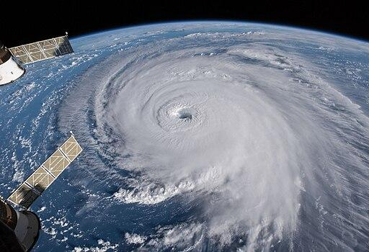

# Contents

**Chapter 1:** Where are our flood hazard areas? And who is living there?

**Chapter 2:** Exploring the characteristics and impacts of historical hurricanes

**Chapter 3:** Want to fly a drone? Know B4UFLY!

**Chapter 4:** Analyzing wildfire extent and response in California

**Chapter 5:** Assessing social vulnerability in areas impacted by Hurricane Florence

**Chapter 6:** Analyzing volcanic hazards near Kilauea Volcano, Hawai’i

**Chapter 7:** Collecting field data with ArcGIS Field Maps

**Chapter 8:** Natural hazards on the edge

**Chapter 9:** Exploring the world’s water resources

**Chapter 10:** Visualizing global climate change under different emission scenarios

**Chapter 11:** Plan your Mars landing

# Preface

When I first started teaching Geographic Information Systems (GIS) over 15 years ago, there were only a handful of GIS tutorial books on the market. While a few of them focused on a particular theme, many of them were mainly technical publications with no unifying theme. These publications are perfect for teaching new users about basic GIS operations and continue to be invaluable to many users today. However, these publications consisted of tutorials focusing on vastly different real-world scenarios, and felt a little disjointed to integrate into a class that focuses on a specific field (e.g. Environmental Science, Geography, Urban Planning). Since then, I am happy to see that there has been a proliferation of publications that are not only focused on introducing the technology, but also provide an introduction to a specific field as well as GIS.

It is with this consideration in mind that I wrote this book to not only introduce students to the tools in ArcGIS Pro, but also to provide a glimpse into some of the topics that may be covered in an introductory course in Geography, Environmental Science, or related disciplines. I aimed to achieve a balance of technical instruction and information about Earth, Space, and Environmental Sciences, to make this publication helpful for new GIS learners, as well as students who may be interested in learning about the applications of GIS in the Earth, Space, and Environmental Sciences.

Before you begin with the book, please download and unzip the data for the book at <https://tinyurl.com/eseshub>. Each chapter will begin with a list of the technical objectives for the lab exercise, which is particularly useful to refer to should you need a refresher on how to perform a particular task on a later date. The list of technical objectives is followed by a short introduction that provides the context for the exercise. Subsequently, you will find the step-by-step directions for the exercises with questions embedded throughout (in yellow highlight) to ensure that you are on the right track. To obtain a copy of the answer key for the questions, please email me at [wcheung@palomar.edu](mailto:wcheung@palomar.edu) with a copy of your current faculty identification or other forms of professional identification.

To complete the exercises in this book, you will need access to ArcGIS Pro 3.4 (and ArcGIS Online with credits for some chapters). Please remember to first download the exercise data for the book at <https://tinyurl.com/eseshub>.

I wish you a wonderful time exploring various topics in GIS and Earth, Space, and Environmental Sciences in this book.

*Wing Cheung PhD, GISP*

# Acknowledgments

I will like to thank my former student and editor, Diana Valdez, for offering feedback on the directions and suggesting clarifications in the text. I also want to thank students in my GIS classes, who also offer valuable feedback on the exercises and tested the directions. I will also like to express my sincerest thanks to prior authors whose works inspired some of the chapters in this book.

I also want to thank my colleagues, friends, and family for offering their technical and personal support to help me complete this project.

*Earth, Space, and Environmental Science Explorations with ArcGIS Pro by Wing Cheung is licensed under the Creative Commons* [*Attribution 4.0 International (CC BY 4.0)*](http://creativecommons.org/licenses/by/4.0/)

*All images in this textbook are created by Wing Cheung and licensed under*[*CC BY 4.0*](http://creativecommons.org/licenses/by/4.0)*/ A derivative from the*[*original work*](https://www.esri.com/en-us/arcgis/products/arcgis-pro/overview)

# Chapter 1: Where are our flood hazard areas? And who is living there?

*In this exercise, you will:*

* *Create a new project and map*
* *Add layers to a new map*
* *Share and publish a web layer*
* *Analyze spatial relationships using the “enrich layer” function in ArcGIS Online*
* *Explore summary statistics*
* *Filter out missing data values and features*
* *Visualize data in 3D*

## **Introduction**

*A floodplain is defined as “the flat low-lying area flanking a stream channel that is subjected to recurrent flooding” (Christopherson, 2002). Floodplains are frequently formed when a stream meanders (i.e. shifts) across a flat and wide low-lying area (McKnight and Hess, 2009). Floodplains are occasionally inundated during periods of heavy precipitation when water spills over the normal stream channel.*

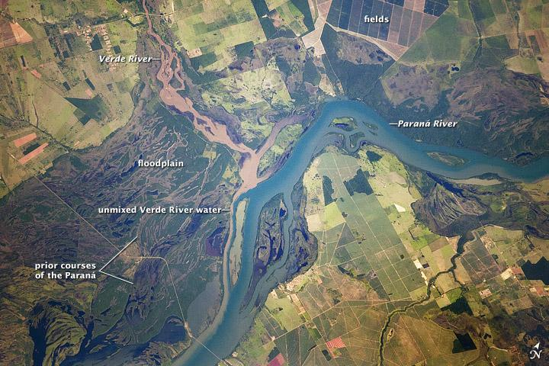

The Paraná River appears as a wide, blue strip with the muddy brown water of the smaller Verde River entering from the northwest (top left). (Source: NASA Astronaut photograph ISS030-E-90012, Public domain, via Wikimedia Commons)

*While a floodplain is usually associated with riverine flooding, flooding may also occur in coastal regions as a result of high tides, storm surges, and precipitation. Hence, a more inclusive term used to describe areas subjected to occasional flooding is flood hazard areas. In particular, the Federal Emergency Management Agency (FEMA) calls areas that have a 1 percent chance of being flooded in a given year the 100-year floodplain, and identifies these Special Flood Hazard Areas (SFHA) in its flood insurance rate maps (FEMA, 2019). Within a flood insurance rate map, 100-year floodplains may include Zone AE (shown in neon blue in the graphic below) as well as other zones. Homes and businesses within these areas “with mortgages from federally regulated or insured lenders are required to have flood insurance” (FEMA, 2018). You can explore flood hazard areas in your region by visiting* [*FEMA’s Flood Map Changes Viewer*](https://hazards-fema.maps.arcgis.com/apps/webappviewer/index.html?id=8b0adb51996444d4879338b5529aa9cd)*.*

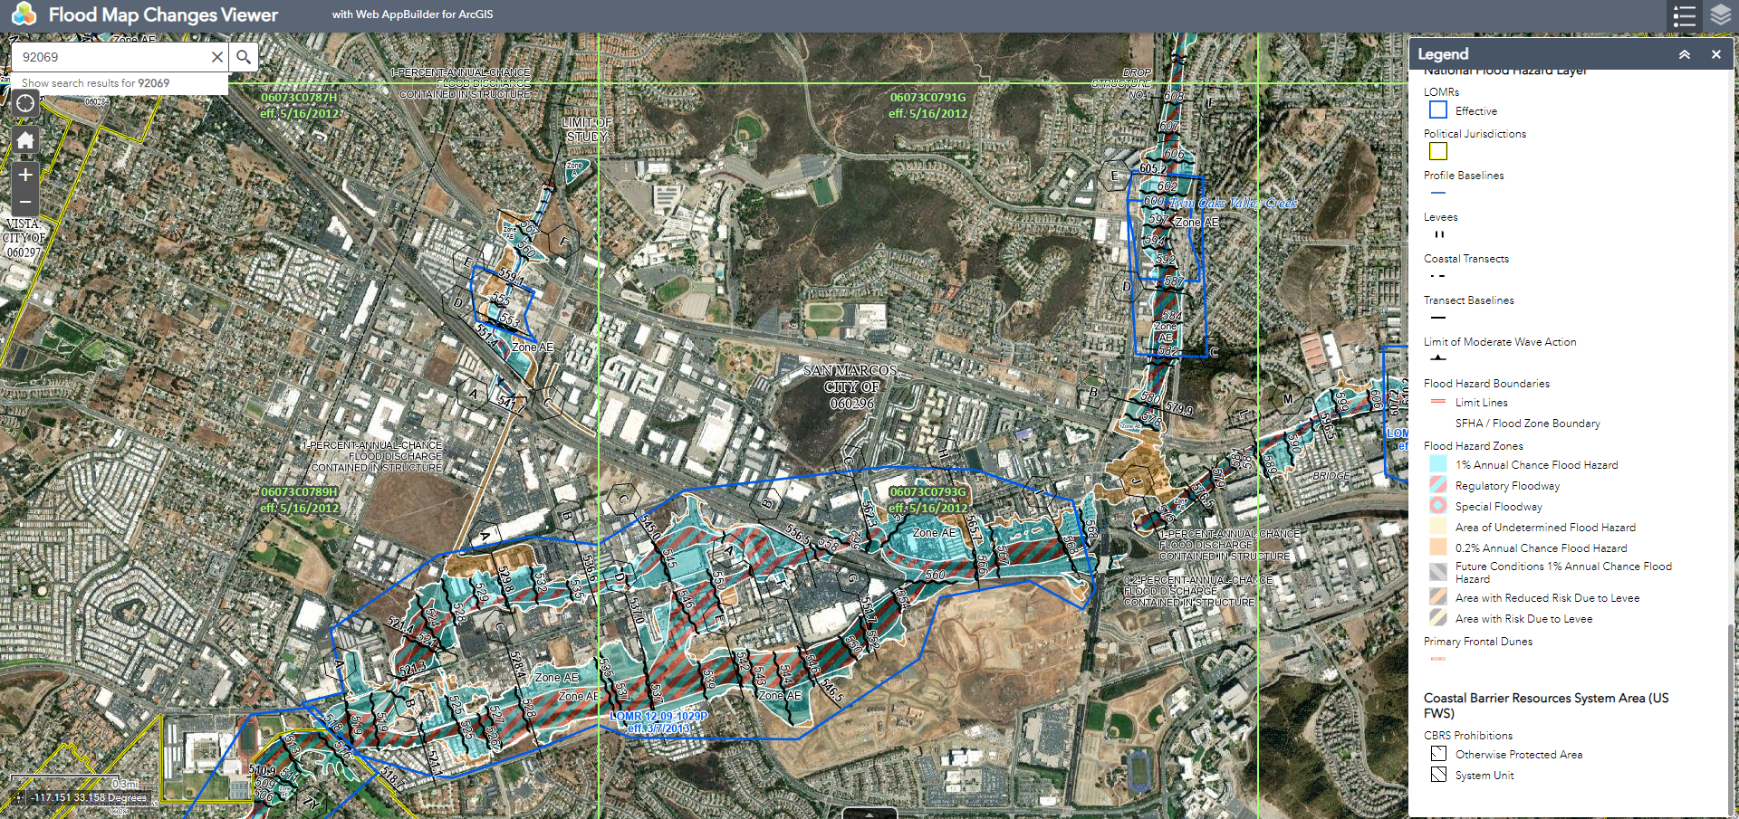

A look at special flood hazard areas within the City of San Marcos generated using the Flood Map Changes Viewer. (Source: FEMA)

*In this exercise, you will explore the location of the 100-year floodplains in San Diego County, and analyze the socioeconomic characteristics of the residents in these areas. Specifically, you will use ArcGIS Online as your primary platform for visualization and analysis in this exercise.*

### **Start a project and add layers**

* 1. Start **ArcGIS Pro.** 
  2. In the Welcome screen, click **Map** to start a new project, name it something descriptive (e.g. Floodplain), and save it in a safe location.

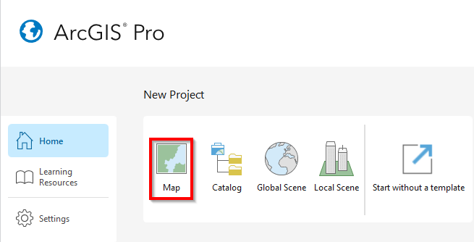

* 1. Add a layer that shows the areas within San Diego County that has a 1% chance of being flooded in any given year according to the Federal Emergency Management Agency (FEMA), these areas are also called 100-year floodplains.

Go to **Add Data** (found under the **Map** tab in the main menu), and add in the **Floodplain_100_Year_CN.shp**

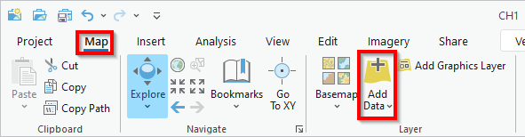

### **Share your layer online**

* 1. To share the layer as a web layer on ArcGIS Online, go to the **Share** tab in the main menu. Click on **Web Layer**>**Publish Web Layer**.

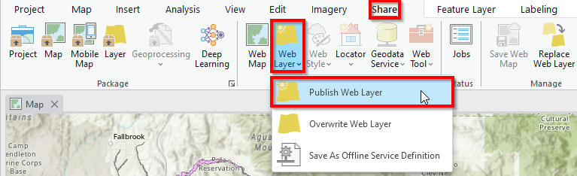

* 1. In the Sharing Map As A Web Layer pane, enter the following:
     1. Name: **SDFloodplain_(first initial and last name)**

*\*\*Tip: Each item published to ArcGIS Online must have a unique name within the organization\*\**

* + 1. Summary: **FEMA floodplains in San Diego County**
    2. Tags: **Flood Hazard**
    3. Layer Type: **Feature**
    4. Share with: **Everyone**
    5. Click **Analyze** (Right-click the error , select **Auto-Assign IDs Sequentially**, and ignore the warnings .

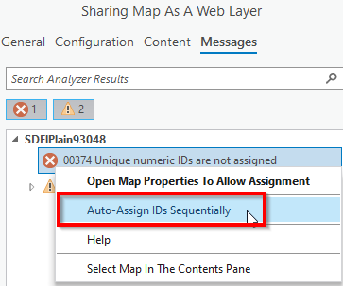

* + 1. Click **Publish**.
  1. Once the publication process is complete, you should see a green box at the bottom of the window telling you that ArcGIS has successfully published the web layer.

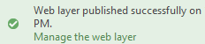

* 1. Click the **Manage the web layer** link at the bottom of the green box to view your web layer on ArcGIS Online.
  2. Click **Open in Map Viewer** within the item details page to view your layer in your internet browser.

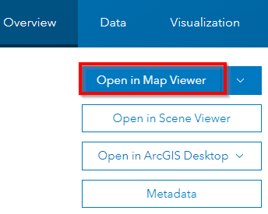

Q1. Hypothesize the relationship between income and 100-year floodplain locations. In other words, do you think the median household income of families living within the 100-year floodplain is higher or lower than the county average ([the median household income for a family in San Diego County is $](https://www.census.gov/quickfacts/fact/table/sandiegocountycalifornia/INC110217)102,285 in 2023)? Why? Write down your hypothesis in 2-3 sentences.

### **Analyze spatial relationships in ArcGIS Online**

* 1. In your **internet browser (not the ArcGIS Pro program)** that is currently displaying the 100-year floodplain layer, click **Sign In** and enter your ArcGIS Online account information. The following steps and tools that we will use are only available to paid ArcGIS Online users.
  2. Click on any on the **polygons** in the map to see its pop-up information. You should be able to see basic information such as the polygon’s FID (feature id), Name, Shape_Area, and Shape_Length at this pointof the exercise, but no socioeconomic data (e.g. income) about the people who live within the polygon. We will append that socioeconomic information in the following steps.
  3. To test your hypothesis, click **Analysis** () on the right margin. (If the Analysis icon is not available, check to make sure you are signed in and not using a free, public ArcGIS Online account)
  4. Select **Tools>Enrich data>Enrich Layer**.

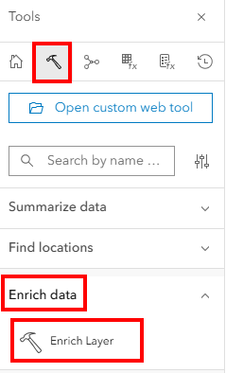

*\*\*Tip: This capability costs credit/money, so use it sparingly\*\**

* 1. Within the Enrich Layer dialog, enter the following:
     1. Features to enrich: SDFloodplain_(first initial and last name)
     2. Enrichment data: click 
     3. In the Data Browser window, select **United States** from the dropdown on the right. Ensure that **Esri 2025** is selected. Type in **income** in the box on the left and hit **Enter** on your keyboard.

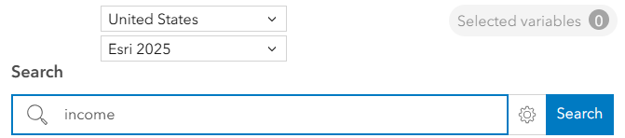

* + 1. On the next window, check the box next to **2025 Median Household Income (Esri)**. Click **Select**.

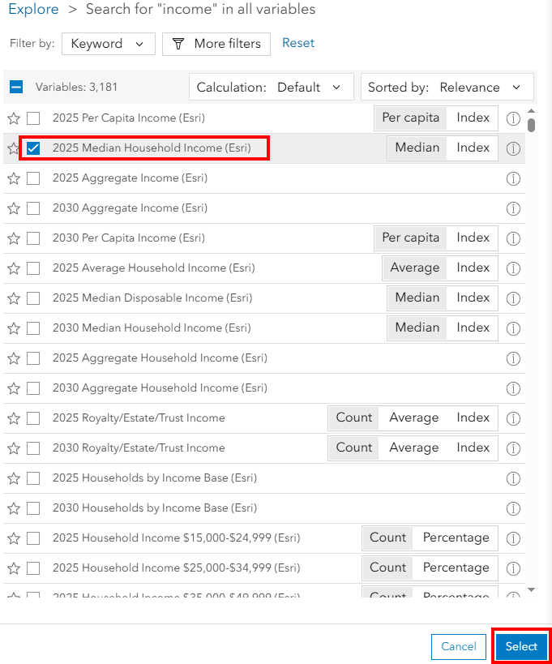

* + 1. Result layer: type in a name for the Output name. E.g. FloodplainMedianIncome_(first initial and last name)
    2. Expand **Environment settings**, and make sure that **Full extent** is selected for Processing extent. Click **Estimate credits** (should cost less than 2 credits).

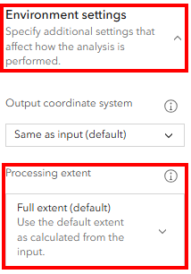

* + 1. Click **Run** (this may take a few minutes)
  1. Once the analysis is complete, you should see your new layer (i.e. FloodplainMedianIncome) listed in the Layers pane on the left side of the window.

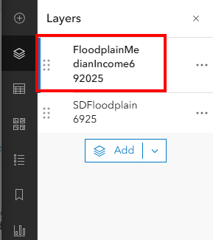

### **Explore and filter your data**

* 1. In the Layers pane, turn off the **SDFloodplain_(first initial and last name)** layer by hovering your mouse over it and clicking on the **visibility** icon.

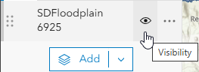

The only layer that should be visible now is the FloodplainMedianIncome layer (i.e. the layer that you just created in the last step).

* 1. Explore the FloodplainMedianIncome layer by clicking on some of the **polygons** and reading the information in the pop-up window. Unlike the pop-up windows we observed in the previous section, the pop-up windows now contain socioeconomic information. Specifically, the information of most interest to us is the value for Median Household Income within the pop-up window. This is the median (i.e. middle or 50th percentile) income of all the households within the specific floodplain polygon that you clicked on.

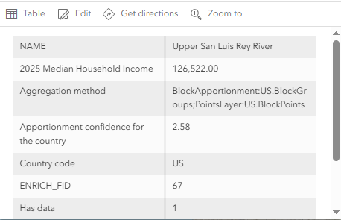

*\*\*Tip: Depending on where you clicked, many of the polygons’ Median Household Income will report 0.00 because they are in the middle of a lake or river, and no one is living within those areas\*\**

* 1. To see if our hypothesis is correct, click the **Options** icons () next to the FloodplainMediaIncome layer and select **Show table**.

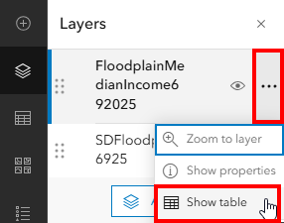

* 1. You should now see the FloodplainMedianIncome layer’s attribute table, and scroll to the right until you see the 2025 Median Household Income fields/columns in the table. Click on the **options** icon (i.e. three dots icon) next to the column name, and select **information**.

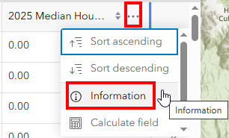

Q2. In the pop-up window, scroll down to see what is reported as the **Average** 2025 Median Household Income amongst families living within the 100-year floodplain in San Diego County?

Given that many of the polygons are in the middle of a lake or river with no data to report, there are many 0.00 values within the Median Household Income field that are skewing/inaccurately depressing the Average Median Household Income. Thus, we must first filter out those 0.00 values before calculating an average again.

* 1. Make sure that the FloodplainMedianIncome layer is still selected in the Layers pane and click on the **Filter** icon on the right side of the window.

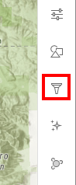

* 1. In the Filte window, click **+ Add new**, then enter the following:
     1. First dropdown: **2025 Median Household Income**
     2. Second dropdown: **is not**
     3. Third box: type in **0**
     4. Click **Save**

This filter operation ensures that we are only retaining areas with income-generating households for our subsequent operations.

* 1. Repeat step d in this section, and find the Average 2025 Median Household Income among families living within the 100-year floodplain in San Diego County.

Q3. What is the updated **Average** 2025 Median Household Income amongst families living within the 100-year floodplain, now that we have excluded the polygons without income-generating households?

Q4. Was your hypothesis correct or incorrect? In two to three sentences, what may this result suggest about the actual relationship between income and natural hazards?

### **(Optional) Visualize your data in 3D**

* 1. Go back to the **ArcGIS Pro** program (not your internet browser) that we worked with in section 1 and section 2 of this exercise.
  2. In the main menu, select the **View** tab. Click on **Convert**>**To Local Scene**.

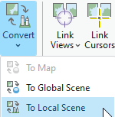

* 1. Use the scroll wheel on your mouse to zoom in on one of the floodplain polygons.
  2. To visualize the terrain in 3D, click the **up arrow**  in the 3D controls in the lower right corner to expand the controls.

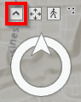

* 1. Click and drag the **inner circle** (shown in blue in the graphic below) in the 3D controls in order to change the perspective of your map.

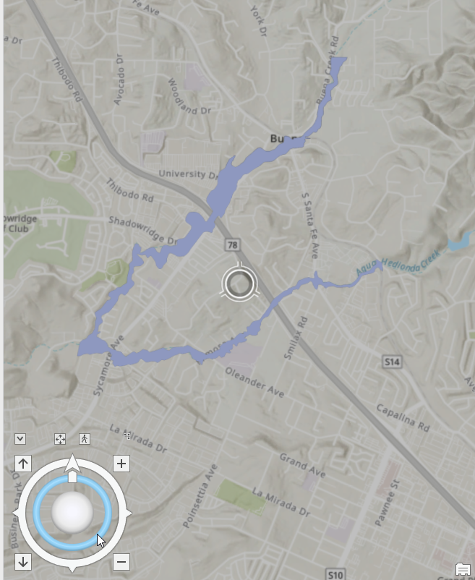

* 1. Repeat the previous step until the **inner circle is nearly flat** and you can see the horizon in your map.

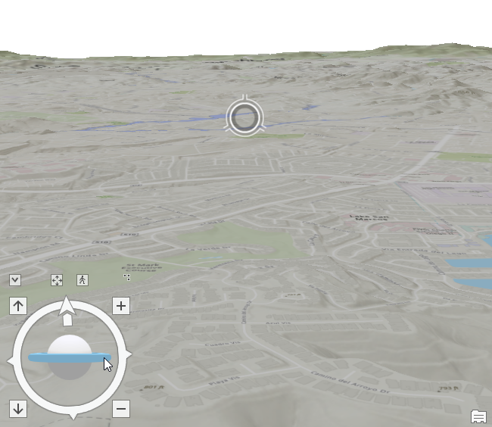

* 1. Go to **Add Data**  (found under the **Map** tab in the main menu).
  2. In the Add Data window, select **ArcGIS Online** (under the Portal section) on the left side of the window.

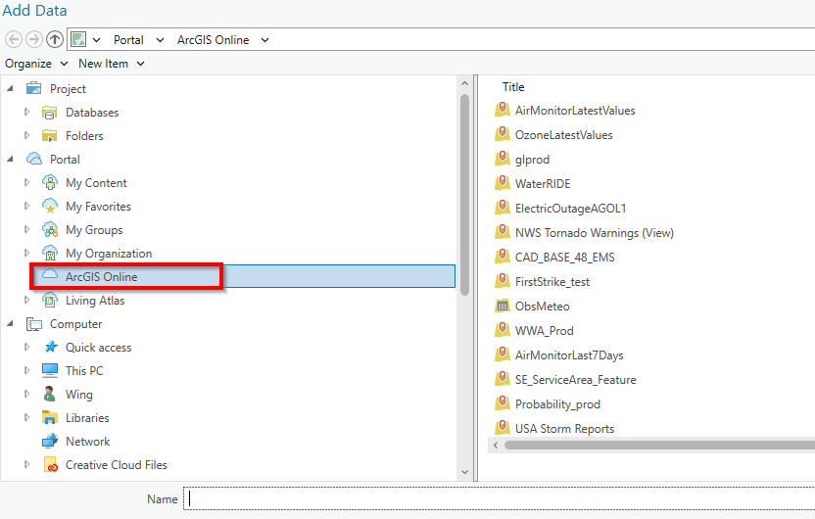

* 1. In the search box in the upper right corner, type in **OpenStreetMap 3D Buildings** and hit the **Enter** key on your keyboard. You should now see the OpenStreetMap 3D Buildings layer owned by esri in the search results. **Double-click** on it **twice** to add it to your map.

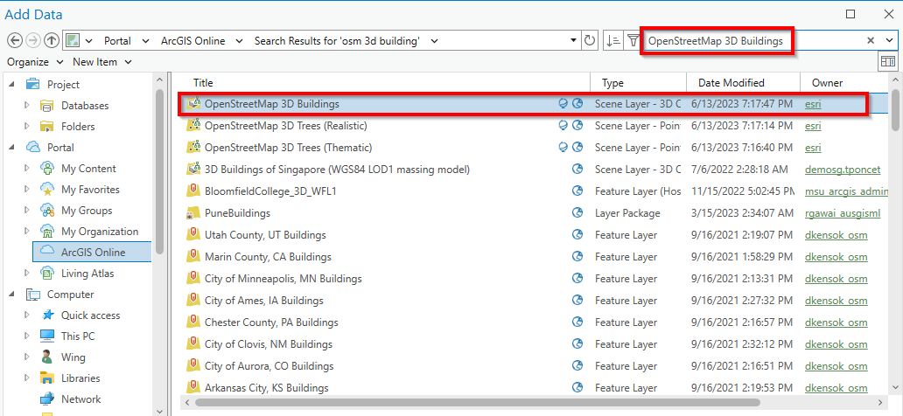

* 1. You should now see the 3D polygons of various buildings in your map, as well as those that may be lying within the floodplain. Keep in mind that the OpenStreetMaps 3D Buildings layer may take a while to load as it contains the 3D polygons for nearly all the buildings in the world. You can also try zooming in and out with your mouse scroll wheel if the layer does not load after several minutes.

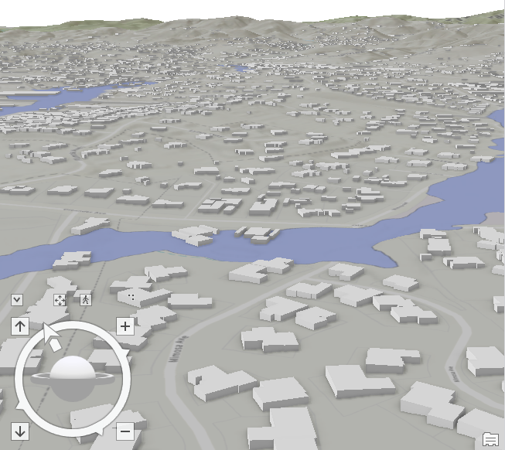

Works Cited

Christopherson, Robert W. *Geosystems : An Introduction to Physical Geography*. Upper Saddle River (N.J.), Prentice Hall, 2002.

FEMA. “Flood Zones.” *Fema.Gov*, Federal Emergency Management Agency, 2019, www.fema.gov/flood-zones. Accessed 26 June 2019.

FEMA. “How Do I Buy Flood Insurance?” *Fema.Gov*, Federal Emergency Management Agency, 2018, www.fema.gov/national-flood-insurance-program/How-Buy-Flood-Insurance. Accessed 26 June 2019.

Mcknight, Tom L, and Darrel Hess. *Physical Geography*. Boston, Ma, Pearson Education, 2009.

‌

# Chapter 2: Exploring the characteristics and impacts of historical hurricanes

*In this exercise, you will:*

* *Create a new project and map*
* *Add layers to a new map*
* *Rename layers*
* *Examine a layer’s attributes*
* *Perform definition queries*
* *Explore summary statistics*
* *Create scatter plots*
* *Select features by their attributes*
* *Select features by their locations*

## **Introduction**

*The Congressional Budget Office (CBO) estimated that hurricanes caused approximately $28 billion in annual damage nationwide in 2016. Partly as a result of coastal development and climate change, the CBO projected that the cost of damages will increase by nearly 40 percent by 2075 (Plumer, 2017). Meanwhile, federal spending in response to these disasters is expected to increase from $18 billion in 2016 to $24 billion in 2075 (CBO, 2016). Moreover, the distribution of hurricane-related damage is not evenly distributed among coastal states, as states such as Florida alone account for more than half of the damage (CBO, 2016).*

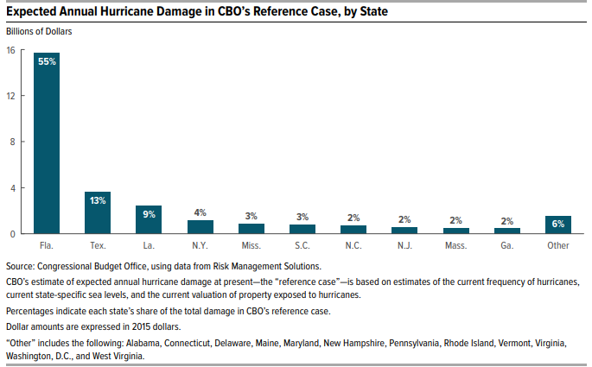

The distribution of annual hurricane-related damage by state based on 2015 hurricane frequency, sea level, and property value information. (Source: US Congressional Budget Office)

*There are five major ways in which hurricanes inflict damage (Amadeo, 2019), they are:*

*(1)* ***high winds****, which are used to classify whether a hurricane is a category 1,2,3,4, or 5 event according to the Saffir-Simpson Hurricane Wind Scale (NOAA, 2012)*.

| *Category* | *Sustained Wind Speed* |
| --- | --- |
| *1* | *74-95 mph* |
| *2* | *96-110 mph* |
| *3* | *111-129 mph* |
| *4* | *130-156 mph* |
| *5* | *157 mph or higher* |

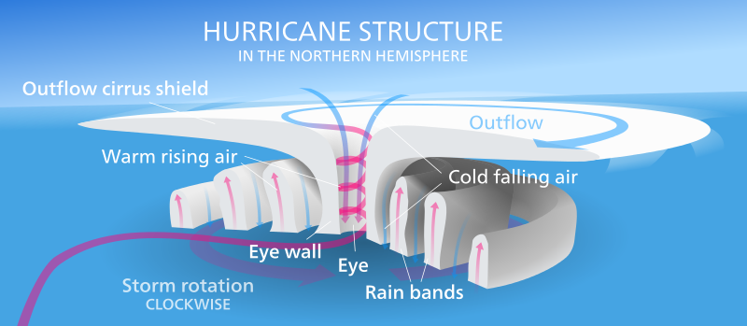

The Saffir-Simpson Hurricane Wind Scale (left). Diagram of a Northern Hemisphere Hurricane (right). (Source: [Kelvinsong](https://commons.wikimedia.org/wiki/File:Hurricane-en.svg), [CC BY 3.0](https://creativecommons.org/licenses/by/3.0), via Wikimedia Commons)

*(2)* ***storm surge****, which is the rise in water above normal high tide.*

*(3)* ***extreme rainfall****, which may cause coastal floods, flash floods, river overtopping, and dam and levee failures, among other disasters that can lead to the loss of lives and properties.*

*(4)* ***location****. Given that hurricanes form over warm ocean waters, and the unprecedented rate of development in many coastal communities, the number of vulnerable properties and people has dramatically increased over time.*

*(5)* ***preparedness****. Timely and orderly evacuation can reduce the loss of lives associated with hurricanes. However, time and again, evacuees have decided to “ride out the storm” due to various reasons (e.g. care for pets, lack of shelter space, mobility issues, etc.), which may add to the hurricane’s death toll. Furthermore, even for those who evacuate, property damage caused by floodwater and wind contributes to the hurricane’s economic toll.*

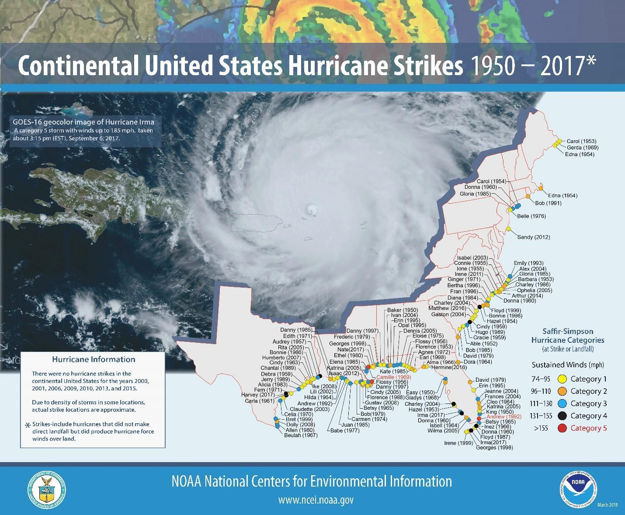

The locations where hurricanes made landfall in the continental United States between 1950 and 2017 categorized by sustained wind speeds. (Source: NOAA)

*In this exercise, you will analyze some of the most destructive hurricanes to hit the Atlantic coast of the United States between 1950 and 2000. In particular, you will examine the economic and human tolls associated with these past extreme weather events, and assess areas and populations that may be vulnerable to future hurricanes.*

### **Start a project, rename layers, add and explore the data**

* 1. Start **ArcGIS Pro**.
  2. In the home screen, click **Map** 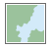 to start a new project. Give it a name (e.g. hurricanes) and save it in a safe location.
  3. Go to **Add data** (found under the **Map** tab), and add the **hurrpath.shp** to your map. This layer shows the paths of hurricanes that have impacted the continental US between 1950 and 2000.
  4. In the Contents pane, right-click hurrpath, and select **Properties**. In the General section of the Layer Properties window, change the Name from hurrpath to Hurricanes. Click **OK**.

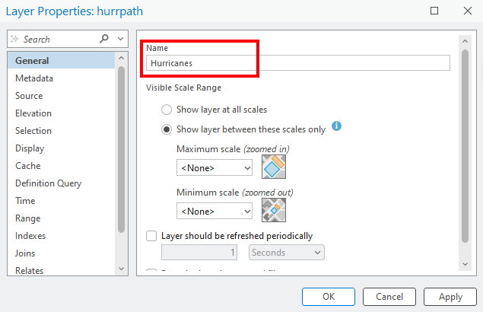

* 1. Return to the Contents pane, right-click **Hurricanes** (formerly hurrpath), and select **Attribute Table **.

Q1. How many hurricane tracks are in the layer?

* 1. Within the attribute table, right-click on the column name of **MAX_WINDSP** (which contains information on the maximum windspeed for each hurricane), and select **Sort Descending** to list the hurricane events sorted from highest windspeed to lowest windspeed.

Q2. What are the names (FIRST_NAME) of the two hurricane events with the strongest maximum windspeed?

### **Filter data with definition queries and compute summary statistics**

* 1. Return to the Contents pane, right-click **Hurricanes**, and select **Properties**. Select **Definition Query** in the left margin.

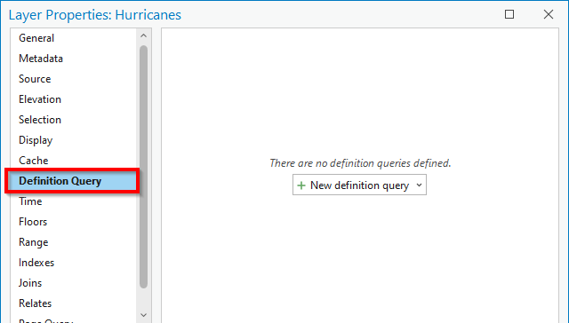

* 1. In the Definition Query section of the Layer Properties window, click **New definition query**, and enter the following:
     1. Select **MAX_WINDSP** for the first dropdown.
     2. Select **is greater than or equal to** for the second dropdown.
     3. Enter **150** in the third box.
     4. Click **Apply**. Click **OK**.

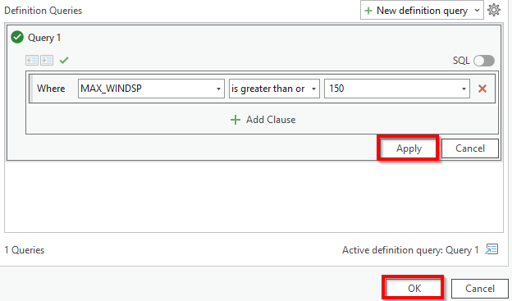

* 1. Return to the Contents pane, right-click **Hurricanes**, and select **Attribute Table**.

Q3. How many hurricane tracks are left in the layer after the definition query?

* 1. Within the attribute table, right-click on the column name **PATH_LEN** (which contains information on the length of the track for each hurricane), and select **Visualize Statistics**.

Q4. What is the mean (average) track length (in kilometers) of the hurricanes that are currently in the attribute table **(round answer to two decimal places)**?

*\*\*Tip: Not sure how to round your answers, review this short video* [*https://youtu.be/qRL_taeUAPw?feature=shared*](https://youtu.be/qRL_taeUAPw?feature=shared) . **

* 1. To clear the definition query filter, return to the Contents pane, right-click **Hurricanes**, and select **Properties**. In the Definition Query section of the Layer Properties window, hover your mouse over the query we previously created, and select the **red X**, click **Yes**. Click **OK**.

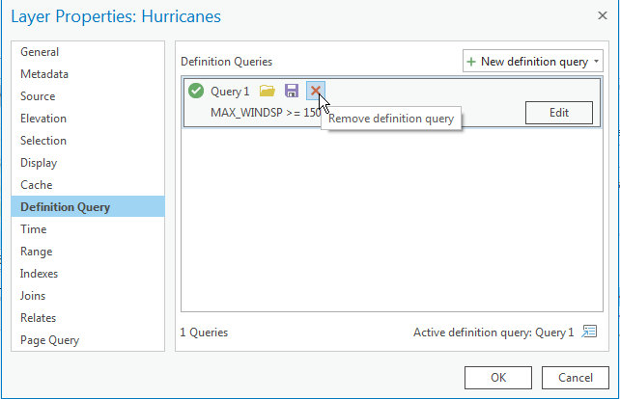

* 1. Return to the Contents pane, right-click **Hurricanes**, and select **Attribute Table**. You should now see a lot more hurricane tracks in the table. This is because the Definition Query previously filtered out a subset of features that meet a specific criterion (i.e. maximum windspeed greater than 150 mph), and once we erased the query, we can see all of the layer’s features again.

### **Explore relationships with scatterplots**

* 1. Right-click the **Hurricanes** layer in the Contents pane, and select **Create Chart**>**Scatter Plot.**

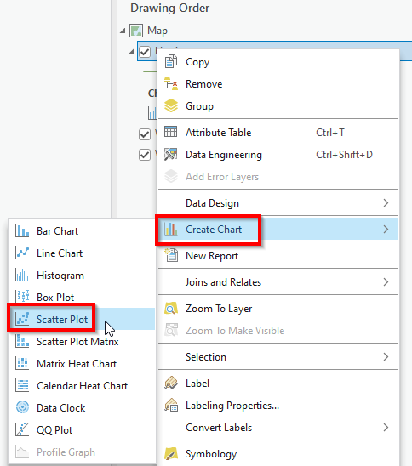

* 1. In the Chart Properties window, explore the relationship between hurricane track length (PATH_LEN) and maximum wind speed (MAX_WINDSP) by selecting **PATH_LEN** for the X-axis Number and **MAX_WINDSP** for the Y-axis Number. 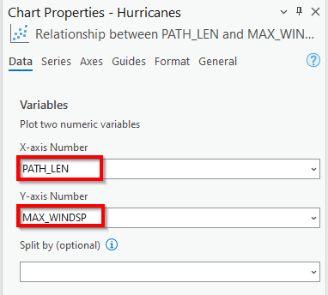

Q5. What is the R2 value (**round answer to two decimal places**)?

*\*\*Tip: The R2 value tells us the percentage of the variation in the hurricanes’ maximum wind speed that is explainable by their path lengths.\*\**

### **Select features by attributes**

* 1. Go to **Add data** (found under the **Map** tab), and add the **top10dam.shp** to your map. This layer shows the paths of the 10 hurricanes with the most monetary and property damage between 1950 and 2000.
  2. To see how many of the hurricanes in the top10dam layer have between 100 and 1,000 deaths, click on **Select By Attributes** 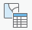 (found under the **Map** tab). In the Select Layer By Attribute window, enter the following:
     1. Input Rows: **top10dam**
     2. Selection Type: **New selection**
     3. Expression:
        1. Select **DEATHS** for the first dropdown, select **is greater than** for the second dropdown, and type in **100** for the third box.

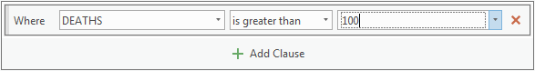

* + - 1. Click **Add Clause**. Now select **And** for the first dropdown, select **DEATHS** for the second dropdown, select **is less than** for the third dropdown, and type in **1000** for the fourth box.

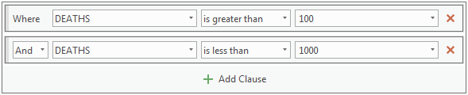

* + 1. Click **OK**.
  1. Return to the Contents pane, right-click **top10dam**, and select **Attribute Table**.

Q6. How many records/features in the top10dam layer’s attribute table are selected? This is the number of hurricanes in the layer that have caused between 100 and 1,000 causalities.

* 1. Clear any currently selected feature by clicking on **Clear**  (found under the **Map** tab).
  2. Repeat and modify steps b and c in this section to:
* Remove the previous conditions by clicking the **Remove** icon  in the Select By Attribute window.
* Create a new expression to find the number of hurricanes within the top10dam layer that took place between the year 1900 and the year 1950. Be sure to include the years 1900 and 1950 in your query (i.e. YEAR is greater than or equal to 1900 AND YEAR is less than or equal to 1950).

Q7. How many records/features in the top10dam layer’s attribute table are now selected? This is the number of highly destructive hurricanes that took place between 1900 and 1950.

### **Select features by location**

* 1. Clear any currently selected feature by clicking on **Clear**  (found under the **Map** tab). This will ensure that any selection that we make in the following steps is based on all features within the layer, rather than just a subset of previously selected features.
  2. Go to **Add data** (found under the **Map** tab), and add the **Florida.shp** to your map. This layer shows all the counties within Florida.
  3. Turn off the Hurricanes layer in the contents pane, leaving the top10dam layer on. To see how many of the top 10 hurricanes with the most monetary and property damages made landfall in Florida, click **Select By Location** 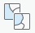 within the **Map** tab. In the Select By Location window, enter the following:
     1. Input Features: **top10dam**
     2. Relationship: **Intersect**
     3. Selecting Features: **Florida**
     4. Selection type: **New selection**
     5. Click **OK**

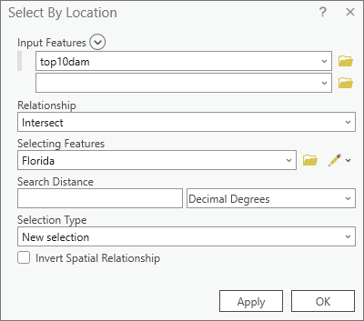

* 1. Return to the Contents pane, right-click **top10dam**, and select **Attribute Table**.

Q8. How many records/features in the **top10dam** layer’s attribute table are selected? This is the number of the 10 deadliest hurricanes that made landfall in Florida.

* 1. Turn off the top10dam layer in the contents pane, turn the Hurricanes layer back on. Repeat and modify steps c and d to find the number of hurricanes within the **Hurricanes** layer (**not the top10dam layer**) that made landfall in (i.e. intersected) Florida. Make sure that you are looking at the Hurricanes layer’s attribute table when answering the question below.

Q9. How many records/features in the **Hurricane** layer’s attribute table are selected? This is the number of hurricanes (regardless of toll or magnitude) that made landfall in Florida.

Works Cited

Amadeo, Kimberly. “How Hurricanes Damage the Economy.” *The Balance*, 25 June 2019, www.thebalance.com/hurricane-damage-economic-costs-4150369. Accessed 25 June 2019.

CBO. *Potential Increases in Hurricane Damage in the United States: Implications for the Federal Budget What Are CBO’s Estimates of Hurricane Damage and of Related Federal Spending?* Congressional Budget Office, 2016.

NOAA. “Saffir-Simpson Hurricane Wind Scale.” *National Hurricane Center and Central Pacific Hurricane Center*, National Oceanic and Atmospheric Administration, 2012, www.nhc.noaa.gov/aboutsshws.php.

Plumer, Brad. “Why Hurricane Irma Could Hurt, a Lot: Much Lies in Harm’s Way.” *The New York Times*, 7 Sept. 2017, www.nytimes.com/2017/09/07/climate/florida-hurricane-irma-damage.html. Accessed 25 June 2019.

‌

# Chapter 3: Want to fly a drone? Know [B4UFLY](https://www.faa.gov/uas/recreational_fliers/where_can_i_fly/b4ufly/)!

*In this exercise, you will:*

* *Geocode a list of addresses*
* *Rematch problematic addresses*
* *Perform buffer analysis*
* *Select features by their locations*
* *Share information as a map package and a layer package*

## **Introduction**

*Unmanned Aircraft Systems (UAS) or drones are increasingly used for a variety of applications, including agriculture, building inspection, environmental assessment, firefighting, search and rescue, and surveying and mapping. Generally, drone operators are discouraged from flying near airports because of potential interference with air traffic (Federal Aviation Administration, 2019). In the past, nefarious drone operators have caused great damage to property (Navarro and Levin, 2018) and chaos in congested airspaces (Pérez-Peña, 2018).*

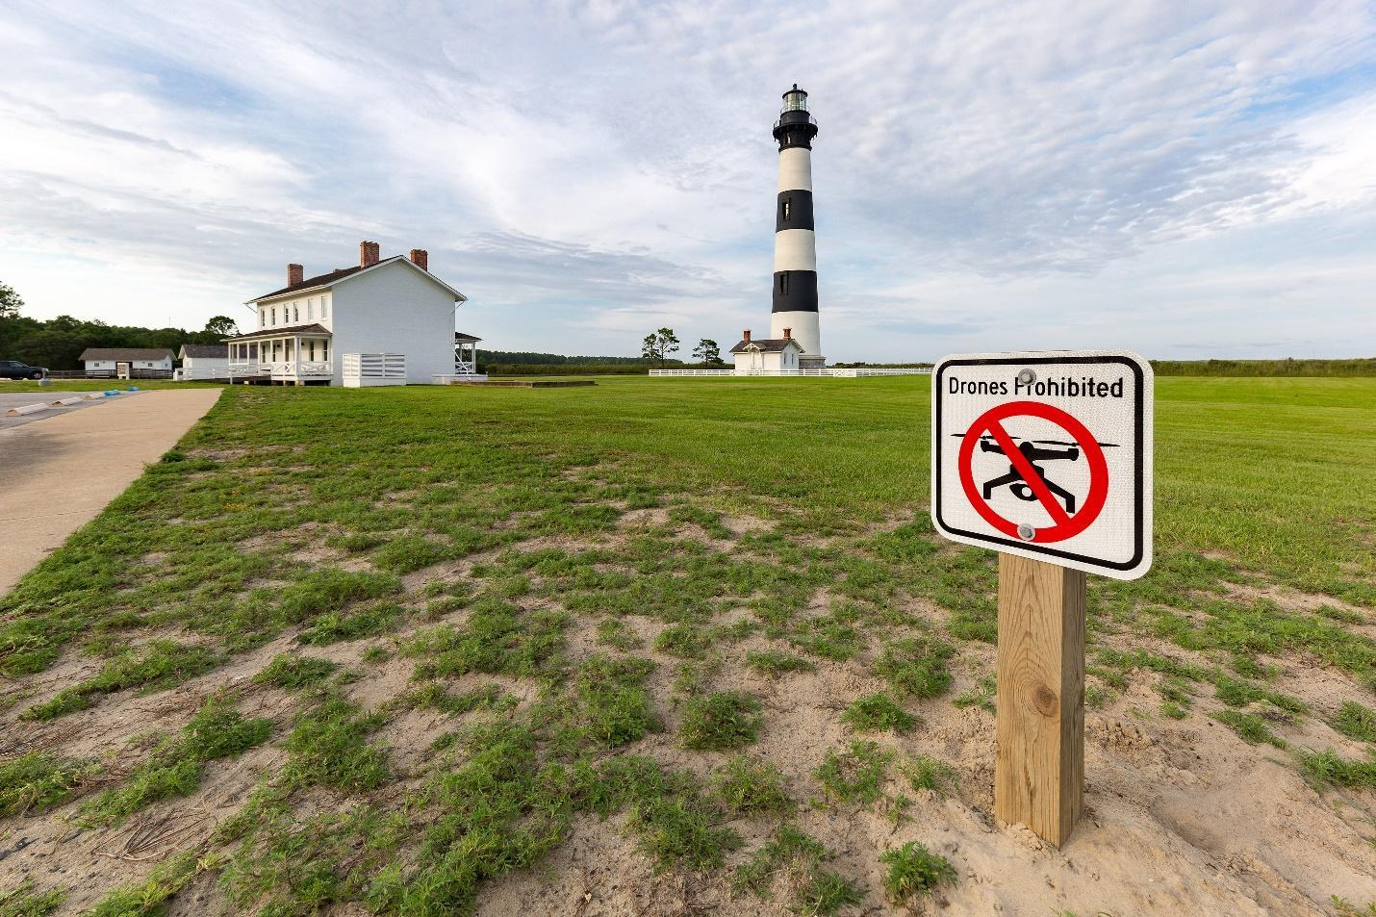

A drone-prohibited sign at the Bodie Island Lighthouse, which was built in 1871 on the Outer Banks of North Carolina. (Source: [Martin Kraft](https://commons.wikimedia.org/wiki/File:MJK49751_Outer_Banks.jpg), [CC BY-SA 4.0](https://creativecommons.org/licenses/by-sa/4.0), via Wikimedia Commons)

*While there is no uniform international regulation governing drone use near airports, governments around the world are beginning to push for the exclusion of drone operations near airports, as well as other anti-drone tactics ranging from signal jammers to eagles that are trained to take down nefarious drones (Pérez-Peña, 2018). Since the Federal Aviation Administration (FAA) Reauthorization Bill of 2018 repealed the Special Rule for Model Aircraft (i.e. Section 336 of the 2012 FAA Modernization and Reform Act), recreational drone operators in the United States are no longer prohibited from operating within five miles of an airport as long as they secure prior permission from the FAA through* [*LAANC*](https://www.faa.gov/uas/programs_partnerships/data_exchange/) *(Low Altitude Authorization and Notification Capability). Nonetheless, as stated before, “drone operators should avoid flying near airports because of busy air traffic in those areas.” (Federal Aviation Administration, 2019)*

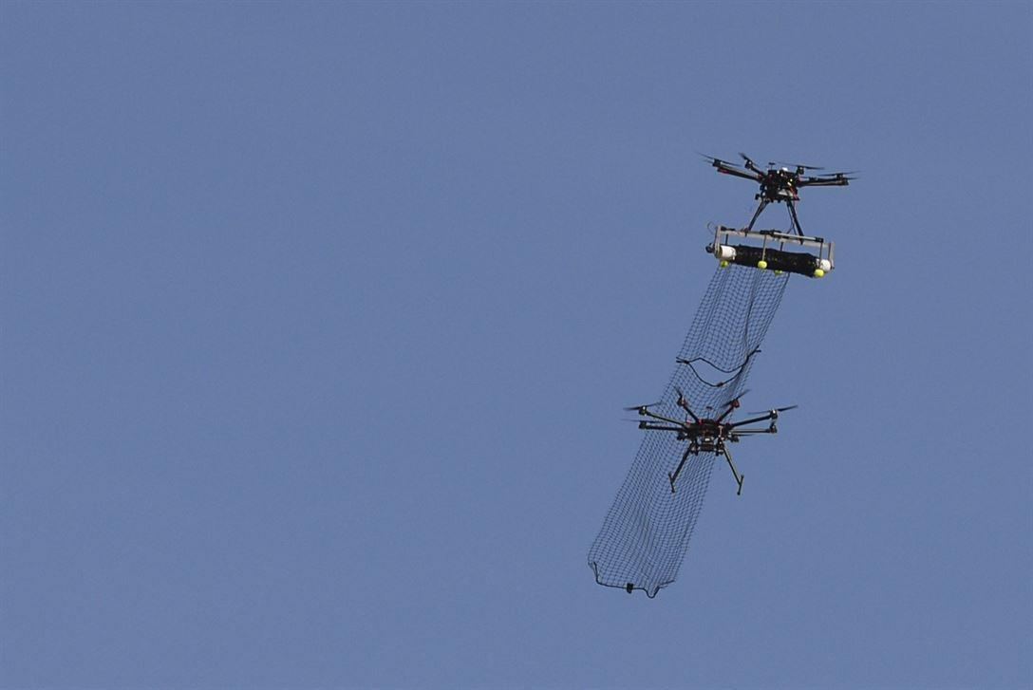

An attack drone with an attached net, part of the counter-unmanned aerial system developed by a team from Wright-Patterson Air Force Base, Ohio. (Source: Wesley Farnsworth via U.S. Department of Defense)

*In this exercise, you will first map all the airports, heliports, glider-ports, and other airfields in San Diego County. Secondly, you will analyze how many of the colleges in San Diego County are within five miles of an airport, and may need to secure permission from the FAA through LAANC before operating in the national airspace.*



**LAANC** in a nutshell: 1) (left) Drone users/operators supply operational parameters (e.g. operation date/time, flight altitude, aircraft model, etc) to a UAS Service Supplier, 2) (middle) the UAS Service Supplier checks the request against various FAA Airspace Data from the FAA UAS Data Exchange, 3) (Right) the drone user/operator receives authorization or denial in near-real time. (Source: U.S. Federal Aviation Administration)

### **Geocode airports and airfields in San Diego County**

* 1. Start **ArcGIS Pro**.
  2. In the home screen, click **Map** to start a new project. Give it a name (e.g. drones) and save it in a safe location.
  3. Go to **Add data** (found under the **Map** tab), and add the **Airport.csv** file to ArcGIS Pro.
  4. Right-click the **Airports.csv** table in the Contents pane and select **Open** to view the contents of the table.

Q1. How many records are in the worksheet?

*\*\*Tip: Remember that records refer to rows (red) in a table and fields refer to columns (blue) in a table.\*\**

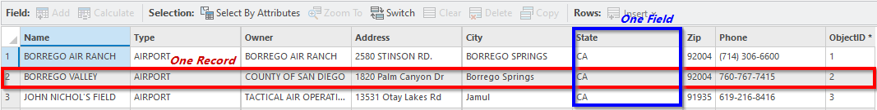

* 1. Geocode the data in the **Airports** table by right-clicking on it in the Contents pane and selecting **Geocode Table**.
  2. In the Geocode Table pane, click **Start**. This pane which walks users through a GIS workflow (i.e. Geocoding) in a step-by-step fashion is an example of a *Task* in ArcGIS Pro.
  3. For step one, select the **ArcGIS World Geocoding Service** for the Input Locator. Click **Next**.

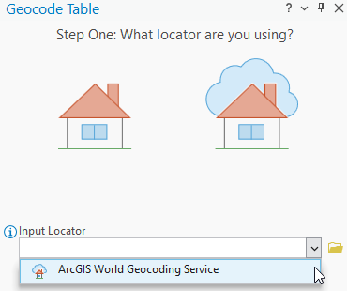

*\*\*Tip: If the ArcGIS World Geocoding Service is not an option, be sure that you are signed into ArcGIS Pro with a paid-ArcGIS Online account with sufficient ArcGIS Online credits\*\**

* 1. For step two, make sure that the Input Table is **Airport.csv**, and specify that the data we want to geocode is in **More than one field** since we will be using address, city, state, and zip code information from the input table to map our airports. Click **Next**.

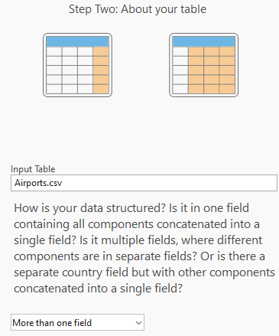

* 1. For step three, click the **Don’t know? Open the table** icon 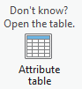at the bottom of the screen to open the attribute table (if necessary) and review the table to answer the following questions:

Q2. What is the name of the field/column in the table that stores the address or place data?

Q3. What is the name of the field/column in the table that stores the city data?

Q4. What is the name of the field/column in the table that stores the state data?

Q5. What is the name of the field/column in the table that stores the zip code data?

Using your answers above, ensure that the appropriate options are selected for the **Address or Place**, **City**, **State**, and **Zip** dropdown in the Geocode Table pane. It may already be pre-populated by ArcGIS Pro for you. Click **Next**.

*\*\*Tip: Even though the names of the fields/columns in this example correspond nearly exactly with the type of address information that they store, this is not always the case. In most cases, you will need to manually tell ArcGIS Pro which fields contain specific address information (e.g. which field in the input table contains zip code data).\*\**

* 1. For step four, name the output **AirportPoints** *(**Tip: You must use the browse icon  to change the output name**)*. Make sure that the checkbox for **Add output to map** after completion is checked, select **Address Location** for the Preferred Location Type, and select **All** for Output Fields. Click **Next**.
  2. For Optional Step Five, check **United States**. Click **Next**.
  3. For Optional Step Six, check **Address**. Click **Finish**.
  4. In the Geocode Table pane, you are now presented with a summary of the options that you have chosen in the previous six steps. Click **estimate credits** near the top of the pane (this process should cost less than 2 credits).Click **Run**.

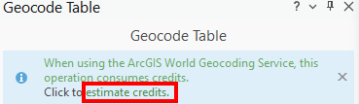

* 1. In the Geocoding Completed result window, you should see that 2 addresses were unmatched. However, there may be some addresses that were matched erroneously, so it is always a good practice to check where the matched addresses are. We will click **No** in the rematch process window for now but we will come back to it later.

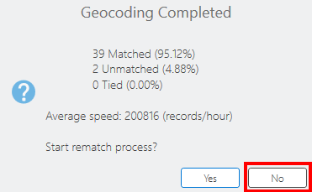

* 1. **Close** the Geocode Table pane.

### **Identify and fix problematic address matches**

* 1. Since we are mapping airports, glider-ports, and helipads, these features should be relatively easy to spot in an aerial photo or satellite photo. We will check our geocoded airport points by going to the **Map** tab, and select **Basemap**>**Imagery**. Keep in mind that many of the points will not be directly on the airstrip or helipad since these facilities (i.e. runways) don’t always have an exact address. Instead, the addresses we used may be that of a facility near the airstrip or helipad.
  2. Open the AirportPoints layer’s **attribute table**.
  3. You can double-click on the **left margin** (see below) of a row in the attribute table to center the map on the point tied to that row, and double-click again and again on the left margin to zoom in to get a closer look at the point.

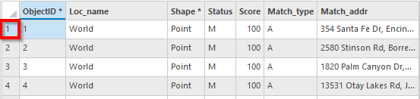

* 1. There are 4 problematic addresses in our table. Their names as listed in the USER_Name (*\*\*Tip: Depending on where you saved your file, this column may also be called Name, between the Country and Type columns\*\**) column are:
     1. FALLBROOK COMMUNITY AIRPORT*
     2. PAUMA VALLEY AIR PARK*
     3. JACUMBA
     4. SCE SONGS MESA

The addresses for FALLBROOK COMMUNITY AIRPORT and PAUMA VALLEY AIR PARK were entered incorrectly in the original address table (i.e. Airports.csv), which produced the 2 unmatched addresses (*) in our results window. FALLBROOK COMMUNITY AIRPORT and PAUMA VALLEY AIR PARK should have a value of “U” in the Status column, which stands for Unmatched. We will use the rematch address tool in the following steps to correct their addresses.

Clear any selection in your attribute table by going to the **Map** tab, and clicking on the **Clear** icon .

* 1. To access the rematch address tool, right-click on the name of the **AirportPoints** layer (not the Airports table) in the Contents pane. Go to **Data**, and select **Rematch Addresses.**
  2. In the Rematch Addresses pane, click on **Unmatched** (if needed), and you should see that there is a total of 2 unmatched address records. You will correct their addresses one at a time.

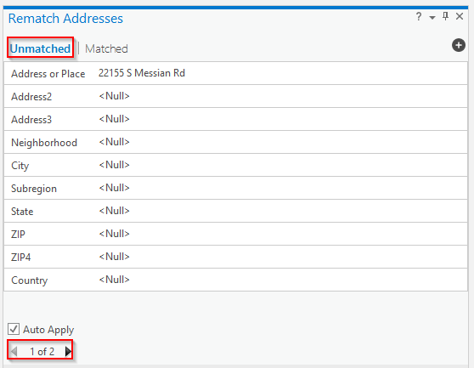

* 1. One of the unmatched addresses was entered as “22155 S Messian Rd” in the original Airports table. Change the address to **2155 S Mission Rd** in the Address or Place field, enter **Fallbrook** in the City field, and enter **92028** as the Zip. Make sure the **Auto Apply** box is checked.
  2. As you type in the corrected information, you should see the list of candidates is automatically updated in the lower half of the pane. If the list is not automatically updated, make sure the Auto Apply box is checked, or try closing the rematch addresses window and reopening it (see step e above).

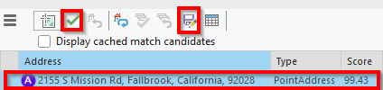

Click the **first candidate** in the list, click the **green checkmark**  to rematch the point based on the corrected address information, and then click the **disk icon**  to save your edits.

* 1. Repeat step 2.f. to 2.h. to correct the remaining unmatched address of “133129 ColeG Ln”. Change its Address or Place information to **33129 Cole Grade Rd**, enter **Pauma Valley** for the City, and **92061** for the Zip. Remember to click the **green checkmark** to rematch your point, and then click the **disk icon** to save your edits. Do not close the Rematch Addresses pane.
  2. Open the AirportPoints layer’s **attribute table** if necessary, and review the Status column. “M” should be the only value found in the column (i.e. no “U”) since we just fixed the 2 unmatched addresses.
  3. While JACUMBA and SCE SONGS MESA were mapped by ArcGIS Pro (as indicated by the value of “M” under the Status column for their rows/records), their locations are not in the correct locations. We will use the rematch address tool in the following steps to manually fix their placement.

Find **JACUMBA** under the USER_Name column (*\*\*Tip: Depending on where you saved your file, this column may also be called Name, between the Country and Type columns\*\**)in the AirportPoints layer’s attribute table. Double-click on the row’s **left margin** to select the record and zoom into it on the map. You should see that there are no airports or helipads anywhere near its currently mapped location.

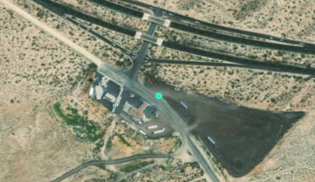

* 1. Since JACUMBA Airport is in a relatively remote location without an easily identifiable address, we will use its latitude and longitude to locate it, then manually click on a location on the map to match it to the correct location.

In the main menu, click on the **Map** tab, then select **Go To XY** 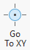.

* 1. In the toolbar, enter **-116.1655389** for Long, **32.6158806** for Lat, and leave dd (decimal degree) selected. Click on the **Pan** tool to center your screen on the location, and click on the **Flash** tool if you wish to see the precise location on your screen again. Zoom in if necessary. This is the correct location of the JACUMBA Airport.

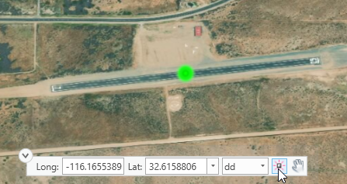

* 1. Once you have remembered the approximate correct location of the runway for JACUMBA Airport, click the **Pick from Map** tool  in the lower half of the Rematch Addresses pane, then click the location identified by the Pan and Flash tool in the previous step. This will automatically reposition the point for JACUMBA to the clicked location. Finally, click the **green checkmark** to accept the repositioned point location, click **No** when asked if you want to cache the matched map point candidate, and click the **disk icon** to save your edits.
  2. Repeat steps 2.k. to 2.n. to find **SCE SONGS MESA** under the USER_Name (or Name) column in the AirportPoints layer’s attribute table. It is a helipad. Its current location has been incorrectly placed by ArcGIS Pro. Using the **Go To XY** tool, navigate to its correct longitude of **-117.5597778** and latitude of **33.3794722**. Click the **Pick from Map** tool and reposition the point to the correct location. Click the **green checkmark** to accept the repositioned point location, and the **disk icon** to save your edits. **Close** the Rematch Addresses pane**.**

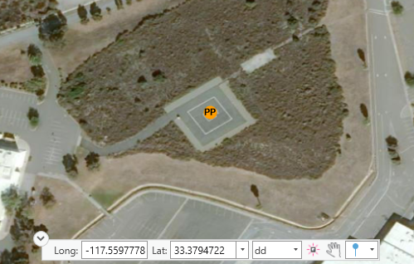

* 1. Clear any selected records by using the **Clear Selection** tool  in your attribute table before continuing.

*\*\*Tip: If you are still seeing a blue circle with the letter A on your map, you need to close the Rematch Address pane.\*\**

### **Symbolize facilities by category or type**

* 1. To symbolize our AirportPoints layer based on the type of facility being represented (e.g. airport, helipad, glider-port), select the **AirportPoints** layer in the Contents pane, and go to the **Feature Layer** tab in the main menu. Select **Symbology **.
  2. In the symbology pane, select **Unique Values** from the dropdown list under Primary symbology. Select **USER_Type** (*\*\*Tip: This may also be called Type depending on where you saved your files, be sure to choose the Type field that is between the Name and Owner fields*) for Field 1 since that is the column/field we used to distinguish between different types of facilities. **Change the Color scheme** to something that readily distinguishes between the three types of facilities. Click the Add All Values icon.

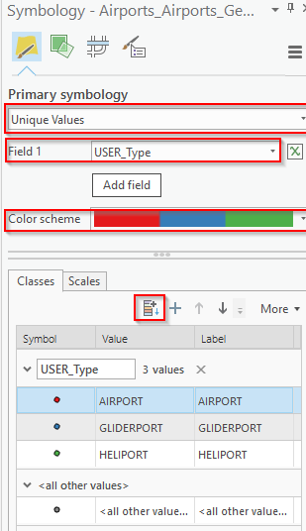

### **Analyze features with geoprocessing tools**

* 1. Since the Federal Aviation Administration generally discourages drone operators from flying near airports or other air transportation facilities (Federal Aviation Administration, 2019), we will create 5-mile buffers around all the points in the AirportPoints layer.

Go to the **Analysis** tab, click on **Tools**, and search for **Buffer** in the Geoprocessing pane. Select **Buffer (Analysis Tool)** from the results.

* 1. In the Buffer tool pane, enter the following:
     1. Input Features: **AirportPoints**
     2. Output Feature Class: **NoFly** *(**Tip: Replace the characters after the last backslash ( \ ) with NoFly. Do not delete everything and just type in NoFly**)*
     3. Distance: **5 US Survey Miles**
     4. Method: **Planar**
     5. Dissolve Type: **No Dissolve**
     6. Click **Run**
  2. **Add** the **Colleges.shp** layer (from the files you download for this exercise) to your map to see how many colleges are within the 5-mile radius of an airport (or heliport or glider-port).
  3. Look for Palomar College in your map. You can go to the **Map** tab, click on **Locate**, and enter Palomar College’s Address: **1140 West Mission Road, CA 92069**.

Q6. Is Palomar College within a 5-mile radius of an airport (or heliport or glider-port)?

* 1. Click on each **buffer circle** to see its attribute information in a pop-up window. Since the buffers were created by drawing circles with a 5-mile radius around each airport facility, each buffer circle’s pop-up window will give you the name of the facility (i.e. Name or USER_Name) that generated the specific buffer.

*\*\*Tip: If no pop-up is showing, click the word Explore in the main menu under the Map tab, and ensure that Topmost Layer is checked\*\**

Q7. Give the **names** of the two airports that generated the 2 buffer circles that cover Palomar College in San Marcos, CA. Be sure to check your spelling.

I:

II:

* 1. To find out how many colleges in San Diego County are within a 5-mile radius of an airport facility (excluding military facilities since those were not in our Airports$ table), go to the **Map** tab, **clear**  any selected features, and click **Select By Location** 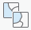.
  2. In the Select Layer By Location pane, enter the following:
     1. Input Feature Layer: **Colleges**
     2. Relationship: **Completely within**
     3. Selecting Features: **NoFly**
     4. Click **OK**
  3. Open the **Colleges** layer’s attribute table to see how many features were selected at the bottom of the table.

Q8. How many colleges are within a 5-mile radius of an airport or related facilities?

Q9. What percentage of the region’s colleges are within a 5-mile radius of an airport or related facilities?

* 1. **Clear**  all selected records in your attribute table.

### **Share your work with others**

* 1. To package and share your data with others, you must first select the name of the layer in the Contents pane. For this exercise, select the **AirportPoints** layer in the Contents pane, go to the **Share** tab and select **Layer **.
  2. In the Sharing As A Layer Package pane, enter the following:
     1. Select **Save package to file**
     2. Name: (any name you like, but carefully note where the file is being saved)
     3. Summary: (any summary you like)
     4. Tags: (any keywords you like)
     5. Click **Analyze**
     6. (If no errors or warnings are found) Click **Package**

Layer package is an excellent way to package and share individual GIS layers with others, because it basically packs up all the data, tables, and symbology for your layer into one file, so you can easily move that file between locations or email the file to others.

To open a layer package in ArcGIS Pro, go to the **Map** tab, click on **Add Data** and add in the layer package (.lpkx).

* 1. In order to save your entire map and all of its layers so you can share it with others, go to the **Share** tab and select **Map** 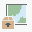.
  2. In the Share Map As A Map Package pane, enter the following:
     1. Select **Save package to file**
     2. Name: (any name you like, but carefully note where the file is being saved)
     3. Summary: (any summary you like)
     4. Tags: (any keywords you like)
     5. Click **Analyze**
     6. (If no errors or warnings are found) Click **Package**

The map package packages all the layers and their properties (symbology information) into one file, so you can easily move the entire map and its data to a different location, or share your map and data with others as a single file.

To open the map package in ArcGIS Pro, go to the **Insert** tab, click on **Import Map**, and add the map package (.mpkx).

Works Cited

“FAA Reauthorization Bill Establishes New Conditions for Recreational Use of Drones.” *News and Updates*, Federal Aviation Administration, 12 Oct. 2018, www.faa.gov/news/updates/?newsId=91844.

“Flying Near Airports.” *Airspace Restrictions*, Federal Aviation Administration, 31 May. 2019, www.faa.gov/uas/recreational_fliers/where_can_i_fly/airspace_restrictions/flying_near_airports/.

Pérez-Peña, Richard. “Gatwick Airport Drone: Lots of Second-Guessing, but Not Many Answers.” *The New York Times*, 27 Dec. 2018, www.nytimes.com/2018/12/27/world/europe/gatwick-airport-drone.html.

‌

# Chapter 4: Analyzing wildfire extent and response in California

*In this exercise, you will:*

* *Create a new project and map*
* *Add layers to a new map*
* *Examine a layer’s attributes*
* *Create a new geodatabase*
* *Import data into your geodatabase*
* *Summarize data in your layers or tables*
* *Join tabular data with vector layers*

### *Standardize temporal data*

### *Perform field calculations*

* *Perform calculations and validations with attribute rules*
* *Change the symbology of features*

## **Introduction**

*California is no stranger to wildfires. However, what is novel for the state is the intensity and length of recent fire seasons. Unlike the “typical” fire season of the past, which lasted from June to October, a year-long fire season with more frequent and more destructive wildfires is becoming the new normal due to climate change (Adams, 2008; Ortiz, 2018; Thorne et al., 2018). Specifically, a lethal mix of (1) prolonged droughts and record-breaking heat waves which left vegetation “tinder dry”, (2) an epidemic of bark beetles that caused the death of millions of trees, and (3) the usual dry and gusty Santa Ana Winds have combined to create more and more destructive and expensive wildfire seasons (Ortiz, 2018; Adolphe, 2018). As an example, the 2007 wildfire season killed 17 people, injured 140 firefighters and an unknown number of civilians, destroyed 3,069 structures, and caused property damages in excess of $2 billion (Mitchell et al., 2007; Girnius et al., 2008). To make matters worse, as California’s population continues to grow, people and developers are increasingly building in areas of high fire risk, which increases the population’s vulnerability to wildfire hazards (Adolphe, 2018; Ortiz, 2018).*

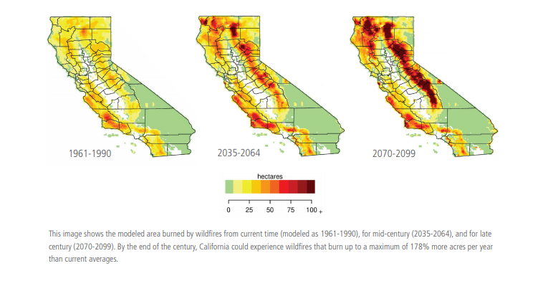

Modeled area burned by wildfires for the current time period (modeled as 1961-1990), for mid-century (2035-2064), and for late century (2070-2099). (Source: State of California’s Fourth Climate Change Assessment)

*Of the 6,043 fires that occurred in California in 2007 alone, an estimated 1,520,362 acres were affected (CalFire, 2018). CAL FIRE responded to about 60% of the fire incidents, while Federal Firefighting Agencies and Local Governmental Agencies responded to about 32% and 8% of the fires, respectively (CalFire, 2018).*

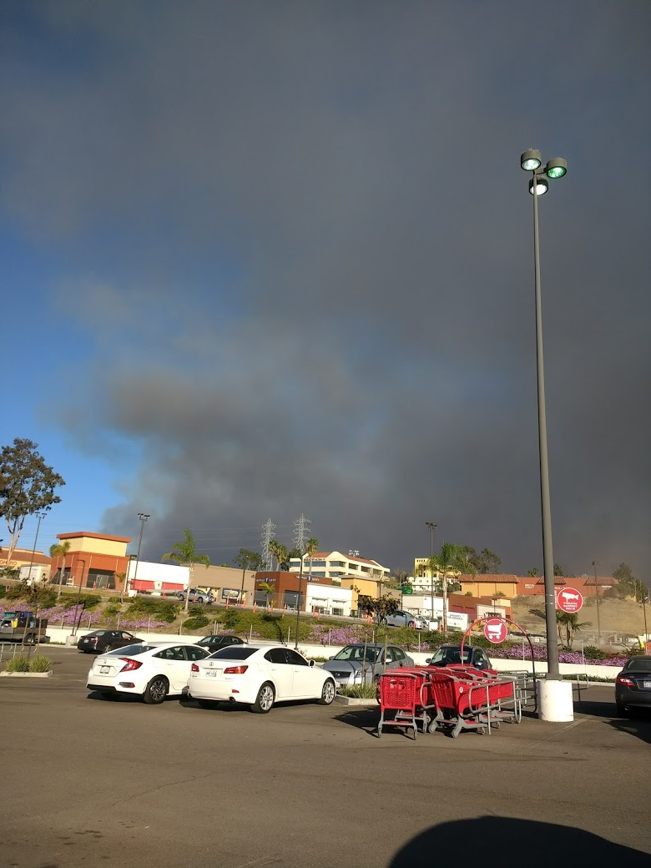 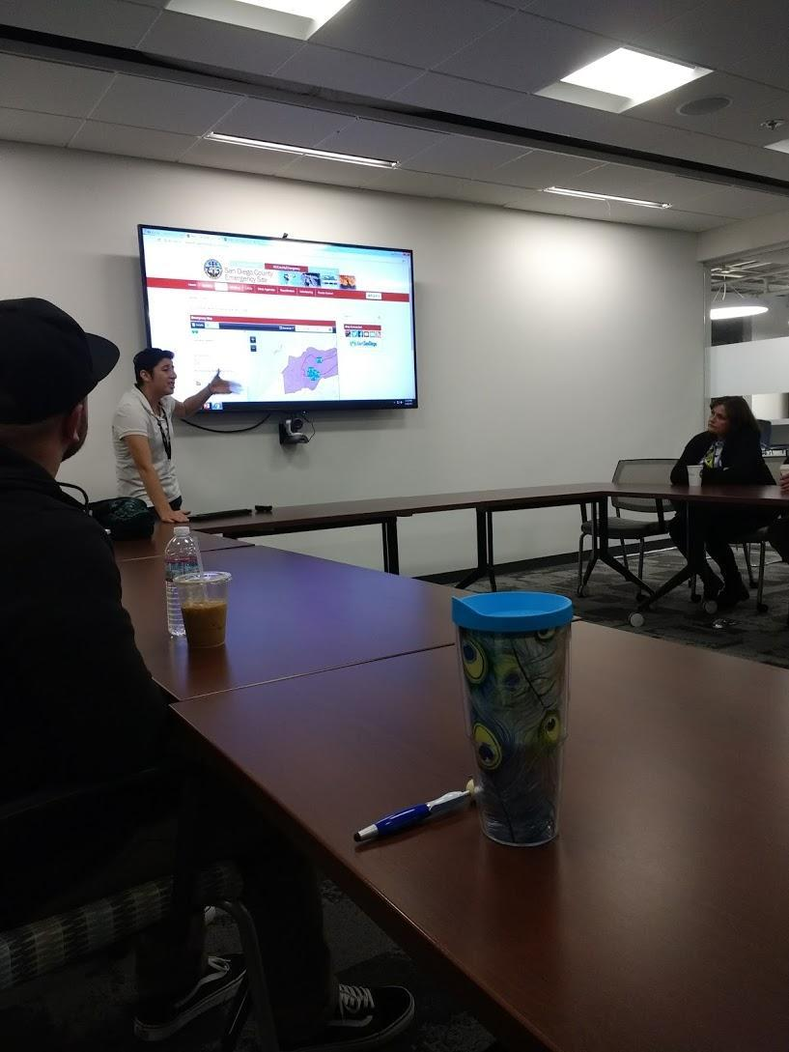

Smoke from the Lilac Fire on December 7, 2017 in Oceanside, CA (Left). Staff from 2-1-1 using ArcGIS Online maps provided by the San Diego County Office of Emergency Services to assist evacuees and residents (Right).

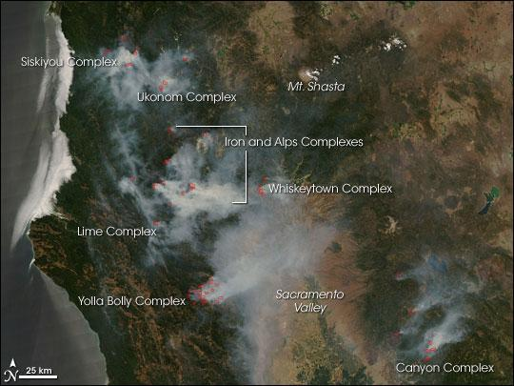

Wildfires in Northern California triggered by thunderstorms as of August 2008. The satellite image was captured with the Moderate Resolution Imaging Spectroradiometer [(MODIS)](http://modis.gsfc.nasa.gov/) on NASA’s [Terra](http://terra.nasa.gov/) satellite. (Source: NASA)

*In this exercise, you will explore a small subset of the wildfires that occurred during the 2007 wildfire season in California. You will not only see information such as the alarm date and containment date, but also the fire’s name and the agency that handled the primary response to the fire.*

### **Start a project, add and explore the data**

* 1. Start **ArcGIS Pro**.
  2. In the home screen, click **Map** to start a new project. Give it a name (e.g. Fires) and save it in a safe location.
  3. We will add a layer that shows the extent of wildfires in California in 2007. Go to **Add data** (found under the **Map** tab), and add the **CAFires2007.shp** to your map.
  4. Right-click on the **CAFires2007 layer** in the Contents pane, and select **Attribute Table** to examine the attribute table of the CAFires2007.shp file.

Q1. How many fields are present in the CAFires2007 layer?

Q2. What other fields may be useful for researchers in a layer depicting the size of wildfire extents?

### **Create a geodatabase and import data**

* 1. Go to the Catalog pane (or go to **View**>**Catalog Pane** if the Catalog pane is not already open), and expand the **Databases** icon . Note that a database with the same name (e.g. Fires.gdb) as your project has already been automatically created for you when you first created this new project.
  2. We will create our own geodatabase to store the data that we will be working with in this exercise.

Right-click on the **Databases** icon within the Catalog tab, and select **New File Geodatabase**. Navigate to the location where you want to save this new database. Name the new database **Wildfires**. You should now see Wildfires.gdb under the Database icon.

* 1. We will now import the CAFires2007 shapefile and a standalone table into the newly created Wildfires geodatabase.

Right-click on the **Wildfires.gdb** within the Catalog pane, and select **Import**>**Feature Class(es)**

* + 1. Select **CAFires2007** as the Input Features
    2. Make sure that **Wildfires.gdb** is selected as the Output Geodatabase
    3. Click **Run**

You should now see a new feature class called CAFires2007 in the Wildfires.gdb geodatabase when you **refresh** the Wildfires.gdb geodatabase in the Catalog pane (i.e. right click Wildfires.gdb and select refresh) and expand it.

* 1. Right-click on the existing **CAFires2007** layer in the Contents pane and select **Remove** to take it off the map.
  2. **Add** the new **CAFires2007** layer that was just created in step c (within the Wildfires.gdb) to the map, by dragging it from the Catalog pane to anywhere in the map.
  3. Next, we will import the standalone table called **2007FireTable** into the Wildfires.gdb. The process is the same as what you did in step c, except you will select the **Import>Table(s)** option (instead of Import>Feature Class(es)) since we are now working with tables.
  4. Once the Table to Geodatabase dialog opens, enter the following:
     1. Input Table: (browse  to the lab data folder and locate) **2007FireTable.dbf**.
     2. Output Geodatabase: **Wildfires.gdb**
     3. Click **Run**

You should now see a new T2007FireTable item in the Wildfires.gdb geodatabase in the Catalog pane (i.e. right click Wildfires.gdb and select refresh, if needed).

**Tip: ArcGIS Pro automatically added the T to the start of the filename, because a filename cannot start with a number.**

* 1. **Add** the new **T2007FireTable** that was just created in step g to the map, by dragging it from the Catalog pane to anywhere in the map.
  2. Open the **T2007FireTable** by right-clicking on it in the Contents pane, and selecting **Open** to see the information stored in the table.

Q3. How many fields are present in the T2007FireTable?

### **Summarize attribute data**

* 1. To see which agency handled the most wildfires in 2007 within California, right-click on the **AGENCY** field name within the T2007FireTable, and select **Summarize**. Enter the following:
     1. Input Table: **T2007FireTable**
     2. Output Table: **FireInfo2007_Statistics**
     3. Statistics Field(s): select **AGENCY** for Field, and **Count** for Statistic Type
     4. Case field: **AGENCY**
     5. Click **OK**

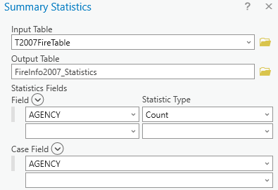

You should now see the FireInfo2007_Statistics table in the Contents pane.

Q4. Open the FireInfo2007_Statistics table, which AGENCY handled the most fires in California in 2007?

Q5. How many fires did the AGENCY from question 4 handle?

### **Join a table to a polygon feature class**

* 1. We will now join the CAFires2007 feature class with the T2007FireTable table in order to bring the tabular information from the table to the feature class. In a later section, this will allow us to symbolize the polygons in the feature class based on the information that was initially only in the T2007FireTable table.

Right-click on the **CAFires2007** layer name in the Contents pane, select **Joins and Relates**>**Add Join**.

* 1. In the Add Join dialog, enter the following:
     1. Input Table: **CAFires2007** (This is the layer we are attaching the table information to)
     2. Input Field: **OBJECTID_1** (This is the field that will map how each feature/polygon in the CAFires2007 feature class matches up with each row in the T2007FireTable table)
     3. Join Table: **T2007FireTable** (This is the item from which we are getting the tabular information)
     4. Output Join Field: **OBJECTID** (This is the field that will map how each row in the T2007FireTable table connects to each feature/polygon in the CAFires2007 feature class)
     5. Click **OK**

The following graphic demonstrates how the join process works and the importance of the Input Join Field and Output Join Field. By using fields containing common data (i.e. *OBJECTID* and *OBJECTID_1\** in the following example) to match the polygons in the feature class with the records in the table, we can *temporarily* bring the information from the table to the feature class for analysis and visualization purposes.



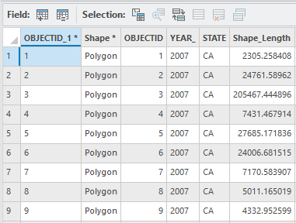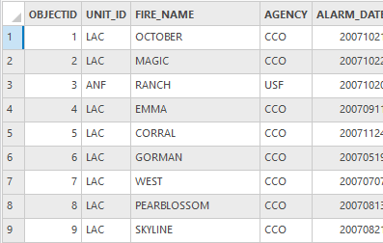



* 1. Open the **attribute table** for the **CAFires2007** layer, you should now see the fields from the CAFires2007 layer as well as the T2007FireTable table all in one place.
  2. In order to make the table data a permanent part of the feature class, go to the Map tab in the main menu and select clear (if needed), then right click the **CAFires2007** layer in the Contents pane and select **Data**>**Export Features**.

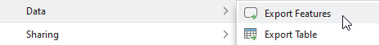

* 1. In the Export Features dialog, enter the following:
     1. Input Features: **CAFires2007**
     2. Output Feature Class: **CAFires2007Export** (Be sure to save this in your project’s Geodatabase, i.e. **Fires.gdb** that you created at the beginning of the lab NOT the Wildfires.gdb created in section 2, or the following sections won’t work)
     3. Click **OK**

### **Standardizing temporal data (dates) and performing calculations**

* 1. In the Contents pane, right click and **remove** the original **CAFires2007** (not the CAFires2007Export) layer from the map. Leaving you with only the **CAFires2007Export** layer in the map.
  2. Right click on the **CAFire2007Export** layer, and open its **Attribute Table**. You should see there is a field called ALARM_DATE that tells us when the fire was reported, and a field called CONT_DATE that tells us when the fire was contained. The problem is neither of these fields are in the standard ArcGIS date format, so we cannot perform any calculations. We will fix this in the next step.

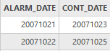

* 1. Go to **Analysis**>**Tools**, search for the **Convert Temporal Fied (Data Management Tools)** tool.
  2. In the Convert Temporal Field dialog, enter the following:
     1. Input Table: **CAFires2007Export**
     2. Input Field: **ALARM_DATE**
     3. Input Format: click the **Set Format**  icon, and select **yyyyMMdd** for Data Format.
     4. Output Field Name: **Alarm**
     5. Output Field Type: **Date**
     6. Click **Run** (ignore any warnings)
  3. To standardize our Containment dates, run the Convert Temporal Field tool again with the following:
     1. Input Table: **CAFires2007Export**
     2. Input Field: **CONT_DATE**
     3. Input Format: click the **Set Format**  icon, and select **yyyyMMdd** for Data Format.
     4. Output Field Name: **Containment**
     5. Output Field Type: **Date**
     6. Click **Run** (ignore any warnings)
  4. You should now see the two new fields (i.e. Alarm, Containment) at the far right end of the CAFires2007Export layer’s attribute table. We will create a new field to calculate the number of days it took for each fire to be contained. In the CAFires2007Export layer’s attribute table, click the **Add Field** icon .
  5. At the bottom of the new Fields table, change the currently highlighted FIeld Name from Field to **Days**, and change the Data Type to **Short**.

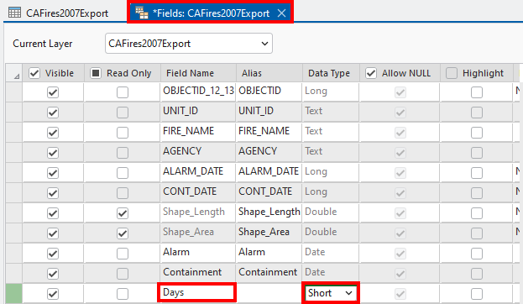

* 1. In the main menu, go to the **Fields** tab if needed, and hit **Save**. Close the new Fields table, and return to the attribute table of the CAFires2007Export layer.
  2. In the attribute table of the CAFires2007Export layer, right click on the new **Days** field name and select **Calculate Field**.

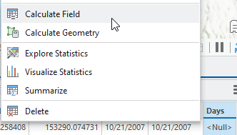

* 1. In the Calculate Field dialog, enter the following:
     1. Input table: **CAFires2007Export**
     2. Field Name: **Days**
     3. Expression Type: **Arcade**
     4. In the box below Days = , copy and paste this expression into the box (you will learn more about Arcade expressions in a later lab)

**DateDiff($feature.Containment, $feature.Alarm , 'days')**

* + 1. Click **OK**

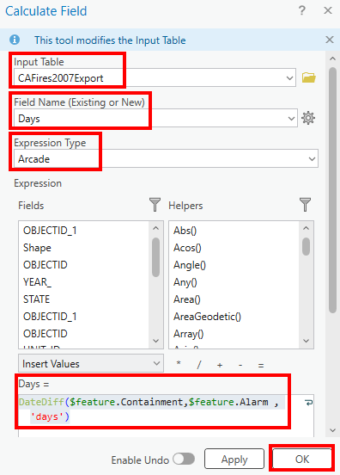

### **Automating field calculations and checking attributes with attribute rules**

* 1. In the main menu, go to **View**>**Catalog Pane**. Expand **Databases**, and look for the geodatabase that shares the name of your project. Expand the geodatabase to see the **CAFires2007Export** feature class in the catalog pane.
  2. Right click on **CAFires2007Export** in the Catalog Pane, and select **Manage**.

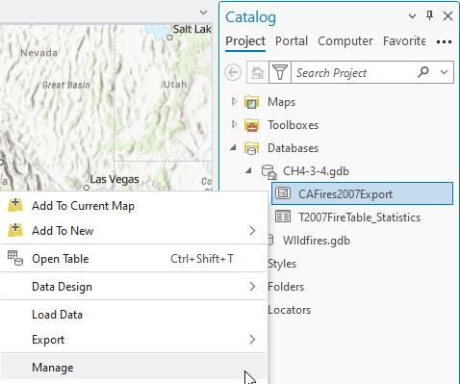

* 1. Global IDs and editor tracking need to be turned on for the calculation and validation attribute rules that we will be building later. Make sure that **Global IDs** and **Editor tracking** are checked. Click **OK**.

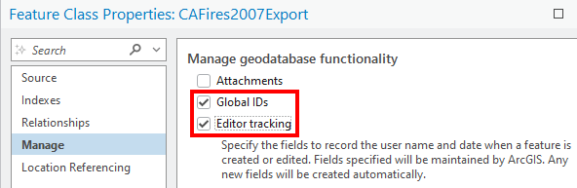

* 1. Right click on **CAFires2007Export** in the Contents pane (Not the Catalog pane), select **Data Design>Attribute Rules**.

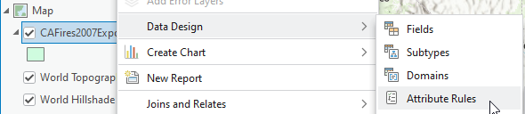

* 1. In the Attribute Rules window, make sure **Calculation** is selected, click **Add Rule**.

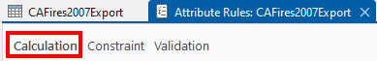

* 1. In the New Rule dialog, enter the following:
     1. Rule Name: **Calculate Response**
     2. Description: **This rule will automatically calculate the difference between alarm date and containment date for any new features.**
     3. Field: select **Days** (leave Editable checked)
     4. In the Expression box, enter the same Arcade Expression we entered earlier: (see next page)

**DateDiff($feature.Containment, $feature.Alarm , 'days')**

* + 1. Triggers: check **Insert** and **Update**
    2. In the main meun, under the **Attribute Rules** tab, hit **Save**

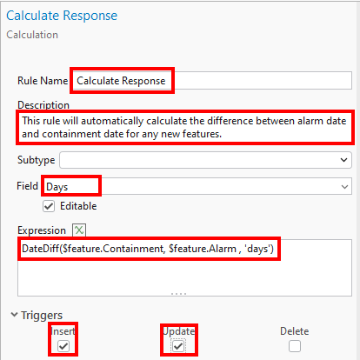

* 1. Back in the Attribute Rules window, make sure **Validation** is selected, click **Add Rule**.

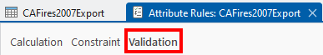

* 1. In the New Rule dialog, enter the following:
     1. Rule Name: **Error in response**
     2. Description: **This rule will check for unrealistic response times.**
     3. In the Expression box, cut and paste the following expression:

**if($feature.Days<0)**

**return false**

**return true**

* + 1. Error Number: **101**
    2. Error Message: **The days it takes to put out a fire cannot be negative.**
    3. In the main meun, under the **Attribute Rules** tab, hit **Save**

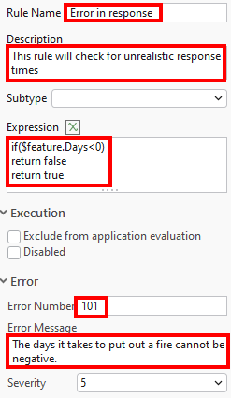

* 1. To test our calculation and validation attribute rules, we need to create a new feature. **Close** the Attribute Rules window. **Navigate** back to your map. Go to the **Edit** tab in the main menu, and select **Create**.
  2. In the Create Features pane, select **CAFires2007Export**, and select the **Polygon** tool.

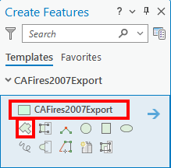

* 1. In the Create Features pane, click the right pointing **arrow**.

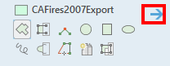

* 1. Enter any **Alarm** and **Containment** date you like. Just make sure that the Containment date should be later than the Alarm date.

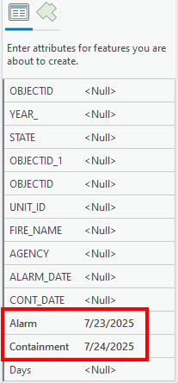

* 1. **Draw** a polygon of any size anywhere in your map.
  2. Open the **attribute table** of the CAFires2007Export layer (if needed), and scroll to the bottom of the table to see the record/row of your new feature. You should see that the value in the Days field has been automatically calculated for you thank to the calculation attribute rule.
  3. Clear any selected features by clicking the **Clear** icon under the **Edit** tab in the main menu.
  4. We will now use the validation attribute rule to evaluate all of the values in the Days field. But first, in the main menu, go to the **Edit** tab, select **Discard** and select **Yes** to discard the imaginary fire polygon that you drew in step m. Click the **Error Inspector** icon .
  5. Right click CAFires2007Export in the Contents pane, and select **Add Error Layer.** (If that option is grayed out, which is most likely the case, **save** your project  and reopen it, then perform this step.)

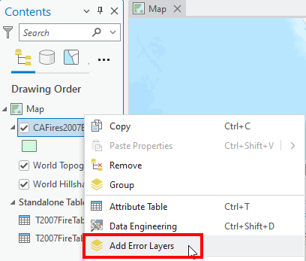

* 1. Back in the Error Inspector window, click the **down arrow** next to the Evalute Rules icon , and select only **Validation** and **Full Extent**.

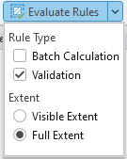

* 1. Click the **Evaluate Rules** icon. Click the **Map Extent** icon  in the Filter section of the Error Inpector window to make sure it is turned off (not shaded in blue). You should now see three fires with negative Days values were flagged in the list and colored red in your map.

*\*\*Tip: If the fires with negative Days values are not colored red in your map, try saving your project, exit ArcGIS Pro, reopen your project, and try this step again\*\**

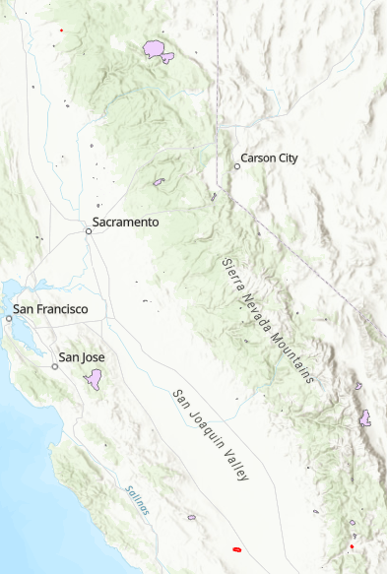

Q6. According to the Error Inspector window, what are the **Feature ObjectIDs** of the three fires which reported negative Days value (i.e. violated our validation attribute rule).

(Optional) If you like, you can find those feature object IDs in the CAFires2007Export layer’s attribute table, look at their Days values and Zoom to them in your map.

### **Adjust layer symbology and print the map**

* 1. To symbolize each wildfire polygon based on the agency responsible for it, select **CAFires2007Export** in the Contents pane, click on the **Feature Layer** tab, and select **Symbology**.
  2. In the Symbology pane, enter the following:
     1. Select **Unique Values** under Primary symbology**.**
     2. Field 1: select **AGENCY**
     3. Color scheme: pick any color ramp that provides contrast between the different agency values.

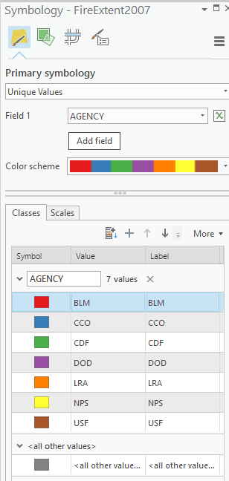

* 1. Go to the Contents pane, right-click on the **CAFires2007Export** layer, and select **Zoom To Layer**. Turn off the **Error Layers** in the Contents pane.
  2. **Create a visually pleasing and informative map** **layout** with the essential map elements. Review the skills covered in this tutorial (<https://www.esri.com/training/catalog/5ce42f0c88c6106da2d52fdc/creating-a-map-layout/>) if necessary.

Q7. Submit a copy of your map with your answers.

Works Cited

Adams, Guy. “50,000 Flee Homes as Fires Rage in California.” *The Independent*, 17 Nov. 2008, www.independent.co.uk/news/world/americas/50000-flee-homes-as-fires-rage-in-california-1021729.html.

Adolphe, Juweek. “Why Are California Wildfires so Bad? An Interactive Look.” *The Guardian*, The Guardian, 2018, www.theguardian.com/world/ng-interactive/2018/sep/20/why-are-california-wildfires-so-bad-interactive.

CalFire. *California Wildfires and Acres for All Jurisdictions*. 14 Feb. 2018, cdfdata.fire.ca.gov/pub/cdf/images/incidentstatsevents_269.pdf.

Girnius, Tomas, et al. *California Wildfire: How Large Can the Losses Be?* AIR Worldwide Corporation, 2008, web.archive.org/web/20171212031708/air-worldwide.com/_public/NewsData/001563/AIRCurrents_CaliWildfires.pdf.

Mitchell, Wayne, et al. *California Fire Siege 2007: An Overview*. California Department of Forestry and Fire Protection , the Governor’s Office of Emergency Services, U.S. Forest Service, 2007.

Ortiz, Erik. “There’s No More Typical California Wildfire Season. It May Be Year-Round, Experts Warn.” *NBC News*, NBC News, 9 Nov. 2018, www.nbcnews.com/news/us-news/there-s-no-more-typical-wildfire-season-california-it-may-n934521.

Thorne, James Franco., et al. *California’s Changing Climate 2018. California’s Fourth Climate Change Assessment*. California Natural Resources Agency, 2018.

‌

# Chapter 5: Assessing social vulnerability in areas impacted by Hurricane Florence

*In this exercise, you will:*

* *Download data from the US Census Bureau (*[*data.census.gov*](https://data.census.gov/cedsci/)*)*
* *Pre-process census data using Microsoft Excel*
* *Add and calculate new fields*
* *Join tabular data with vector layers*
* *Select features by their attributes*
* *Export new layers*
* *Perform statistical analysis using the Ordinary Least Squares tool*
* *Interpret statistical output*

## **Introduction**

*On September 14, 2018, Hurricane Florence made landfall as a Category 1 hurricane just south of Wrightsville Beach in North Carolina (Almansy et al., 2018). By definition, as a Category 1 hurricane on the Saffir-Simpson Hurricane Wind Scale, Florence had sustained wind speed in the range of 74 to 95 miles per hour (National Hurricane Center). While still dangerous, the wind speed of Florence is dwarfed by the wind speed of Hurricane Michael, which made landfall on October 9, 2018 near Mexico Beach, Florida, as a Category 4 hurricane with a peak wind speed of 155 miles per hour (NOAA, 2019). However, unlike Hurricane Michael, Florence moved at a much slower speed of 2-3 miles per hour, which was the main cause of widespread flooding, wind damage, and the loss of property and human lives. In fact, research has shown that the speed at which hurricanes and tropical cyclones lingered over land (i.e. translation speed) has slowed globally by 10 percent between 1949 and 2016, and this is partly attributed to changes in the atmospheric circulation caused by greenhouse gas emissions and climate change (Kossin, 2018).*

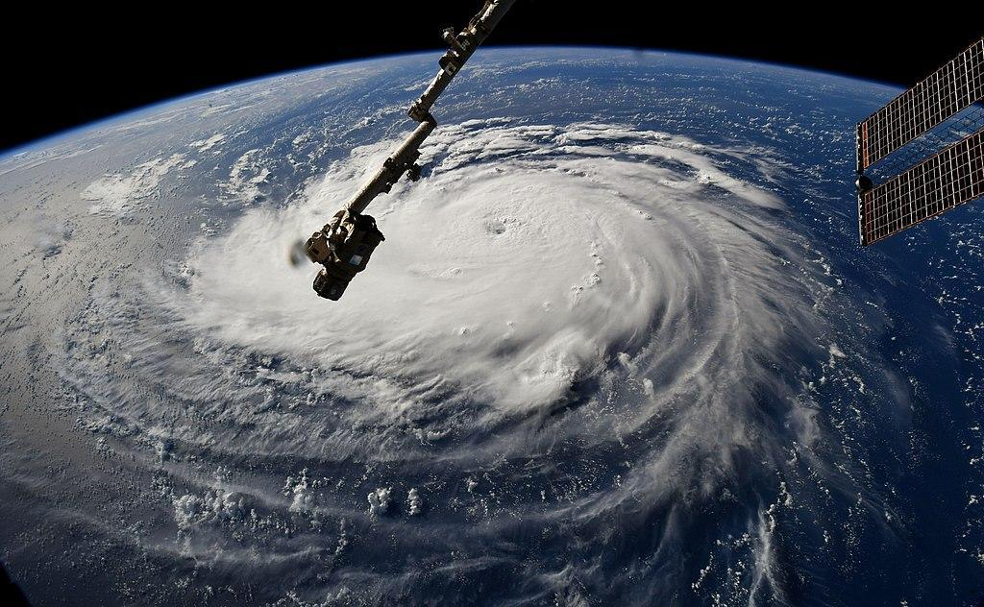

Astronaut Ricky Arnold, from aboard the International Space Station, shared this image of Hurricane Florence on Sept. 10, taken as the orbiting laboratory flew over the massive storm. (Source: NASA)

*In this exercise, you will look at the statistical relationship between poverty and unemployment in one of the states (i.e. South Carolina) that was hard hit by Hurricane Florence, and many of its counties were approved for federal assistance under Presidential Disaster Declarations DR-4393, DR-4394, and DR-4401. It is important to examine factors such as poverty in disaster-stricken areas, because empirical and anecdotal data from past natural disasters such as Hurricane Harvey and Hurricane Katrina have shown that residents in lower-income neighborhoods have an especially difficult time getting timely or sufficient assistance that is needed to rebuild their homes (Fernandez, 2018; Allen, 2015; Milligan, 2018).*

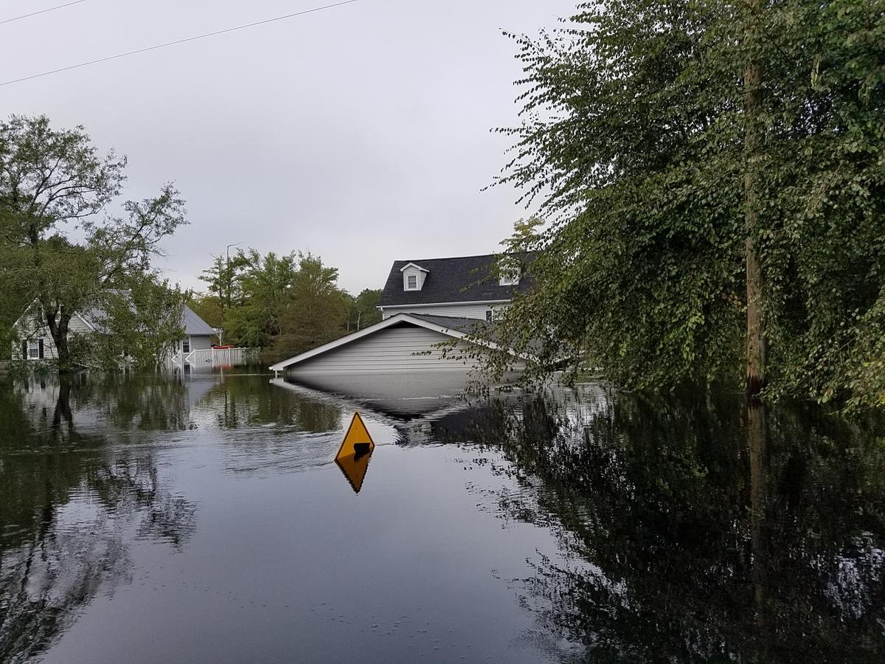  
Photo of widespread flooding caused by Hurricane Florence near Lees Landing Cir., Horry County, South Carolina. (Source: National Weather Service)

### **Download tabular data from the U.S. Census Bureau**

* 1. In your internet browser (preferably Chrome), go to [**https://data.census.gov**](https://data.census.gov/)**.**
  2. In the search bar, type in **Economic characteristics**, and hit **Search**.

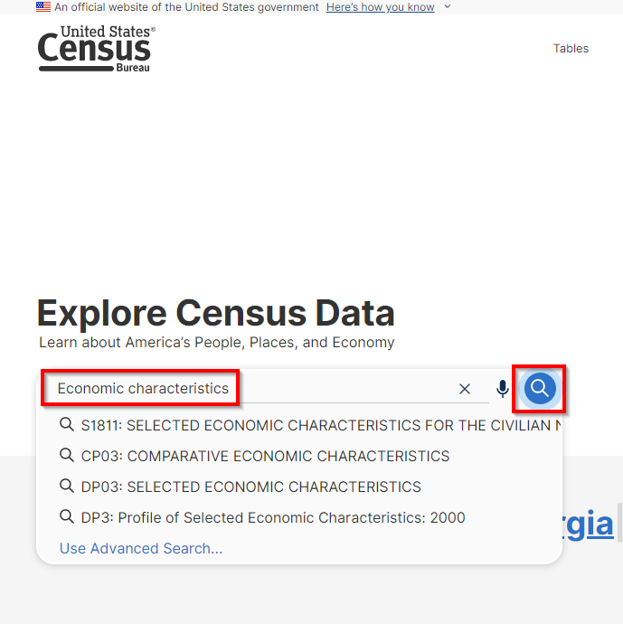

* 1. In the list of results, be sure to select the one that will give you the table that was created by the **American Community Survey** program, with a Table name of **DP03.** 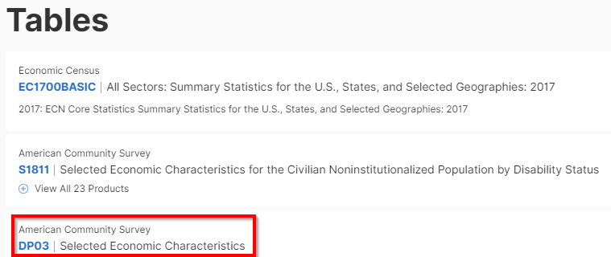
  2. Click on the **DP03** (not DP3) result.

*\*\*Tip: Make sure that you are selecting the right table. Picking the wrong table will give you different results in this exercise, and you will need to redo the exercise again.\*\**

* 1. Specify the exact time period you want by clicking on the Product dropdown arrow and selecting **2018: ACS 5-Year Estimates Data Profile**s.

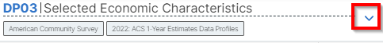

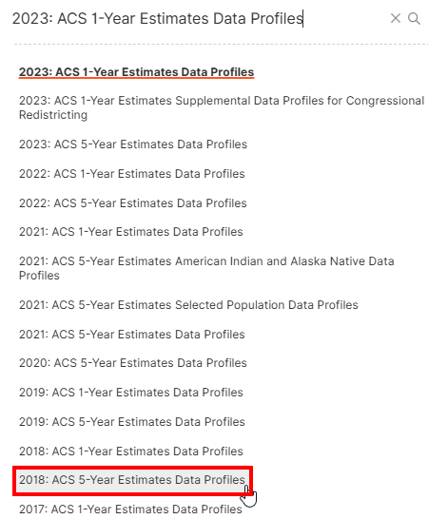

* 1. Narrow the geographic scope of the data you are downloading by clicking the **Geos** icon.



* 1. Under All Geographies, select **Census Tract**>**All Census Tracts within United States**. Click the X in the upper right to close the Select Geography window.

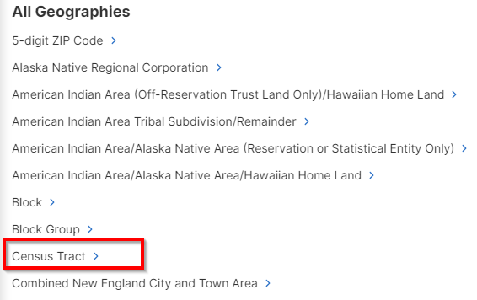

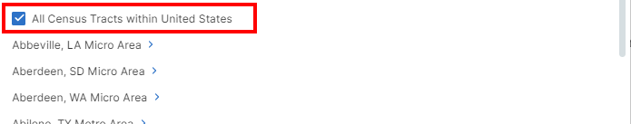

* 1. Once the product and the geography have been properly selected, click **DOWNLOAD TABLE**.

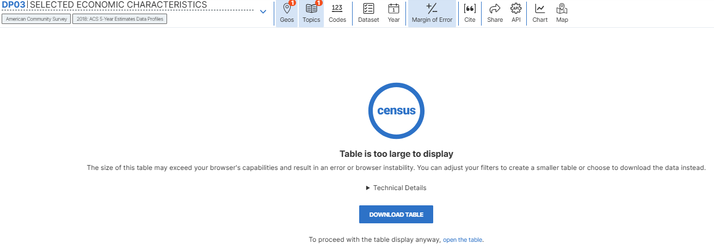

* 1. In the Download Tables window, make sure that the table being downloaded is called **DP03**, and that the **5-year** **estimate** published in **2018** is selected. Click **Download .ZIP**.

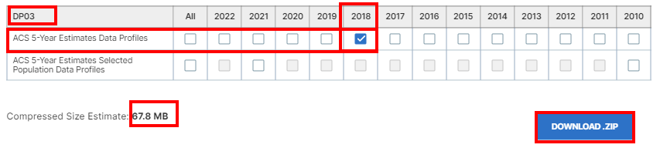

* 1. The zip file is about 65MB in size. The download will take a few minutes. When the progress bar of the Downloads window reaches 100%, the file should be automatically downloaded to your system. Find the file that you just downloaded and **unzip** it.

*\*\*Tip: If nothing seems to be happening, make sure that your browser’s pop-up blocker is not blocking the Census website’s download, and also try refreshing the webpage\*\**

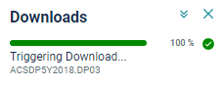

### **Prepare data in Microsoft Excel**

* 1. In the **unzipped folder**, locate the **ACSDP5Y2018.DP03-Data.csv** file, and open it with Microsoft **Excel**.
  2. We only need to retain and format three columns for this exercise. There is no action you need to take for this step (step b), the next step(step c) will show you how to retain and format the three columns listed below.
     1. The column with the label of **GEO_ID** (the description is Id2)
     2. The column with the label of **DP03_0005PE** (the description is *Percent Estimate!!EMPLOYMENT STATUS!!Population 16 years and over!!In labor force!!Civilian labor force!!Unemployed*)
     3. The column with the label of **DP03_0119PE** (the description is *Percent Estimate!!PERCENTAGE OF FAMILIES AND PEOPLE WHOSE INCOME IN THE PAST 12 MONTHS IS BELOW THE POVERTY LEVEL!!All families*)
  3. We will create a new Excel spreadsheet by copying and pasting the three columns (GEO_ID, DP03_0005PE, DP03_0119PE) that we want from the original spreadsheet into the new one.
     + 1. To start a new spreadsheet, in Excel, go to **File**>**New**>select **Blank workbook**.
       2. Go back to the original spreadsheet (i.e. ACSDP5Y2018.DP03-Data.csv), and find the desired column by pressing the **Ctrl** and **F** keys at the same time on your keyboard, then enter the desired **column’s name** (e.g. **GEO_ID**).
       3. Click on the **column header** (i.e. A, B, C, D…) to select the entire column.

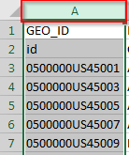

* + - 1. With the column selected, press the **Ctrl** and **C** keys at the same time to Copy the column to your virtual clipboard.
      2. Go to your new spreadsheet, click on the column header of an empty column, and press the **Ctrl** and **V** keys at the same time on your keyboard to paste the information that was stored in the virtual clipboard.
      3. Go back to your original spreadsheet and **click anywhere outside** the currently selected column. **Repeat steps 2 thru step 5** in this section to find, copy, and paste the information from the **DP03_0005PE** and **DP03_0119PE** columns into the new spreadsheet.

Your table should now look like the following:

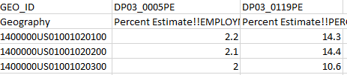

* 1. We need to clean up the names for each of our columns before opening the table in ArcGIS. Delete the second row (the row with the descriptions such as Geography, Percent Estimate!!EMPLOYMENT…; Percent Estimate!!PERCENTAGE…) by right-clicking on the **row number** and selecting **Delete**.

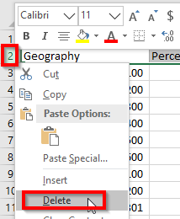

* 1. We also need to clean up the values in the GEO_ID column in order to join it with our polygon layer later in this exercise. Click on the **column header** above the GEO_ID column’s name (i.e. A) to select it.
  2. Once the GEO_ID column is selected, press the **Ctrl** and **F** keys to access the find and replace window.
  3. In the Find and Replace window, click on the **Replace** tab.
  4. Under the replace tab, enter **1400000US** in the Find what area, and leave the Replace with area blank. Click **Replace All**. This step allows us to erase the unnecessary 1400000US prefix from all of our GEO_ID values.

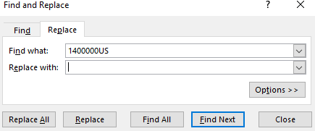

Your GEO_ID column should look like the following after this step.

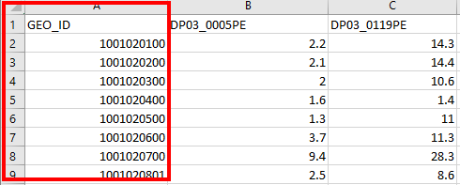

* 1. **Remember that names for columns in ArcGIS cannot have special characters or symbols such as: . > * or even spaces**, we will rename the column names as follows to make them more GIS-friendly:
     1. Replace the label of **GEO_ID** with **GeoID**
     2. Replace the label of **DP03_0005PE** with **NotEmployed**
     3. Replace the label of **DP03_0119PE** with **UnderPoverty**

Your table should now look like the following:

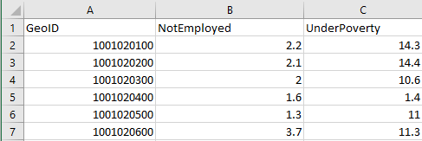

* 1. In Excel, make sure you are looking at your new spreadsheet with the three columns, go to **File**>**Save As** to save the file as a **CSV (Comma delimited)** file and call it **Datatbl**, click **Save,** click **Yes** when warned by Excel about the CSV file format, and **close Excel**.

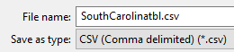

### **Download geographic layers from the U.S. Census Bureau**

* 1. In your internet browser (preferably Chrome), go to [**https://www.census.gov/cgi-bin/geo/shapefiles/index.php**](https://www.census.gov/cgi-bin/geo/shapefiles/index.php)
  2. Since the tabular data (i.e. data table) you downloaded in the previous section was published in 2018, you need to download geographic layers from the same time period. Select **2018** for the year, and select **Census Tracts** for the layer type. Hit **Submit**.

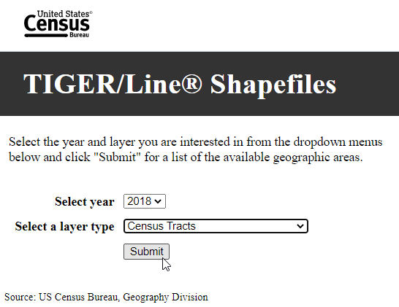

* 1. On the next screen, select **South Carolina** and click **Download** in order to download the census tract polygons for the state. Once downloaded, place it in your lab folder and **unzip** the file (tl_2018_45_tract.zip).

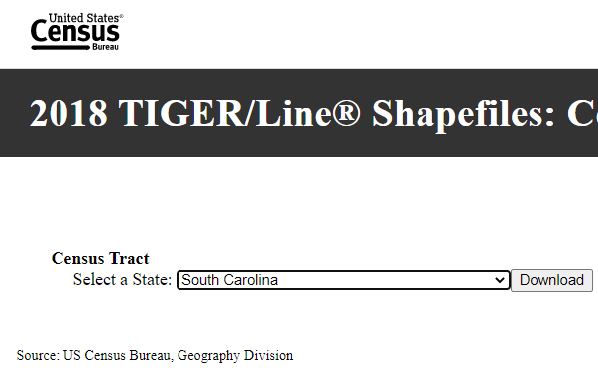

### **Add and calculate a new field**

* 1. Open **ArcGIS Pro**, and start a new **project** and a new **map**.
  2. Add in the census tract layer (**tl_2018_45_tract.shp**) you downloaded and unzipped in section 3, and rename it **SCTracts** in the Contents pane. *\*\*Tip: Single click on the layer name in the Contents pane and wait until it is highlighted, then type in the new name\*\**

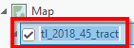

Q1. Open the attribute table of the SCTracts layer, how many fields are there at this point in the exercise?

* 1. Within the SCTracts layer’s attribute table, click **Add**  in the upper left to create a new field.
  2. In the Fields tab within the attribute table, in the new row found at the bottom of the window, replace the word Field with **SCID** under the **Field Name** column, and replace the word Long with **Double** under the **Data Type** column. **Close** the Fields tab, and select **Save** when prompted to save your unsaved changes.

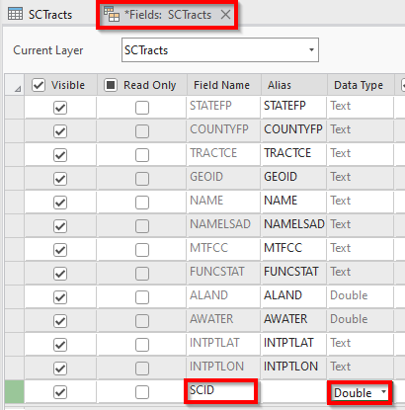

* 1. Within the SCTracts layer’s attribute table (reopen it if needed), scroll to the far right to find the newly created **SCID** column.
  2. Right-click the **SCID column’s name** within the attribute table, and select **Calculate Field.**

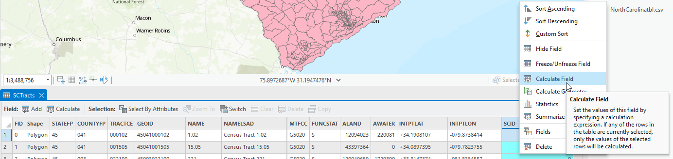

* 1. Within the Calculate Field window, enter the following:
     1. Input Table: **SCTracts**
     2. Field Name (Existing or New): **SCID**
     3. Fields: **Double click on GEOID** (to see !GEOID! populated under the SCID = field)
     4. Click **OK**

*\*\*Tip: What you have done in steps c thru g of this section is basically copying the data from the GEOID field to the SCID field. Although the data in both columns are exactly the same, the format in which the data is stored is different in each field. Specifically, the GEOID field stores the data as Text, whereas the SCID field stores the same data as Double (a numeric data type). We need the data in a numeric format in order to perform the join operation in the next section.\*\**

* 1. Repeat steps c thru g in this section to [1] create a new field with the **Field Name** of **TID** and the **Data Type** of **Short**. [2] Thenuse the **Calculate Field** tool to populate the **TID** field by copying the data from the **FID** field.

Your finished attribute table should look similar to the following:

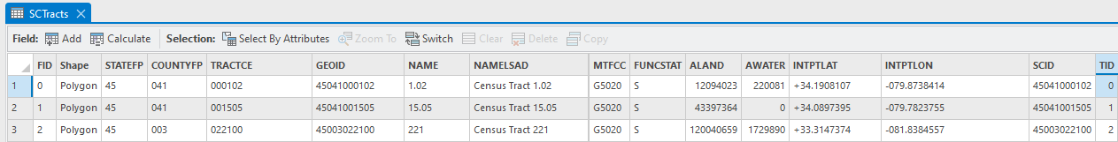

### **Join tabular data with geographic layers**

* 1. In ArcGIS Pro, add in the **Datatbl** CSV table that you prepared in Excel in section 2.
  2. Join the CSV table with the SCTracts layer by right-clicking on **SCTracts** in the Contents pane, selecting **Joins and Relates**, and clicking **Add Join**.
  3. In the Add Join window, enter the following:
     1. Input Table: **SCTracts**
     2. Input Join Field: **SCID**
     3. Join Table: **Datatbl.csv**
     4. Output Join Field: **GeoID**
     5. Click **OK**

Q2. Open the attribute table of the SCTracts layer again, how many fields/columns are there now after the join process?

*\*\*Tip: You should have now noticed that the last three columns in the SCTracts layer’s updated attribute table after the join process were brought over from the Datatbl table as a part of the join process.\*\**

### **Export a new layer to make the joined data permanent and analysis-ready**

* 1. In case you have any features selected in your map, go to the **Map** tab in the main menu, and click **Clear**  to deselect them.
  2. To ensure that we are only running our analysis on census tracts with valid data in the next section, go to the **Map** tab in the main menu, click **Select By Attributes** 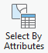 , and enter the conditions as shown in the screenshot below. Click **OK** when you are done.

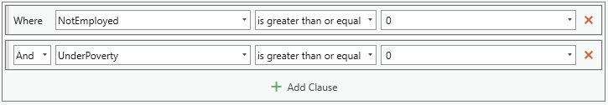

* 1. With only those features that are reporting unemployment and poverty data selected, right click on the **SCTracts** layer in the Contents pane, and go to **Data>Export Features**.

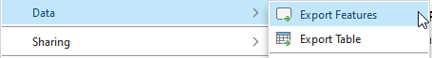

* 1. In the Export Features window, enter the following:
     1. Input Features: **SCTracts** *(It should warn you that: The input has a selection. Records to be processed is 1,083. If not, ask the instructor for help.)*
     2. Output Feature Class: **SCTractsExport**
     3. Click **OK** (ignore any warnings)

*\*\*Tip: This step is crucial because any tables that you joined to a layer is only temporary*

*unless you create a copy of the layer with the Export Features function.\*\**

* 1. **Compare** the SCTractsExport layer with the original SCTracts layer, you should see that the tract polygons off the coast and several other polygons with no data have been omitted from the SCTractsExport layer. **Remove** the original SCTracts layer from the map.

### **Analyze the statistical relationship between poverty and unemployment**

* 1. Open the attribute table of the SCTractsExport layer, repeat steps c thru g in section four [1] create a new field with the **Field Name** of **SCNotEmp** and the **Data Type** of **Double**. [2] Thenuse the **Calculate Field** tool to populate the **SCNotEmp** field by copying the data from the **NotEmployed** field.
  2. Again, repeat steps c thru g in section four [1] create a new field with the **Field Name** of **SCUnderPov** and the **Data Type** of **Double**. [2] Thenuse the **Calculate Field** tool to populate the **SCUnderPov** field by copying the data from the **UnderPoverty** field.
  3. We are now ready to explore the relationship between the percentage of a census tract’s population that is living below the poverty line (i.e. UnderPoverty) and the percentage of a census tract’s population that is not employed (i.e. NotEmployed). Go to the **Analysis** tab in the main menu, click **Tools**, and search for **OLS**. In the results, click on the **Ordinary Least Squares (OLS)** tool.

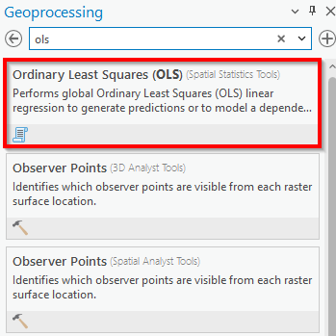

Q3. Write a hypothesis of how you think the percentage of the tract’s population that is living below the poverty line (i.e. UnderPoverty) and the percentage of the tract’s population that is not employed (i.e. NotEmployed) may be related. Are the two things positively correlated? (i.e. high number of not employed people is related to a high number of people living below the poverty line) Or are the two things negatively correlated? (i.e. high number of not employed people is related to a low number of people living below the poverty line)

* 1. In the Ordinary Least Squares (OLS) window, enter the following:
     1. Input Feature Class: **SCTractsExport**
     2. Unique ID Field: **TID**
     3. Output Feature Class: **OLS**
     4. Dependent Variable: **SCUnderPov**
     5. Explanatory Variable: **SCNotEmp**
     6. Click **Run**

*\*\*Tip: Since people are likely to fall below the poverty line due to not being able to find employment, rather than not being able to find employment due to falling below the poverty line, BelowPov was selected as the dependent variable and NotEmploy was selected as the explanatory variable (also known as the casual variable or the independent variable). In other words, we are hypothesizing that the poverty rate is dependent on the unemployment rate.\*\**

* 1. When the Ordinary Least Squares (OLS) operation is complete, click **View Details** at the bottom of the pane.

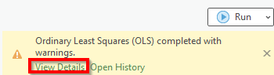

* 1. Look at the results in the details window (maximize the window if needed), the two numbers that we are particularly interested in are covered by box 1 and box 2 below:

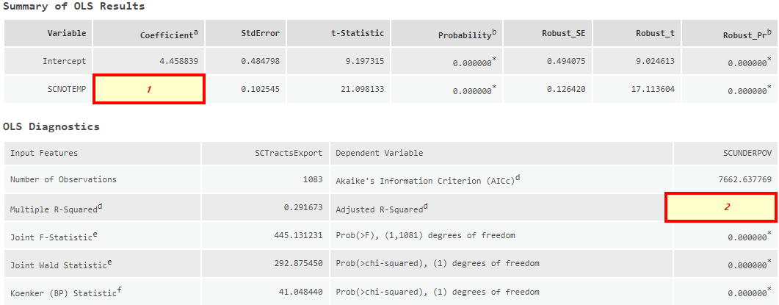

To understand the meaning of the two numbers, insert the value from box 1 and box 2 in the following sentences.

Q4. For every 1 percentage point increase in a census tract’s population that is not employed, the amount of people living below the poverty line in the census tract is expected to increase by (insert box 1 value here: ) percentage point. (Round to two decimal places)

Q5. (Round box 2 value to two decimal places **first**, and **then** multiply by 100) percent of the variation in various census tracts’ poverty levels can be explained by the unemployment levels in those tracts.

Q6. Create one map containing **two data frames.** One of the data frames should show the variation in not employed population in various census tracts, and the other one should show the variation in population living below the poverty line in various census tracts. Please include relevant map elements.

Works Cited

Allen, Greg. “Ghosts Of Katrina Still Haunt New Orleans' Shattered Lower Ninth Ward.” *NPR*, NPR, 3 Aug. 2015, www.npr.org/2015/08/03/427844717/ghosts-of-katrina-still-haunt-new-orleans-shattered-lower-ninth-ward.

Fernandez, Manny. “A Year After Hurricane Harvey, Houston's Poorest Neighborhoods Are Slowest to Recover.” *The New York Times*, The New York Times, 3 Sept. 2018, www.nytimes.com/2018/09/03/us/hurricane-harvey-houston.html.

Karimi, Faith, et al. “Days of Flooding Ahead in the Carolinas as Florence Leaves at Least 13 Dead.” *CNN*, Cable News Network, 16 Sept. 2018, www.cnn.com/2018/09/15/us/storm-florence-carolinas/index.html.

Kossin, James P. “A Global Slowdown of Tropical-Cyclone Translation Speed.” *Nature News*, Nature Publishing Group, 6 June 2018, www.nature.com/articles/s41586-018-0158-3.

Milligan, Susan. “The Forecast for Recovery.” *U.S. News & World Report*, U.S. News & World Report, 21 Sept. 2018, www.usnews.com/news/the-report/articles/2018-09-21/hurricanes-hit-everyone-but-the-poor-have-the-hardest-time-recovering.

“Saffir-Simpson Hurricane Wind Scale.” *Hurricane Preparedness - Hazards*, National Hurricane Center, www.nhc.noaa.gov/aboutsshws.php.

US Department of Commerce, and Noaa. “Hurricane Michael 2018.” *National Weather Service*, NOAA, 10 Jan. 2019, www.weather.gov/tae/HurricaneMichael2018.

# Chapter 6: Analyzing volcanic hazards near Kilauea Volcano, Hawai’i

*In this exercise, you will:*

* *Georeference images*
* *Create and edit polygons features*
* *Create and test task items*
* *Perform spatial analysis using the erase tool*
* *Perform attribute calculations using the summary statistics tool*

## **Introduction**

*May 3, 2018 marked the start of the lower Puna eruption on the East Rift Zone of the Kilauea Volcano on the island of Hawaii (Chiu and Bever, 2018). The eruption was accompanied by many earthquakes, active fissures and lava flow, dangerously high levels of sulfur dioxide (i.e. Vog), and the deposition of volcanic bombs (i.e. large ballistic blocks) and ashes in the region (BBC, 2018).*

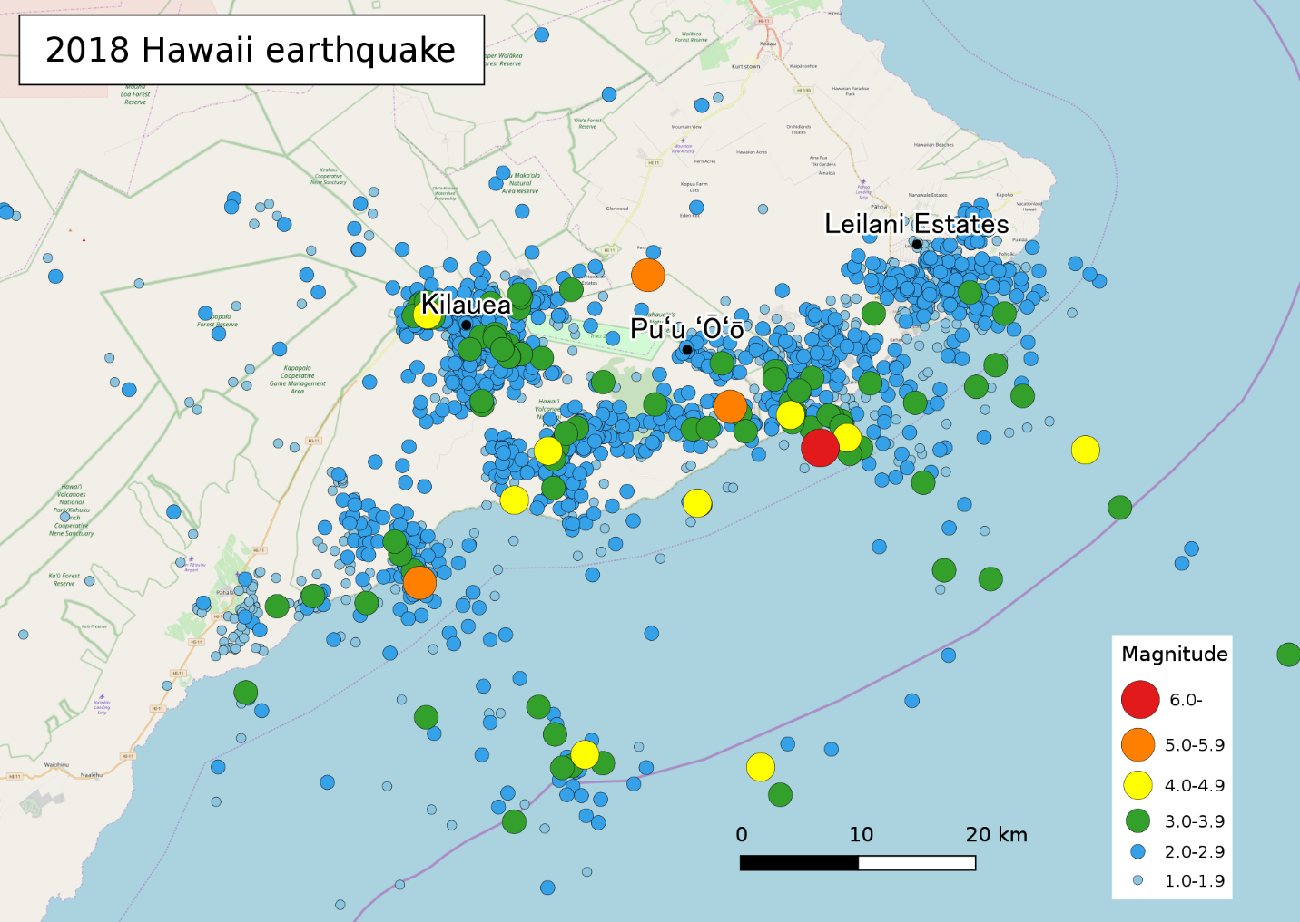

Map of 2018 earthquakes in selected parts of Hawai’i (Source: [Phoenix7777 Own work](https://commons.wikimedia.org/wiki/File:Map_of_2018_Hawaii_earthquake.svg), [CC BY-SA 4.0](https://creativecommons.org/licenses/by-sa/4.0), via Wikimedia Commons)

*The Kilauea volcano is an example of a shield volcano, which is built up slowly over time with the accretion of fluid lava flow (Watson, 2011). It is not only regarded as one of the world’s most active volcanoes, but it is also considered a relatively young volcano given that 90% of its surface is formed by lava flows of less than 1,100 years old (Oregon State University, 2019).*

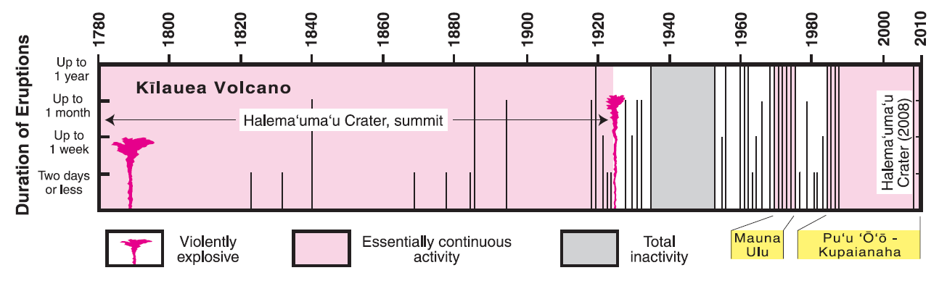

Timeline of the eruption of Kilauea during the last 200 years (Source: [Robert I. Tilling, Christina Heliker, and Donald A. Swanson](https://commons.wikimedia.org/wiki/File:Kilauea_eruptions_in_record_history.png), Public domain, via Wikimedia Commons)

*In this exercise, you will georeference and examine two map images of the Kilauea Volcano area that were created roughly two weeks and fourteen weeks after the initial major eruption on May 3, 2018. In particular, you will identify areas that were impacted by Kilauea’s lava flow to appreciate the scale of this eruption, which destroyed 716 homes before abruptly settling down in August 2018 (Loomis, 2018a; Loomis, 2018b).*

### **Georeference map images**

* 1. Open **ArcGIS Pro**, and start a new **project** and a new **map**.
  2. Add in the **5_15_18.jpg** image. Click **Yes** if asked about calculating statistics for the image. Right-click on the layer name in the Contents pane and select **Zoom to Layer** to see its approximate extent.

Q1. Zoom out and describe the approximate location of the 5_15_18 image in the world at the end of step 1b.

* 1. Go to the **Map** tab, click **Locate** 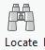, and search for **Kapoho, Pahoa, HI**.
  2. Zoom out to approximately **1:100,000** map scale.
  3. With the **5_15_18** image selected in the contents pane, go to the **Imagery** tab, select **Georeference**, and click **Fit to Display** 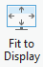 (make sure that your ArcGIS Pro window is maximized if you do not see the Fit to Display icon).
  4. Find at least four point locations (e.g. obvious natural features, major intersections) that you can readily identify in the 5_15_18 image **as well as** the topographic basemap. These points are called control points. They will enable us to carry out the process of **georeferencing** by aligning the image to the topographic basemap, which results in the image adopting the spatial reference information (i.e. coordinate system, projection) of the topographic basemap.
  5. To specify each control point, make sure that the **5_15_18** image is still selected in the Contents plane. Click **Add Control Points** 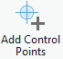 (within the Georeference tab). **FIRST**, in the **5_15_18 image,** click on one of the readily identifiable points you noted in the previous step. **THEN,** temporarily **turn off (uncheck)** the 5_15_18image layer in the Contents pane so you can see the basemap,and click on the point’s corresponding location in the **topographic basemap**.

**Turn back on** the 5_15_18 image layer in the Contents pane, and **repeat** this process for at least 3 other control point pairs.

*\*\*Tip: When georeferencing an image to a basemap, always put the control point on the image first, then the basemap.\*\**

*\*\*Tip: To temporarily pan the map to a different area while you are placing your control points, press the C key on your keyboard while using the mouse to pan.\*\**

I have suggested 5 control points for you below (you can also feel free to use your own). Please refer to the image below for their locations.

* The north end of the cinder cone
* The south end of the cinder cone
* The intersection of Highway 132 and Pohoiki Rd
* The intersection of Highway 130 and Highway 132
* The intersection of Highway 137 and Kamaili Rd

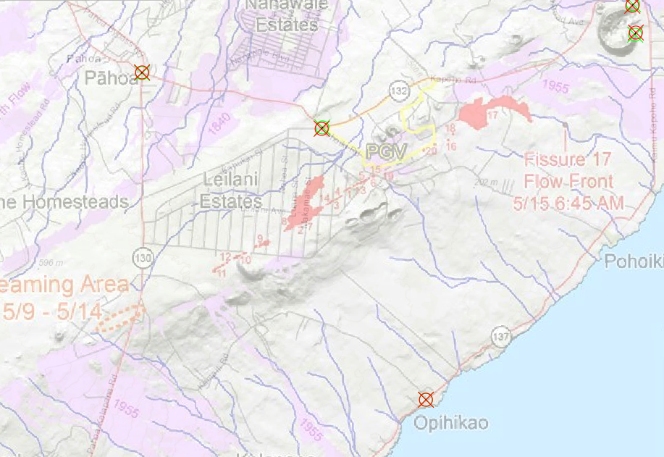

* 1. After you have placed **at least 4 control points**, you should see the 5_15_18 image aligns reasonably well with the topographic basemap. Click **Save** within the Georeference tab. Click **Close Georeference** 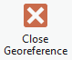.

Q2. Zoom out and describe the approximate location of the 5_15_18 image in the world at the end of step 1h.

* 1. **Turn off** the 5_15_18 image layer in the Contents pane to reduce clutter**. Modify and repeat** steps 1b through 1h to add in the **8_14_18.jpg** image and georeference it.
  2. Compare the 5_15_18 and the 8_14_18 images with the basemap to ensure the images are in reasonably correct locations before continuing on to the next section.

### **Create a new feature class and perform basic edits**

1. If the Catalog pane is not already opened, go to **View**>**Catalog Pane**.
2. Find the file geodatabase that was already created for you when you created this project, by expanding **Folders**>**(your project name)**>**(your project name).gdb**
3. Right-click on **(your project name).gdb** in the Catalog pane, and select **New**>**Feature Class**. The Create Feature Class pane should appear. Enter the following:
   1. Name: **May15Lava**
   2. Feature Class Type: **Polygon**
   3. Click **Finish**

This empty polygon feature class will be used to store the polygons that you trace in the next steps to document the lava extent around Kilauea on 5/15/18.

1. Turn on only the **May15Lava** layer and the **5_15_18** layer in the Contents pane.
2. Select the **May15Lava** layer in the Contents pane, click the **Edit** tab, and select **Create**.
3. In the Create Features pane, select **May15Lava**.
4. Ensure that the **Polygon** tool is selected . **Trace** all of the bold red polygons (see image below) that represent active lava flow in the 5_15_18 image. (Only trace the polygons, ignore the points and the numbers. No need to be extremely precise.)

*\*\*Tip: If you cannot see what you just finished tracing, double-check to make sure that the May15Lava feature class is turned on in the Contents pane.\*\**

*\*\*Tip: If you need to move to another part of the map after you have started tracing, hold down on the C key on your keyboard while using the mouse to pan.\*\**

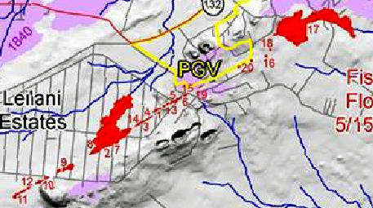

1. When you have finished tracing the bold red polygons from the 5_15_18 image, be sure to go to the **Edit** tab, and hit **Save** to save your edits.
2. **Modify and repeat** steps 2a-2c from this section to create a new polygon feature class in (your project name).gdb called **Aug14Lava**. Turn on only the **Aug14Lava** layer and the **8_14_18** layer in the Contents pane. **Read the ctips below first**, then **modify and repeat** steps 2d through 2h to trace the lava flows in the **8_14_18** image. **Save** your edits. 

*Tip: Since the lava c polygons in the 8_14_18 images have “holes” (areas with no lava coverage) within them (see image below), you will need to:*

1. *Digitize the* ***outer boundary*** *of the polygon as one feature.*

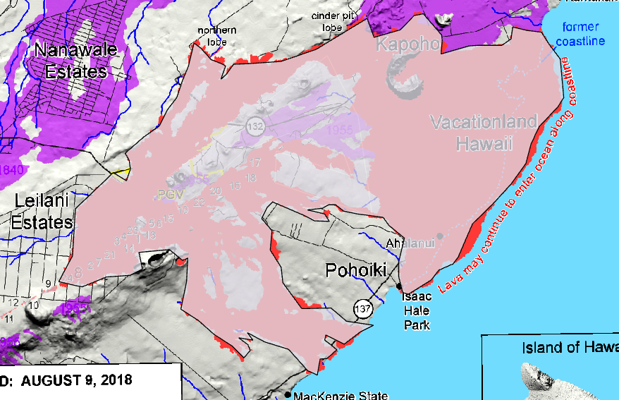

1. *You will need to adjust the Aug14Lava to see the “hole” currently covered by the layer. With Aug14Lava selected in the Contents pane, go to the* ***Feature Layer*** *tab, and adjust* ***Transparency*** *. Trace one or more new polygons to cover the* ***“hole”****.*

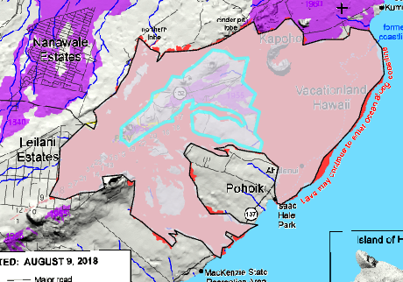

1. *Select the “hole” polygon(s) that you just digitized by opening the Aug14Lava layer’s* ***attribute table*** *and* ***selecting*** *the record(s)/row(s) associated with the “hole” polygon (use the Ctrl key on your keyboard to select multiple rows at the same time), then go to the* ***Edit*** *tab, and* ***expand*** *all of the edit Tools options (see image 1 on the next page). Select* ***Clip*** *(2). In the Clip window, make sure that* ***Discard*** *is selected and* ***Clip all editable features*** *is checked, click* ***Clip*** *(3). Finally, verify the “hole” polygon(s) that you previously selected are still selected (or re-select them in the attribute table if needed), and hit the* ***delete*** *key on your keyboard to get rid of them. You should now see the lava polygon with a hole in it (4).* ***Save*** *your edits. (*Tips continue on next page*)*



1. 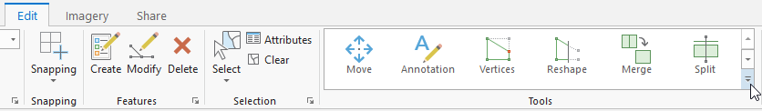
2. 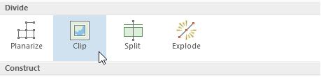
3. 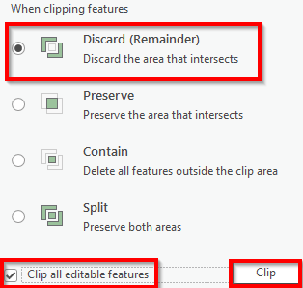

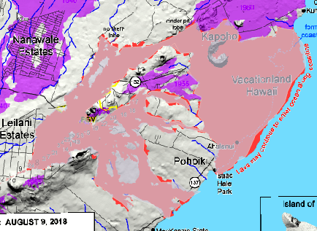

### **Creating a task**

Now we will use a combination of geoprocessing tools (i.e. Erase, Summary Statistics) to calculate how the extent of lava flow changed between May 2018 and August 2018. Furthermore, we will document our workflow using **Task**, which is a collection of steps or a recipe for a common workflow.

1. Go to **Insert**>**New Map** to start a new map.
2. To start building a Task, go to the **Insert** tab. Click **Task**, and select **New Task Item**. 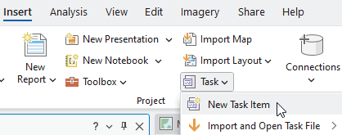
3. In the Task Designer window, enter the following:
   1. Name: **Lava change over time**
   2. Author: **(your name)**
   3. Summary: **Follow these steps to show lava change around Kilauea.**
   4. Tags: **Editing, Kilauea**
4. Within the Tasks pane, click the **New Task** icon .
5. In the Task Designer window, enter the following:
   1. Name: **Lava change**
   2. Description: **This task will calculate the area of lava change around Kilauea over time**

**Tip: Leave the task designer window open until you are told to close it**

1. In the Tasks pane (not the Task Designer window), click the **Record** icon  to record the commands/tools we will be using in the following steps to calculate the change in lava-covered areas. Specifically, these tools will be added to our task by just opening them in the following steps, but not actually running any of them yet.
2. The first step is to add in the polygon feature showing lava flows from an earlier time point (i.e. earlier feature or May15Lava in our case). Go to **Map**>**Add Data** and **close** the Add Data window.
3. Note how the Add Data tool is automatically added to the Tasks pane. Within the Task Designer window (not the Tasks pane) Enter the following and do not close the Tasks pane or Task Designer windows:
   1. Name: **Add May lava polygon layer**
   2. Step Behavior: **Manual**

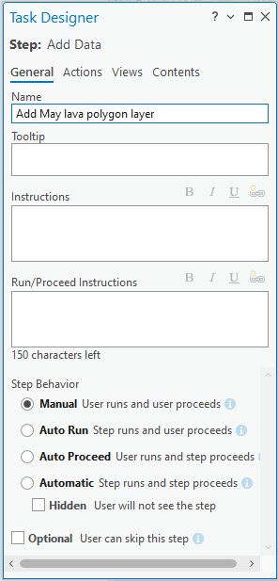

1. The second step is to add in the polygon feature showing lava flows from a later time point (i.e. later feature or Aug14Lava in our case). Go to **Map**>**Add Data** and **close** the Add Data window.
2. Note how the Add Data tool is automatically added to the Tasks pane. Enter the following in the Task Designer window, and do not close the Tasks pane or Task Designer window:
   1. Name: **Add Aug lava polygon** **layer**
   2. Step Behavior: **Manual**

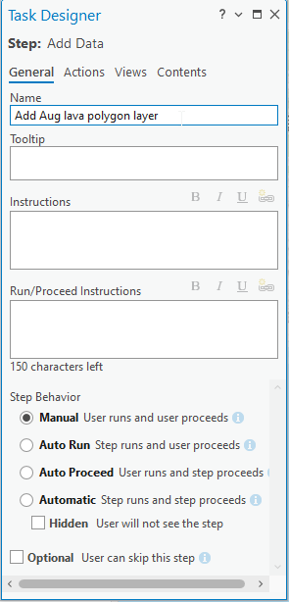

1. You should now see both steps that we added in the Tasks Window.

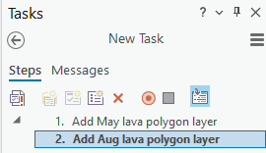

1. Your task designer window should still be open. The third step is to subtract the earlier lava polygon from the later lava polygon in order to see the new area covered by lava between the two timepoints. Go to **Analysis**>**Tools**, and search for the **Erase** tool. **Click** on the search result and **close** the Geoprocessing: Erase window (do not close the Tasks pane or Task Designer window).
2. Note how the Erase tool is automatically added to the Tasks pane. Enter the following in the Task Designer window and do not close the Tasks pane or Task Designer window:
   1. Name: **Difference in lava cover**
   2. Instructions: **Enter the Aug lava polygon layer (Aug14Lava, NOT the original 8_14_18 image) as the Input Features, and the May lava polygon layer (May15Lava, NOT the original 5_15_18 image) as the Erase Features. Name your output.**
   3. Step Behavior: **Manual**

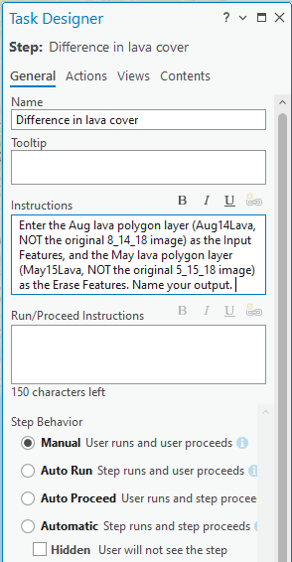

1. Your task designer window should still be open. The final step in this task is to sum the areas that are covered by the polygons generated by the previous step. In other words, we need to sum up the size of the new areas that are newly covered by lava between the two dates (May 15, 18 vs. Aug 14, 18). Go to **Analysis**>**Tools**, and search for the **Summary Statistics** tool. **Click** on the search result and **close** the Geoprocessing: Summary Statistics window (do not close the Tasks pane or Task Designer window).
2. Note how the Summary Statistics tool is automatically added to the Task pane. Enter the following in the Task Designer window:
   1. Name: **Sum of new lava area**
   2. Instructions: **Enter the output from the previous step for the Input Table. Name the Output Table. Select Shape_Area for Field, and Sum for Statistics Type.**
   3. Step Behavior: **Manual**

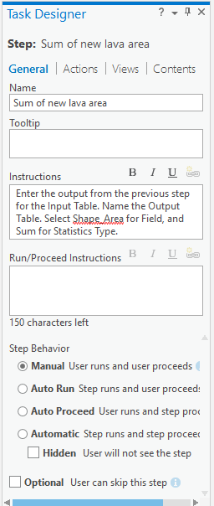

1. **Review** your Tasks pane. It should consist of 4 steps similar to the following image:

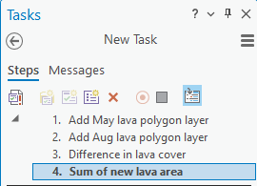

1. Click the **Stop** icon  to stop recording your steps. **Close** the Task Designer window (not the Tasks pane).
2. **(Optional)** You can also share your Tasks with co-workers by going to the **Share** tab, and selecting **Task Item** 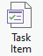. From here, you can choose to **save the task item to a file** that you can email to co-workers. Alternatively, you can save the task item to ArcGIS Online.

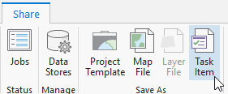 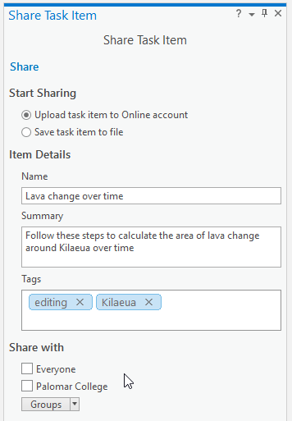

### **Test your Task Item**

* 1. You can access the Task you just created from the Tasks window, or if you closed the Tasks window, you can find it in the **Catalog pane** within the **Tasks** folder.

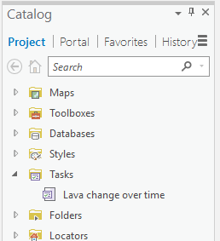

* 1. Run the task by double-clicking on the **Lava Change** task in the Tasks Window.

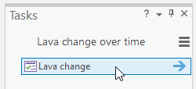

Click **Run** on the page for each step to run each of the four tools we previously added to the task. Remember to use your **May15Lava** polygon layer (not the 5_15_18 image) as the earlier lava polygon layer for Step 1, and your **Aug14Lava** polygon layer (not the 8_14_18 image) as the later lava polygon layer for Step 2. Click **Next Step** to advance between steps in the task.

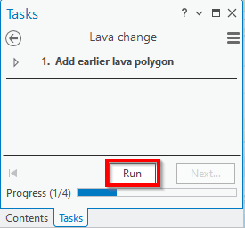

* 1. For Step 3 of your task, **follow the instructions** you previously typed in when creating the task. Click **Run**, then click **Next Step** to go onto Step 4.

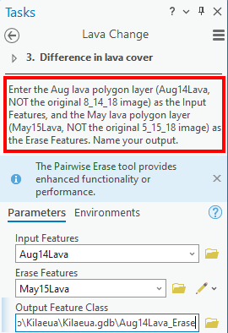

* 1. For Step 4 of your task, **follow the instructions** you previously typed in when creating the task. Click **Run**, then click **Finish**. **Close** the Tasks window.
  2. When you have finished going through all of the steps in the Task, go to the Contents pane. You should see:
     + The May15Lava layer
     + The Aug14Lava layer
     + The Difference layer (i.e. Erase output) that you created in Step 3 of your task
     + A table containing the sum of the additional areas that were covered by lava between May 15th and August 14th.

Q3. **Open** the table containing the sum of the additional areas that were covered by lava, what is the value recorded for the Shape_Area field?

Q4. **Turn off** all layers in your map except the **May15Lava** layer and the topographic layer. Go to the **Share** tab, and click **Export Map to File** 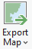. In the Export Map window, name the file **May15Lava**, and select **JPEG** or **PNG** as the Save as type.

Q5. **Turn off** all layers in your map except the **Aug14Lava**layer and the topographic layer. Go to the **Share** tab, and click **Export Map to File **. In the Export Map window, name the file **Aug14Lava**, and select **JPEG** or **PNG** as the Save as type.

Q6. **Turn off** all layers in your map exceptand the topographic layer and the **Difference** feature class that you create in Step 3 of your task. Go to the **Share** tab, and click **Export Map to File **. In the Export Map window, name the file **Difference**, and select **JPEG** or **PNG** as the Save as type.

Works Cited

Chiu, Allyson, and Lindsey Bever. “Earthquakes Rattle Hawaii's Big Island after Kilauea Shoots Lava, 'Dangerous' Gas into the Air.” *The Washington Post*, WP Company, 5 May 2018, www.washingtonpost.com/news/morning-mix/wp/2018/05/04/hawaiis-kilauea-volcano-finally-erupts-evacuations-underway-as-lava-threatens-communities/?noredirect=on&utm_term=.959f14d1eb5d.

“Hawaii's Volcano Kilauea Spews out 'Ballistic Blocks'.” *BBC News*, BBC, 17 May 2018, www.bbc.com/news/world-us-canada-44152515.

Loomis, Ilima. “Kīlauea Eruption Abruptly Slows Down.” *Eos*, 9 Aug. 2018a, eos.org/articles/kilauea-eruption-abruptly-slows-down.

Loomis, Ilima. “Lava Clues Chronicled Kīlauea's Unusual 2018 Eruption.” *Eos*, 26 Dec. 2018b, eos.org/articles/kilauea-eruption-abruptly-slows-down https://eos.org/features/lava-clues-chronicled-kilaueas-unusual-2018-eruption.

“Volcano World.” *Deadliest Eruption | Volcano World | Oregon State University*, Oregon State University, 2019, volcano.oregonstate.edu/kilauea.

Watson, John. “Principal Types of Volcanoes.” *Mercury Contamination from Historical Gold Mining in California*, U.S. Geological Survey, 3 Jan. 2011, pubs.usgs.gov/gip/volc/types.html.

# Chapter 7: Collecting field data with ArcGIS Field Maps

*In this exercise, you will:*

* *Create a feature layer in ArcGIS Online*
* *Create, and share web maps in ArcGIS Online*
* *Enable attachments for feature layers*
* *Access a web map in ArcGIS Field Maps*
* *Collect data using ArcGIS Field Maps*
* *Customize pop-ups in web maps using Arcade expression*

## **Introduction**

*Gathering ground control points (GCPs) is an essential part of a drone data collection workflow. While a drone may have its own onboard global navigation satellite system (GNSS) receiver to help it navigate, the accuracy and capability of the onboard receiver are highly variable. As a result, for commercial applications requiring a high level of accuracy (e.g. land surveying, city planning, construction), the GNSS data from the drone should be supplemented with GCP data carefully gathered from the field.*



An example of a ground control point target with high-contrast colors

*To enhance the locational accuracy of your drone data with GCPs, you will first need to create GCP targets that are large, clear, and have high-contrast colors, because you will eventually need to be able to identify these targets from your drone photos. Secondly, you will need to have a sufficient number of GCP targets distributed evenly across your study area. What is considered a sufficient number of targets greatly depends on the complexity, terrain, and size of your study area, but you should generally have at least 5 to 10 GCPs in a study area. Thirdly, you will need to use a high-accuracy GNSS unit, such as a real-time kinematic Global Positioning System (RTK GPS) receiver unit to record the location of each of the GCPs in your study area. Lastly, you will match the recorded coordinates of each GCP target (provided by the RTK GPS) with its location as it appears in your drone photos.*

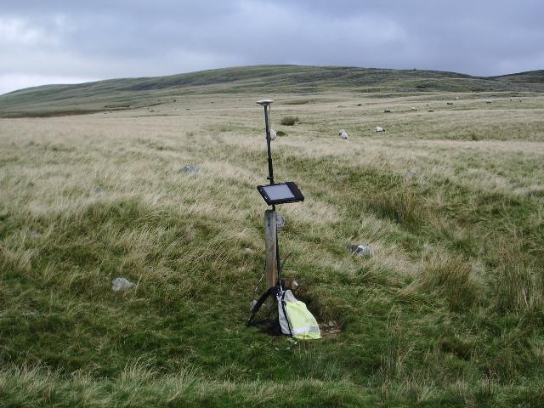

Example of a real-time kinematic global positioning system receiver unit (Source: Alexander P Kapp / Leica RTK with finger post)

*In this exercise, you will create a layer on ArcGIS Online (and use ArcGIS Field Maps on your mobile device, if one is available) to record the coordinates of several targets that can be used as GCPs.*

### **Create a feature layer**

* 1. Open an **internet browser** (preferably Chrome), go to [**www.arcgis.com**](http://www.arcgis.com/) and **Sign In**.
  2. Go to the **Content** tab 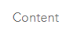 near the top of the window, click **New item** 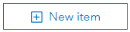, and select **Feature Layer**.

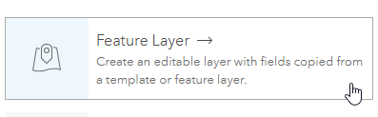

* 1. In the Create a feature layer window, select the **Use a template** option to see some common types of features that people collect in the field. Click **Next**.

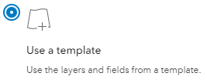

* 1. Select **General** under Industry, and click **Ground Control**. Click **Next**.

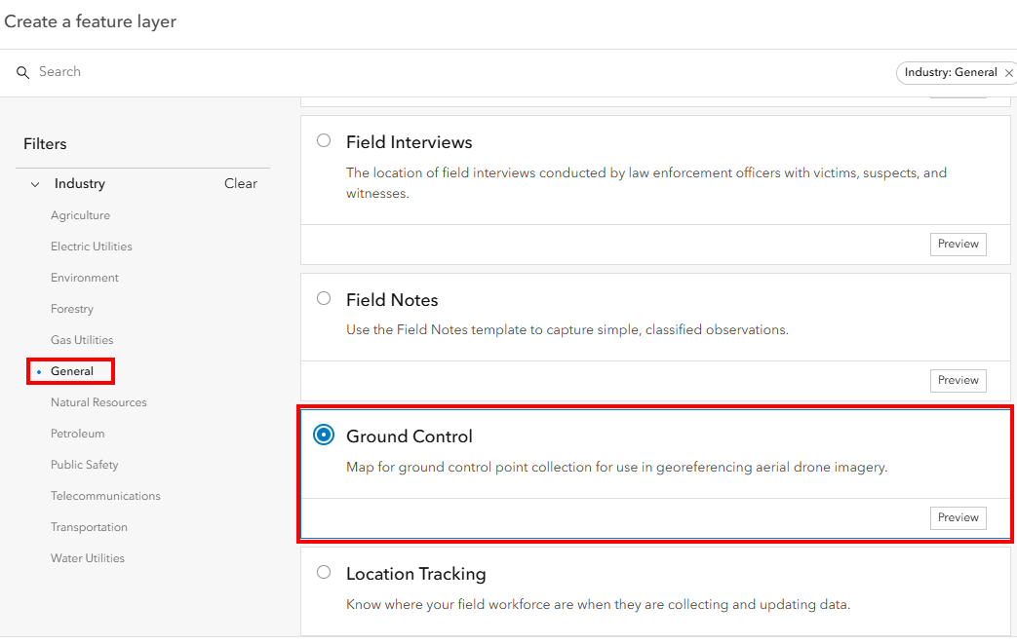

* 1. In the Create a feature layer window, click **Next**. Then on the next screen, under options, make sure that **Add GPS metadata fields** is turned on, and **Enable Z-values** is turned off. Click **Next**.

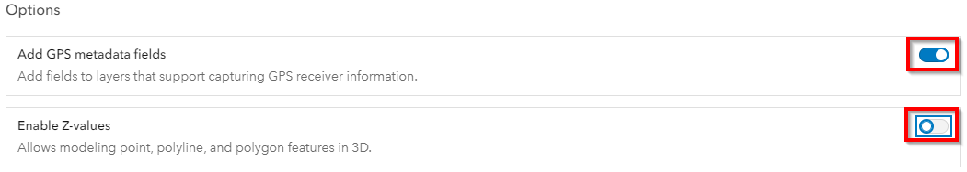

* 1. Lastly, specify some more details for the feature layer you are creating as follows:
     1. Title: **DroneGCP_(enter the last 4 digits of your mobile number here)**
     2. Click **Save**
  2. You should now see the Overview window for the newly created layer. To review what data fields/columns are created with the new layer, click **Data**.

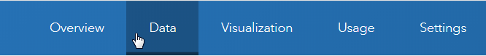

* 1. In the Data window, click **Fields** on the left side of the screen. You can see that there are numerous fields/columns currently in the feature layer. We will delete some of the fields that we don’t need. Check the box next to:
     1. **Speed (km/h)**
     2. **Direction of travel (°)**
     3. **Compass reading (°)**
     4. **Position source type**
     5. **HDOP**
     6. **VDOP**
     7. **Average Horizontal Accuracy (m)**
     8. **Average Vertical Accuracy (m)**
     9. **Averaged Positions**
     10. **Standard Deviation (m)**

Click **Delete**  in the upper right-hand side of the window and confirm. You cannot delete some of the fields needed by the system, such as GlobalID, CreationDate, Creator, EditDate, or Editor.

* 1. Go back to the **Overview** section, and click **Share**. Select **Organization** 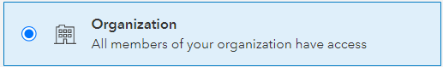 to ensure everyone in your ArcGIS organization can see your layer, and click **Save**. Then click the **layer’s name** (i.e. Ground Control) under the Layers section, and make sure that the **Attachments** option is enabled. This will allow you to capture photos to accompany the spatial data (i.e. point locations) you will be gathering soon.

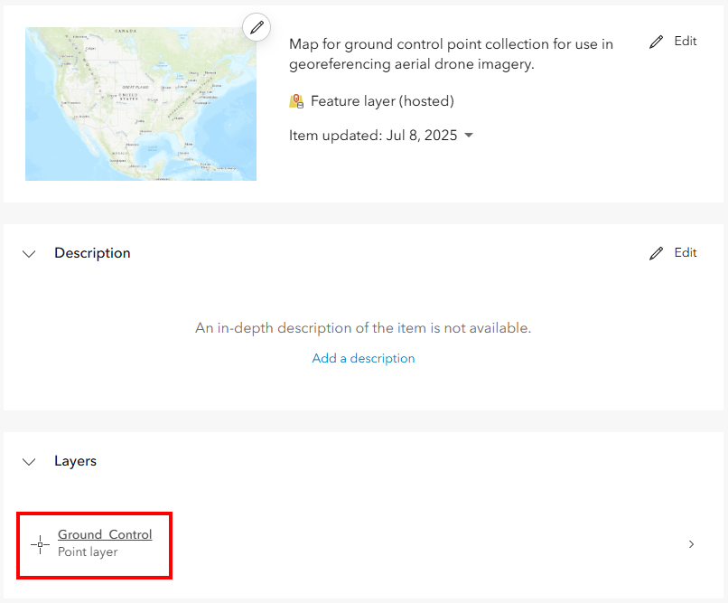

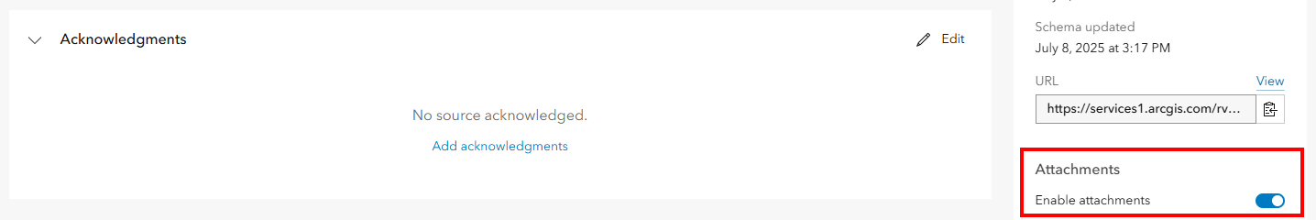

### **Create, save, and share a web map**

* 1. Within the **Overview** tab, select **Open in Map Viewer** 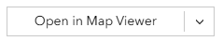. You should now see a web map with your feature layer in the Layers pane on the left side of the window (but the layer is currently empty). To access this map within the Field Maps App on your mobile device in the next section of this exercise, click the **Save** icon () and select **Save as**.
  2. In the Save Map window, enter the following:
     1. Title: **GCP(last 4 digits of your mobile phone number)Map**
     2. Tags: **GCPmaps**
     3. Summary: **Collect GCPs for your drone project with this map**
     4. Click **Save**

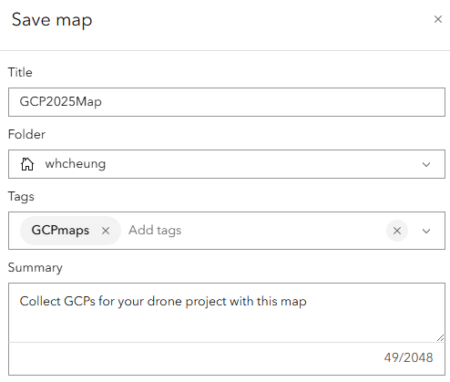

* 1. Click the **Share map** icon , select **Manage sharing**,and share the map with Palomar College by selecting **Organization**. This will grant everyone in the Palomar College ArcGIS Online Organization access to your web map. Click **Save**.

### **Test your map and layer**

* 1. It is a good practice to make sure that your map and layer are functioning properly prior to going to the field. To do this, click the **Edit** icon  on the right side of the web map.
  2. In the Editor pane, click the **Ground_Control** icon (your icon may have a different color), and then **click anywhere** in your map to manually place the point in the map.
  3. Type in **Test1** for the Control Point Notes field in the pane associated with your point. Click **Create** to save your edits.

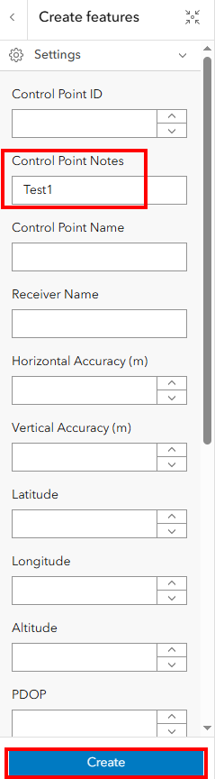

* 1. **Repeat** steps b and c to place **three more test points** in your map, so you should have a total of four test points. Remember to enter the Control Point Notes (i.e. Test2, Test3, Test4) for each point.

### **Customize pop-ups with Arcade expressions**

* 1. You can customize the information that is shown in the pop‐up window for each of your points. To do so, click the Pop-ups icon  on the right side of the window.
  2. Select **Attribute expressions** in the Pop-ups pane, and then select **+ Add expression**.

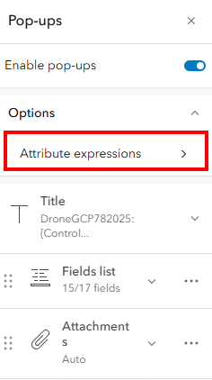 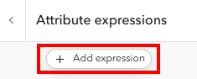

* 1. Now we will use some values in our existing fields to create an **Arcade expression**, so that an informative custom message can be shown in the pop‐up window when someone clicks on a point. When working with Arcade expression, keep in mind that custom text (i.e. values not coming from your layer’s fields) must be enclosed in **single quote (‘)** marks. You can use the **plus (+)** sign to string together different elements.

We will write a simple expression that contains the location of each point along with its notes in the following steps:

* + 1. In the New expression window, select the **Profile variables icon** on the right side of the window.
    2. Now, click the **arrow** to the right of the word $feature to see all the fields in your layer.

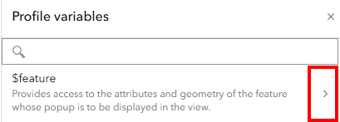

* + 1. **In the following order**, single-click on
* **$feature.ControlPointNotes**
* **$feature.esrignss_latitude**
* **$feature.esrignss_longitude**

to add these field values to your expression box.



* + 1. Type in the **bolded and underlined elements** (see below) to add them to your expression within the expression box, so they will form a complete sentence with the fields you selected in the previous step. (Be very careful with **spaces** and putting the underlined elements below in the correct locations within the expression. Your expression will appear in a single line in the expression box.)

**'Point ' +** $feature.ControlPointNotes **+ ' is located at ' +** $feature["esrignss_latitude"] **+ ',' +** $feature["esrignss_longitude"]

* + 1. Click **Run ** to preview the Result. Since we did not rename the Expression, it has the default name of New expression. And since the test points were entered manually, they lack latitude and longitude values, which will be missing in the output test message. 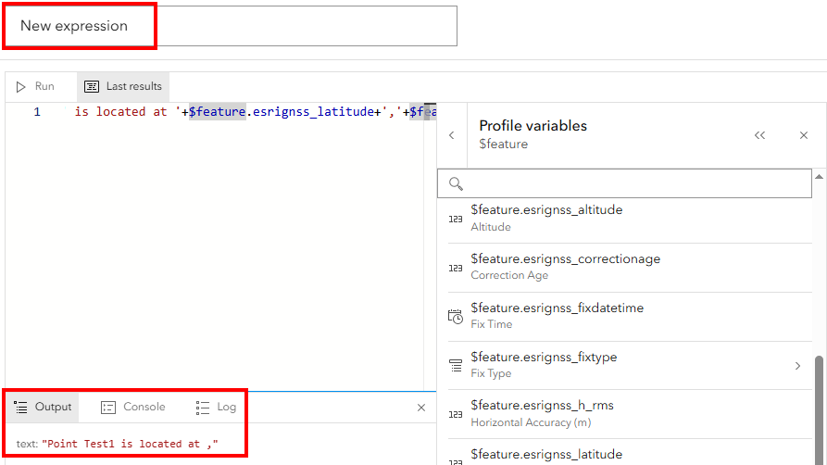
    2. Rename the expression from New expression to **Fieldnotes**. Click **Done**.

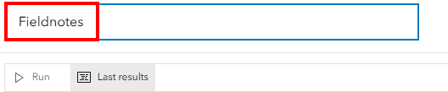

* 1. In the Attribute expressions pane, click **the back arrow**.

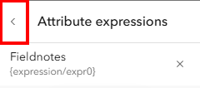

* 1. In the Pop-ups pane, click **Fields list** to see all the attributes that are currently set to display in your feature’s pop-up window.

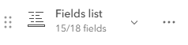

* 1. For this exercise, click the **X** next to all of the attributes to remove them from the pop-up, **EXCEPT for the following:** 
     1. **Control Point Notes**
     2. **Horizontal Accuracy (m)**
     3. **Latitude**
     4. **Longitude**
     5. **PDOP**

Your field list should resemble the following graphic.

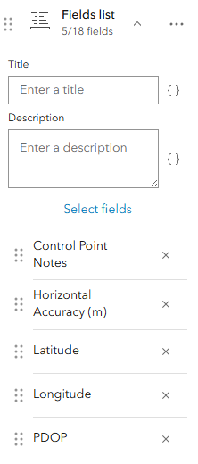

* 1. To include the Arcade expression that we wrote in step c of this section in the field list, click **Select fields**, and check the **box for Fieldnotes**. Click **Done**.

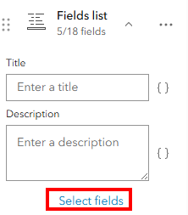 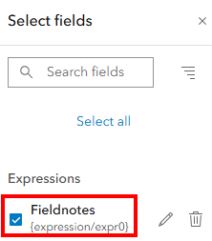

* 1. Back in the Pop-ups pane, click the **six-dot icon**  next to Fieldnotes, and drag it above the Control Point Notes field name. This will enable you to rearrange the order in which attributes are displayed in your feature’s pop-up window.

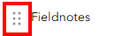

* 1. To change your attribute’s display name (i.e. Alias) in your feature’s pop-up window, click the **Fields icon**  on the right side of the window.

**Tip: If you don’t see the Fields icon, be sure to maximize your window to see all of the icons in the menu on the right side.**

* 1. In the Fields pane, click **PDOP** to see its Manage field window. Change its Display name from PDOP to **Position Dilution of Precision**, and select **1 decimal places** for Significant digits, and turn off **Show thousands separator**. Click **Done**.

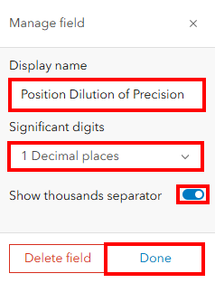

* 1. **Click** on any point in your map to see the new pop‐up information. Note that your Latitude and Longitude values will be missing in the pop-up window, because your test points were manually placed by you in the previous section, rather than collected with your mobile device’s GPS/GNSS

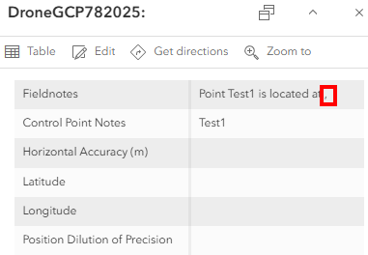

* 1. Click the **Save** icon  to save the latest changes to your web map.

Q1. Click the Share icon  and select **Copy link to map**, write down and submit the web address for your web map. The instructor will use this link to check your work.

### **Collect data using ArcGIS Field Maps**

* 1. On your mobile device, **download**, **install**, and **open** **ArcGIS Field Maps** . Let your instructor know if you need to borrow a compatible mobile device.
  2. **Go outside** where your mobile device can get a clear view of the sky and the satellites. Once the App is open on your mobile device, tap **Sign in with ArcGIS Online** and sign in. You should be able to see the web map that you created, saved, and shared in the previous sections (i.e. *GCP(last 4 digits of your mobile phone number)Map*). **Tap** the item to open it on your mobile device.
  3. You should now see the web map in the app. You will need to give **location permission** to the app. Click the **add data** icon  in the lower right corner of the map.

*\*\*Tip: Do not worry if your app’s and icon’s color is different\*\**

* 1. In the Collect window,
     1. Enter **Field1** in **Control Point Notes** for this first point you are collecting with your mobile device’s GPS/GNSS in the field.
     2. Tap **Take Photo** to include a photo with your point.
     3. If needed, tap **Update Point** to ensure you have the latest Latitude and Longitude data for your location
     4. Tap the **checkmark** in the upper right corner to submit your location.

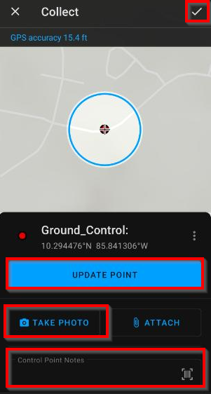

* 1. **Clicking** on the point you just created in the map will show the information (i.e. Control Point Notes) that you entered within the custom message we configured using arcade expression.

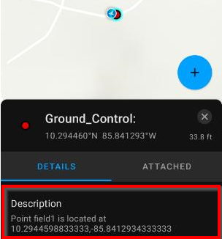

Repeat steps c and d in this section to **collect four additional points** in the field. Remember to enter notes for each point (i.e. Field2, Field3, Field4, Field5) and take photos to go with them. When finished, you should have a total of five points that you collected in the field.

*\*\*Tip: Preferably these points should be the locations of permanent features (e.g. lamp posts, fire hydrants) that you think will be readily identifiable from a drone flyover and can be used as ground control points\*\**

* 1. Once you are finished with data collection, **go back to your computer and open your web map** using the web address you recorded for Question #1. You should be able to see each point that you collected in the field automatically added to the web map.

# Chapter 8: Natural hazards on the edge

*In this exercise, you will:*

* *Create a new project and map*
* *Add layers to a new map*
* *Change the symbology of features*
* *Repair a layer’s data source*
* *Perform definition queries*
* *Use the near tool to calculate the distance between features*
* *Explore summary statistics*
* *Use the Display XY function to map coordinates*
* *Select features by their locations*

## **Introduction**

*Some scientists have compared the Earth’s internal structure to an onion because the Earth consists of four main layers that wrap around each other, with the crust being the outermost layer and the inner core being the innermost layer (Williams, 2015).*

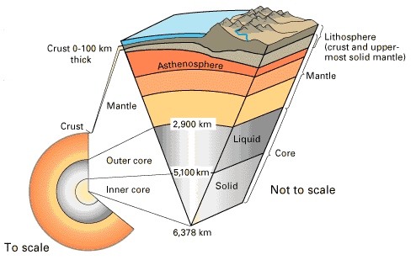

The earth consists of four concentric layers, which are the (1) Crust, (2) Mantle, (3) Outer Core, and (4) Inner Core. (Source: USGS)

*The crust and the uppermost zone of the mantle make up the solid lithosphere, which is broken up into large continent-sized slabs known as tectonic plates (Mcknight and Hess, 2009). These solid plates move slowly over the warm and soft asthenosphere, which sits below the lithosphere (Mcknight and Hess, 2009). As a result of tectonic plate movement, some plates may collide with each other at convergent plate boundaries, other plates may slide past each other at transform plate boundaries, and other plates (or sections of a plate) may move away from each other at divergent plate boundaries (Mcknight and Hess, 2009).*

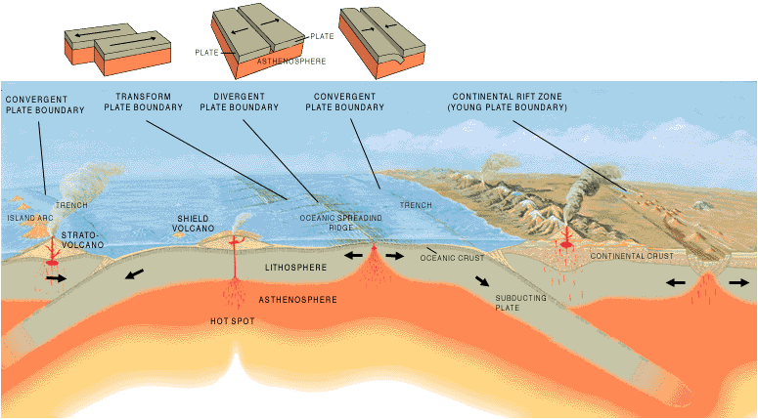

An overview of different types of plate boundaries and landscape features associated with them. (Source: USGS)

*Many of the world’s natural hazards occur as a result of tectonic movements, and are commonly found at the boundaries where tectonic plates may be colliding, sliding past, or pulling apart from each other. For example, earthquakes may occur at a convergent plate boundary, as it abruptly releases the energy that was accumulated at the area of stress between the plates. It is important to remember that earthquakes can occur at other types of plate boundaries (i.e. transform, divergent), and can even occur within a plate or continent in the case of sudden subsidence of the ground.*

*As a result of plate movements that may be associated with earthquakes, landslides, or volcanic eruptions, large waves of water may be set in motion. These large seismic sea waves are known as Tsunamis, and while they may be hardly noticeable in deep water, they can generate huge waves that may crash onto the shore (Mcknight and Hess, 2009). The largest recorded tsunami wave took place in the aftermath of a 7.8 magnitude earthquake in southeast Alaska on July 9, 1958, which created tsunami waves of up to 1,720 feet at Lituya Bay, Alaska that washed away vegetation, soil, and manmade structures in its path (Dutch, 1999).*

*To learn more about the movement of tectonic plates and the types of natural hazards caused by these movements, have a look at this* [*Esri Story Map on the Motion of Tectonic Plates*](http://apl.maps.arcgis.com/apps/MapJournal/index.html?appid=df5f94c0050b4075adfbba54fb13eaeb)*.*

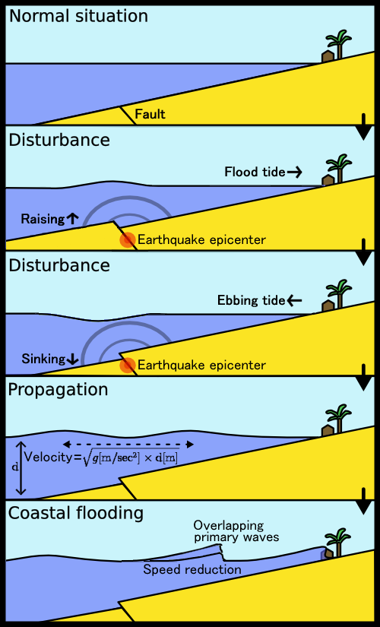

An illustration of how tectonic plate movements such as earthquakes at plate boundaries (fault) can lead to coastal flooding and tsunami waves (Source: CC BY-SA 3.0, <https://commons.wikimedia.org/w/index.php?curid=34403>)

*In this exercise, you will examine the locations of the world’s major tectonic plates and plate boundaries. You will also explore the locations of historical tsunamis and earthquakes, and analyze the locations of those natural hazards with respect to the locations of plate boundaries.*

### **Start a project, add data, change symbology, and explore data**

* 1. Open **ArcGIS Pro**, and start a new **project** and a new **map**.
  2. Go to **Add Data**, and add the **Plate.shp** layer to your map. This layer shows the locations of the major tectonic plates in the world.
  3. Right-click the layer name (i.e. **Plate**) in the Contents pane, and select **Symbology**. Enter the following settings in the Symbology window in order to display each polygon with a unique PLATE_NAME using a unique color:
     1. Primary symbology: **Unique Values**
     2. Field 1: **PLATE_NAME**
     3. Color scheme:  (or something similar)
     4. Click **Add all values** 
     5. **Close** the Symbology window
  4. Go to **Add Data**, and add the **MotionLayer.lyr** layer file (NOT the Motion.shp) to your map. However, the features are not currently showing because the layer’s data source is broken. You will fix this in the next step.
  5. To repair the layer’s data source, click the **red exclamation mark**  next to the layer name in the Contents pane. Then, in the Change data source window, navigate to the location of the **Motion.shp** file, **select** it, and click **OK**.

*\*\*Tip: Broken data source is quite common in GIS, and can be caused by a number of factors such as changes in file names, file locations, or files being saved or deleted improperly.\*\**

* 1. **Drag** the Motion layer above the Plate layer in the Contents pane to see its features (arrows) in the map.
  2. The symbology of the Motion layer is configured such that the size of each arrow corresponds to the speed at which the plate is moving (e.g. bigger arrows represent faster movement), and the orientation of the arrow indicates the direction of the plate’s movement. We will adjust the layer’s symbology in order to increase the contrast between the size of the arrows.

Right-click the layer name (i.e. **Motion**) in the Contents pane, and select **Symbology**. In the Symbology window, enter **1** for the Minimum size, check the box for Maximum size and enter **40**.

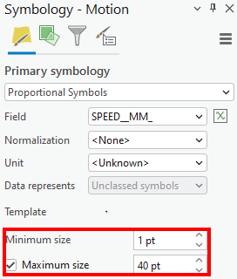

Q1. Based on the relative size of the arrows indicated in the Motion layer, which polygon (i.e. plate) within the Plate layer that is **located** **almost entirely south of the equator** is moving the fastest? (Click on the polygon to get its PLATE_NAME in the pop-up window)

Q2. Which direction is the plate identified in the previous question moving?

Q3. The margin between the South American plate and the Nazca plate is an example of which type of plate boundary (select the correct answer):

* Divergent
* Convergent
* Transform

Q4. The margin between the African plate and the South American plate is an example of which type of plate boundary (select the correct answer):

* Divergent
* Convergent
* Transform

### **Analyze data with a definition query, summary statistics, and the Near tool**

* 1. Go to **Add Data**, and add the **PlateBoundary.shp** layer to your map. This layer shows the locations of the world’s divergent, convergent, and transform plate boundaries. Turn off the Motion and Plate (not PlateBoundary) layers and the basemap in the Contents pane.
  2. **Modify and repeat** what you did in step 1c to symbolize each unique type of plate boundary (i.e. MARGIN_TYP) with a unique color.
  3. Go to **Add Data**, and add the **Tsunami.shp** layer to your map. This layer shows the locations of Tsunami events since the year 1900.
  4. Visually **examine** the relationship between the tsunami points (i.e. Tsunami) and the locations of the different types of plate boundaries (i.e. PlateBoundary). **Turn off** the Motion and Plate layer, if you have not already done so, to help you better visualize the relationship.

Q5. Most tsunami events occur near which type of plate boundary (select the correct answer):

* Divergent
* Convergent
* Transform
  1. To verify your answer to the previous question, we will calculate the average distance between the tsunami points and each of the three types of plate boundaries in the following steps.

We will start with the convergent plate boundaries. Right-click on **PlateBoundary** in the Contents pane, and select **Properties**. Select **Definition Query** on the left. In the Definition Query section of the Layer Properties window, click **New definition query**, and enter the following:

* + 1. Select **MARGIN_TYP** for the first dropdown.
    2. Select **is equal to** for the second dropdown.
    3. Select **Convergent** for the third dropdown.
    4. Click **Apply**. Click **Ok**.

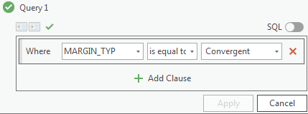

Now you should only see the convergent plate boundaries being displayed.

* 1. In order to calculate the average distance between each tsunami point and its nearest convergent plate boundary, go to the **Analysis** tab and select **Tools**. In the Geoprocessing pane, search for **Near**. Select **Near (Analysis Tools)**.
  2. In the Near window, enter the following:
     1. Input Features: **Tsunami**
     2. Near Features: **PlateBoundary**
     3. Click **Run**
  3. In the Contents pane, right-click on the **Tsunami** layer, and select **Attribute Table**.
  4. Find the NEAR_DIST field in the attribute table (this is the distance between a tsunami point and its nearest convergent plate boundary as calculated by the Near tool). Right-click on the field name **NEAR_DIST**, and select **Explore Statistics **.

Q6. What is the mean distance between the tsunami points in the layer and their nearest convergent plate boundaries (in meters) (round to the nearest whole number)?

* 1. **Modify and repeat** steps e through i above in order to find the mean (average) distance between each tsunami point and its nearest **divergent** plate boundary, as well as the average distance between each tsunami point and its nearest **transform** plate boundary. To complete this task, you need to **edit the definition query** that you built in step e to select the divergent plate margins (as opposed to the convergent ones), **run the Near tool**, and **Explore Statistics** (i.e. steps f thru i). Repeat this entire process for the transform plate boundaries as well.

Q7. What is the mean distance between the tsunami points in the layer and their nearest divergent plate boundaries (in meters) (round to the nearest whole number)?

Q8. What is the mean distance between the tsunami points in the layer and their nearest transform plate boundaries (in meters) (round to nearest whole number)?

### **Map points using XY coordinates**

* 1. We will first clear our definition query, because we need to see all of the plate boundaries for the following steps. In the Contents pane, right-click **PlateBoundary** and select **Properties**. Select **Definition Query**. In the Definition Query section of the window, **hover** your mouse over any existing queries, and click the **red X** to delete them. **Confirm** your decision. Click **OK**.

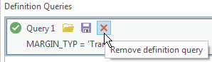

* 1. Go to **Add Data**, and add the **EarthquakeTable$** table to your map (double click on the EarthquakeTable.xls to see the EarthquakeTable$). This table records the earthquakes that occurred between 1900 and 2016.
  2. Right-click on the **EarthquakeTable$** table in the Contents pane, and select **Create Points From Table**>**XY Table to Point**.



* 1. In the XY Table to Point window, enter the following:
     1. Input Table: **EarthquakeTable$**
     2. Output Feature Class: **Earthquakes1900**
     3. X Field: **LONGITUDE**
     4. Y Field: **LATITUDE**
     5. Click **OK**

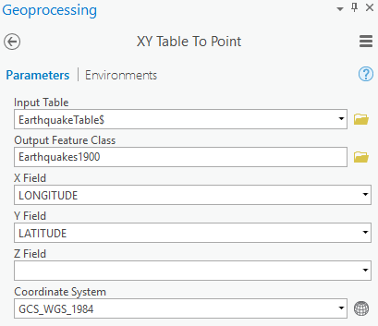

* 1. In the Contents pane, **turn off** all layers except the PlateBoundary and Earthquakes1900 layers.
  2. To explore the relationship between earthquake locations and plate boundary type, we will first run a definition query on PlateBoundary layer to only show convergent plate boundaries (as you did in the previous section).

Right-click on **PlateBoundary** in the Contents pane, and select **Properties**. In the Definition Query section of the Layer Properties window, click **New definition query**, and enter the following:

* + 1. Select **MARGIN_TYP** for the first dropdown.
    2. Select **is equal to** for the second dropdown.
    3. Select **Convergent** for the third dropdown.
    4. Click **Apply**. Click **OK**.
  1. To see the number of earthquake points that are reasonably close (within 500 miles) to convergent plate boundaries, click on **Select By Location** 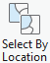 within the **Map** tab. In the Select By Location window, enter the following:
     1. Input Feature Layer: **Earthquake1900**
     2. Relationship: **Within a distance**
     3. Selecting Features: **PlateBoundary**
     4. Search Distance: **500 US Survey Miles**
     5. Click **Apply**

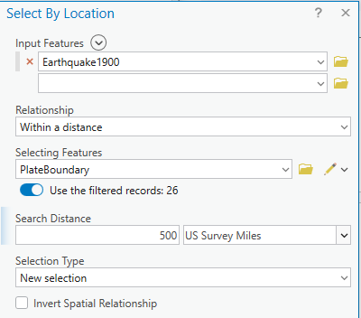

* 1. Open the **Earthquakes1900 layer**’s attribute table to see how many earthquake points are selected (i.e. within 500 miles of a convergent plate boundary).

Q9. How many earthquake points are within 500 US Survey Miles of a convergent plate boundary?

* 1. Within the Earthquakes1900 layer’s attribute table, clear your current selection by clicking on the **clear selection** icon.

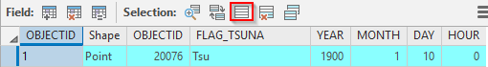

* 1. **Modify and repeat** steps f through i above to find the number of earthquake points that are reasonably close (within 500 US Survey Miles) to **divergent** plate boundaries and **transform** plate boundaries. To complete this task, you need to first **edit your definition query** in step f to show divergent plate margins, run the **Select Layer by Location** tool and examine your results (i.e. steps g thru i). Remember to **clear your selection** before repeating this process for transform plate boundaries as well.

Q10. How many earthquake points are within 500 US Survey Miles of a divergent plate boundary?

Q11. How many earthquake points are within 500 US Survey Miles of a transform plate boundary?

Works Cited

Dutch, Steven. “Giant Waves in Lituya Bay, Alaska.” *Archive.Org*, Internet Archive, 29 Dec. 1999, web.archive.org/web/20131013223418/www4.uwsp.edu/geo/projects/geoweb/participants/Dutch/LituyaBay/Lituya0.HTM. Accessed 28 June 2019.

Mcknight, Tom L, and Darrel Hess. *Physical Geography*. Boston, Ma, Pearson Education, 2009.

Williams, Matt. “What Are the Earth’s Layers?” *Phys.Org*, Universe Today, 7 Dec. 2015, phys.org/news/2015-12-earth-layers.html. Accessed 28 June 2019.

‌

# Chapter 9: Exploring the world’s water resources

*In this exercise, you will:*

* *Create a new project and map*
* *Add layers to a new map*
* *Rename layers*
* *Change the symbology of features*
* *Import symbology from other layers*
* *Explore summary statistics*
* *Work with vector geoprocessing tools (i.e. Clip, Intersect)*
* *Share the map as a PDF*

## **Introduction**

*Water covers approximately 71 percent of the earth’s surface (Perlman, 2005). Water can exist in three states or phases, which are:*

*(1) liquid (e.g. groundwater, lakes),*

*(2) solid (e.g. ice caps), and*

*(3) gases (e.g. water vapor in the atmosphere).*

*In the following graphic, the biggest water sphere (about 332,500,000 cubic miles) represents the volume of* ***all water*** *found in oceans, ice caps, lakes, rivers, groundwater, atmospheric water, and water in living organisms (plants, people) relative to the volume of the earth. The second biggest water sphere (about 2,551,100 cubic miles) represents the world's* ***liquid freshwater*** *found in groundwater, lakes, swamp water, and rivers. The tiny water sphere (about 22,339 cubic miles) represents* ***surface freshwater*** *resources found in the world’s lakes and rivers (Perlman, 2016).*

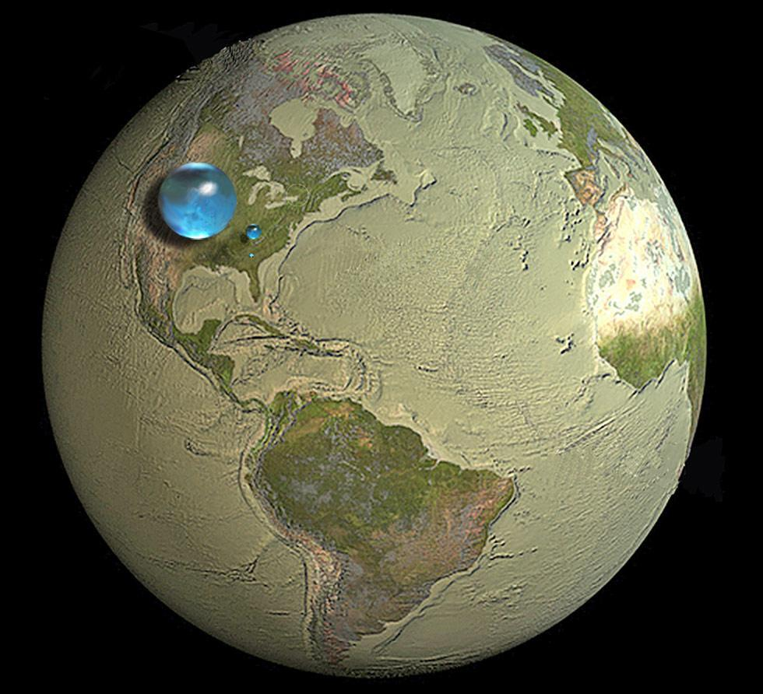

Relative comparison of the world’s total water resources (largest water sphere), the world’s liquid freshwater resources (medium water sphere), and the world’s surface freshwater resources (smallest water sphere). (Source: USGS)

*We can find a majority of the world’s water in* ***oceans****, which holds 96.5 percent of the earth’s water. Meanwhile, the world’s* ***ice caps, glaciers, and permanent snow*** *hold about 1.74 percent of the earth’s water, and* ***groundwater*** *accounts for 1.69 percent of the earth’s water (Perlman, 2005). Surface water sources such as* ***lakes, rivers, and the atmosphere*** *collectively constitute less than 1 percent of the earth’s water. In fact, it is estimated that lakes, rivers, and the atmosphere only hold 0.013 percent, 0.0002 percent, and 0.001 percent of the earth’s water, respectively. The following table shows the percentage of the world’s water that you may find in different places, as well as the percentage of the world’s freshwater found in these locations.*

| ***Water source*** | ***Percent of freshwater*** | ***Percent of total water*** |
| --- | --- | --- |
| *Oceans, Seas, & Bays* | *--* | *96.54* |
| *Ice caps, Glaciers, & Permanent Snow* | *68.6* | *1.74* |
| *Fresh Groundwater* | *30.1* | *0.76* |
| *Saline Groundwater* | *--* | *0.93* |
| *Soil Moisture* | *0.05* | *0.001* |
| *Ground Ice & Permafrost* | *0.86* | *0.022* |
| *Freshwater Lakes* | *0.26* | *0.007* |
| *Saline Lakes* | *--* | *0.007* |
| *Atmosphere* | *0.04* | *0.001* |
| *Swamp Water* | *0.03* | *0.0008* |
| *Rivers* | *0.006* | *0.0002* |
| *Biological Water* | *0.003* | *0.0001* |
| *Adapted from Igor Shiklomanov's chapter "World fresh water resources" in Peter H. Gleick (editor), 1993, Water in Crisis: A Guide to the World's Fresh Water Resources (Oxford University Press, New York).* | | |

*In this exercise, you will explore three common sources of the world’s water resources: (1) the world’s oceans, (2) continental ice caps, and (3) the atmosphere. Specifically, you will approximate the volume of water that is stored in each of these three sources.*

### **Start a project, rename layers, add data, and change and import symbology**

* 1. Open **ArcGIS Pro**, and start a new **project** and a new **map**.
  2. Go to **Add data**, and add the following layers to your map. These layers show the bathymetry of seafloors for the world’s oceans.
     1. **BATHYPAC**
     2. **BATHYIND**
     3. **BATHYATL**
     4. **BATHYARC**
     5. **BATHYSOU**
  3. In the Contents pane, right-click **BATHYPAC**, and select **Properties**. In the General section of the Layer Properties window, change the **Name** from BATHYPAC to **Pacific Depth (km)**. Click **OK**.

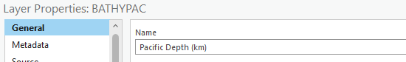

**Repeat** this procedure to change the names of the other layers:

* + 1. **BATHYIND → Indian Depth (km)**
    2. **BATHYATL → Atlantic Depth (km)**
    3. **BATHYARC → Arctic Depth (km)**
    4. **BATHYSOU → Southern Depth (km)**
  1. Follow the directions below to symbolize each bathymetry layer using a blue color ramp that is more consistent with how we perceive ocean features.

Select **Pacific Depth (km)** in the Contents pane, click on the **Feature Layer** tab, and select **Symbology**. In the Symbology window, enter the following:

* + 1. Primary symbology: **Graduated Colors**
    2. Field: **DEPTH_KM**
    3. Method: **Natural Breaks (Jenks)**
    4. Classes: **5**
    5. Color scheme: 
    6. Click the **More** dropdown in the middle of the window, and select **Format all symbols**.

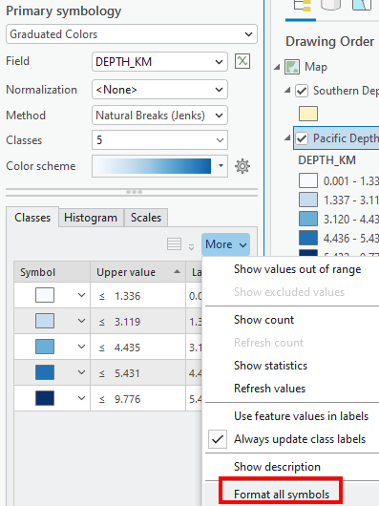

* + 1. In the Format Multiple Polygon Symbols window, select **Properties.**

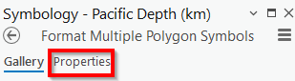

* + 1. Click the dropdown for Outline color, and select **No color**.

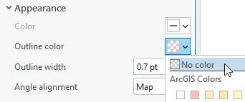

* + 1. Hit **Apply** to save your changes. **Close** the Symbology window
  1. To apply the symbology from the Pacific Depth (km) layer to the other layers in your map, right-click on the other layer’s name (e.g. **Southern Depth (km)**) in the Contents pane. Select **Symbology**. Click the **hamburger button** , and select **Import symbology…**

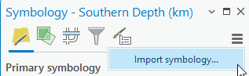

* 1. In the Apply Symbology From Layer window, ensure that **Southern Depth (km)** is the Input Layer, select **Pacific Depth (km)** for the Symbology Layer, and click **Run**.

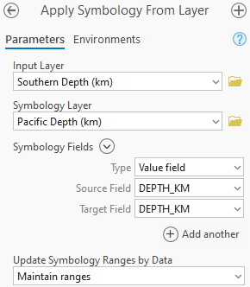

* 1. **Modify and repeat** the previous step to change the symbology for the remaining layers except for the topographic and hillshade layers (i.e. the remaining bathymetry layers), so they match the symbology of the Pacific Depth (km) layer.

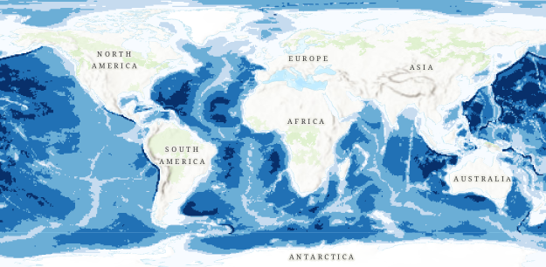

### **Explore your data and summary statistics**

* 1. In the Contents pane, right-click on the **Pacific Depth (km)** layer, and select **Attribute Table**.
  2. Within the attribute table, right-click the column name of **DEPTH_KM**, and select **Explore Statistics**. This field/column stores the depth information for various locations in the Pacific Ocean in kilometers.

Record the Mean DEPTH_KM value for the Pacific Depth (km) layer in **Table 1** (round to 1 decimal place).

* 1. **Modify and repeat** steps a and b in this section for the other ocean depth layers.

Record the Mean DEPTH_KM value for the other ocean depth layers in **Table 1** (round to 1 decimal place).

| Q1. TABLE 1 | Mean Depth (km) | Surface Area (km2) | Volume (km3) |
| --- | --- | --- | --- |
| Pacific Ocean | 3.9 | 172000000 | 670800000 |
| Southern Ocean |  |  |  |
| Indian Ocean |  |  |  |
| Atlantic Ocean |  |  |  |
| Arctic Ocean |  |  |  |

* 1. Go to **Add data**, and add the **5BASINS** layer to your map. This layer shows the rough extents of the five major ocean basins.
  2. Open the 5BASINS layer’s **attribute table**, and find each ocean’s surface area value under **AREA_KM2** column.

Copy each ocean’s surface area value over to Table 1 (be careful to copy over the correct number of zeros). The surface area value for the Pacific Ocean has been entered for you in Table 1 as an example.

Multiply each ocean’s mean depth value by its corresponding surface area value to approximate each ocean’s volume, and carefully record it under the Volume (km3) column in Table 1. **Submit a copy/photo of the completed Table 1 as part of your assignment. (Only jpg, jpeg, png files are allowed)**

Q2. Sum the volume values across the 5 oceans recorded in Table 1, this is the approximate volume of water that is stored in the world’s 5 major oceans. What is the sum (in km3)?

### **Analyze water vapor data with the Clip tool**

* 1. Go to **Add data**, and add the following layers to your map. (Hold down the Ctrl key on your keyboard while selecting multiple items to add them to your map simultaneously.)
     1. **H2OVAPOR** (layer showing the volume of water vapor across the world)
     2. **ICE_ANT** (layer showing the location of the Antarctic continent and ice sheet)
     3. **ICE_GRN** (layer showing the location of Greenland and its ice sheet)
  2. In order to compare the volume of water vapor over Antarctica, Greenland, and the world’s oceans, we will first use the Clip tool to extract the sections of the H2OVAPOR layer that coincide with the ICE_ANT layer.

Go to the **Analysis** tab, and select **Tools**. In the Geoprocessing pane, type in **Clip**. Select **Clip (Analysis Tools)**.

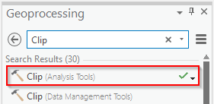

* 1. In the Clip window, enter the following:
     1. Input Features or Dataset: **H2OVAPOR** (i.e. this is the cookie dough, we only want a part of this layer)
     2. Clip Features: **ICE_ANT** (i.e. this is the cookie cutter, this defines the specific part of the input layer that we want)
     3. Output Features or Dataset: **vaporclipant** (i.e. this is the cookie, the parts of the input layer that are inside the clip feature)
     4. Click **Run**
  2. **Turn off** all the layers in the Contents pane except the vaporclipant layer to see your output. Open the vaporclipant layer’s **Attribute Table**, right-click the column name **VAP_KM3**, and select **Explore Statistics**. This field/column stores the volume of water vapor recorded in specific parts of the world.

Q3. What is the mean water vapor volume over Antarctica (in km3)? (Round to three decimal places)

* 1. **Modify and repeat** steps b through d in this section with the **ICE_GRN** and the **5BASINS** layers as the Clip Features to find the mean water vapor volume over Greenland and the world’s oceans, respectively. Name the output for the Greenland water vapor layer **vaporclipgrn**, and the output for the oceans water vapor layer **vaporclipoceans**.

Q4. What is the mean water vapor volume over Greenland (in km3)? (Round to three decimal places)

Q5. What is the mean water vapor volume over the world’s oceans (in km3)? (Round to three decimal places)

Review the attribute table for the oceans’ water vapor layer (i.e. vaporclipoceans), note that while you can find the average water vapor volume over ALL of the world’s oceans, there is no way for us to find out the volume of water vapor over a SPECIFIC ocean at this point (e.g. Pacific Ocean). We will do this in the next section.

### **Analyze water vapor data with the Intersect tool**

* 1. To compare the water vapor volume over specific oceans, we need to get an output that tells us which part of the H2OVAPOR layer coincides with which specific ocean feature within the 5BASIN layer.

Go to the **Analysis** tab, and select **Tools**. In the Geoprocessing pane, type in **Intersect**. Select **Intersect (Analysis Tools)**.

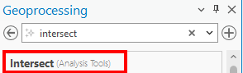

* 1. In the Intersect window, enter the following:
     1. Input Features: select **H20VAPOR**, then select **5BASINS** (leave the Ranks empty)
     2. Output Feature Class: **vaporinteroceans**
     3. Click **Run**
  2. **Compare** the attribute tables for the **vaporclipoceans** and the **vaporinteroceans** layer.

Q6. List some of the field/column names that are present in the vaporinteroceans layer, but are missing in the vaporclipoceans layer.

* 1. To calculate the water vapor volume over a specific ocean basin, we will first select the rows in the vaporinteroceans layer that are associated with a specific ocean and then calculate its statistics. To reduce clutter, **turn off** all layers in the Contents pane except the vaporinteroceans layer.

Go to the **Map** tab, and click **Select By Attribute**. In the Select Layer By Attribute window, enter the following:

* + 1. Input Rows: **vaporinteroceans**
    2. Selection type: **New selection**
    3. Expression:
       1. First dropdown: **OCEAN_NAME**
       2. Second dropdown: **is equal to**
       3. Third dropdown: **Pacific Ocean**
    4. Click **Apply**

You should now see the features in the vaporinteroceans layer that coincide with the Pacific Ocean are selected in your map.

* 1. Open the **vaporinteroceans** layer’s Attribute Table, right-click the column name of **VAP_KM3**, and select **Visualize Statistics** (not Explore Statistics). To get statistics that are calculated based solely on the selected features, make sure that the **Filter by Selection** icon in the Chart window has been turned on. 

Q7. What is the mean water vapor volume over the Pacific Ocean (in km3)? (Round to three decimal places) (Be sure to get this value in the chart window or under the selection column, not the dataset column, in the Chart Properties pane)

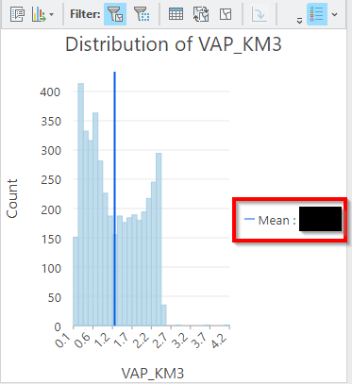

* 1. **Repeat and modify** the expression in step d to find out the mean water vapor volume over the Arctic Ocean, the Atlantic Ocean, the Indian Ocean, and the Southern Ocean.

Q8. What is the mean water vapor volume over the Arctic Ocean (in km3)? (Round to three decimal places) (Be sure to get this value in the chart window or under the selection column, not the dataset column, in the Chart Properties pane)

Q9. What is the mean water vapor volume over the Atlantic Ocean (in km3)? (Round to three decimal places) (Be sure to get this value in the chart window or under the selection column, not the dataset column, in the Chart Properties pane)

Q10. What is the mean water vapor volume over the Indian Ocean (in km3)? (Round to three decimal places) (Be sure to get this value in the chart window or under the selection column, not the dataset column, in the Chart Properties pane)

Q11. What is the mean water vapor volume over the Southern Ocean (in km3)? (Round to three decimal places) (Be sure to get this value in the chart window or under the selection column, not the dataset column, in the Chart Properties pane)

### **Share your map as an image**

* 1. Go to the **Contents** pane, and **turn off** all layers except Pacific Depth (km), Indian Depth (km), Atlantic Depth (km), Arctic Depth (km), Southern Depth (km), and World Topographic Map. Make sure that your layers are properly symbolized as instructed in section 1.
  2. To share your map as an image, go to the **Share** tab and click **Export Map**. 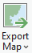
  3. In the Export Map window, be sure to select **PNG or JPEG** as the File Type, specify the **Name** and **location** for your file, and hit **Export**.

Q12. Submit a copy of your exported map for this assignment. (Only jpg, jpeg, png files are allowed)

Works Cited

Perlman, Howard. “How Much Water Is There on Earth.” *The USGS Water Science School*, US Geological Survey, 2005, water.usgs.gov/edu/earthhowmuch.html.

Perlman, Howard. “Water Science Photo Gallery.” *The USGS Water Science School*, US Geological Survey, 2016, water.usgs.gov/edu/gallery/global-water-volume.html. Accessed 27 June 2019.

‌

# Chapter 10: Visualizing global climate change under different emission scenarios

*In this exercise, you will:*

* *Create a new project and map*
* *Add layers to a new map*
* *Change the symbology of features*
* *View basic metadata information*
* *Edit metadata information using the Contents pane and the Catalog pane*
* *Change metadata stylesheet*
* *Verify metadata compliance with established standards*
* *Upload data to ArcGIS Online*
* *Perform raster analysis in ArcGIS Online*

## **Introduction**

*The Intergovernmental Panel on Climate Change (IPCC) is an intergovernmental organization made up of member states from the United Nations and the World Meteorological Organization (IPCC, 2019). The IPCC’s staff and researchers assess and review scientific findings to provide governments with updated information for developing policies to mitigate the risks associated with climate change (IPCC, 2019).*

*The IPCC’s assessments of the future impacts of climate change are based on four representative concentration pathways (RCPs) (i.e. scenarios), which take into account a variety of natural and man-made (e.g. greenhouse gas emission) contributing factors (Alexander et al., 2013).*

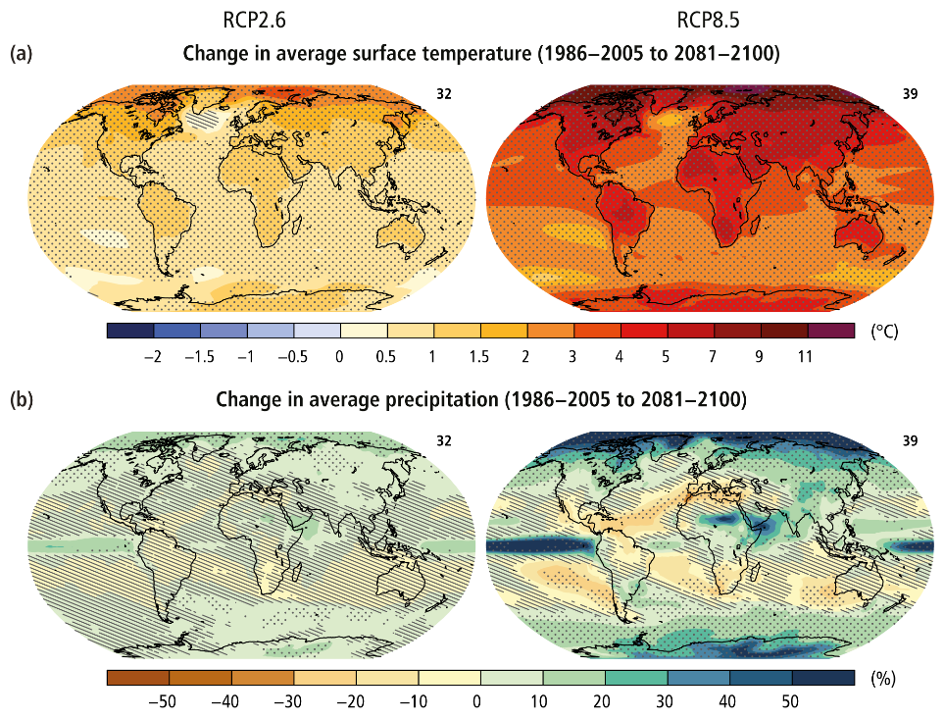

[IPCC](https://ar5-syr.ipcc.ch/topic_summary.php)

Forecasted long-term changes to average surface temperature (a) and average precipitation (b) in 2081-2100 relative to conditions in 1986-2005 under two scenarios (RCP 2.6, RCP 8.5).

*In this exercise, we will look at climate change’s projected impact on global temperatures under two of the four RCPs adopted by the IPCC. Specifically, in the “best case scenario” (i.e. RCP 2.6), it assumes that global carbon dioxide emissions will peak soon and decline, the global population growth is minimal, and there will be a high level of global economic growth (Furphy, 2013). In contrast, the “worst case scenario” (i.e. RCP 8.5) assumes that emissions and population will continue to increase rapidly, while economic growth will be much slower, especially among lower-income populations (Furphy, 2013).*

### **Start a project, add data, and change and import symbology**

* 1. Open **ArcGIS Pro**, and start a new **project** and a new **map**.
  2. Go to **Add data** (found under the Map tab), and add the **TempChangeExtremeEmission** and **TempChangeLowEmission**

layers to your map. These layers show two scenarios of how the global temperatures (in Celsius) may be warmer (positive values) or cooler (negative values) by the year 2040-2059 in comparison to temperatures recorded in earlier periods (1986-2005). The scenarios (i.e. Extreme Emission, Low Emission) were compiled by the Intergovernmental Panel on Climate Change.

* 1. Select **TempChangeExtremeEmission** in the Contents pane, click on the **Feature Layer** tab, and select **Symbology**. In the Symbology window, enter the following:
     1. Primary symbology: **Graduated Colors**
     2. Field: **ContourMin**
     3. Method: **Natural Breaks (Jenks)**
     4. Classes: **5**
     5. Color scheme: 
     6. **Close** the Symbology window.
  2. We will apply the symbology from the TempChangeExtremeEmission layer to the TempChangeLowEmission layer so that the same colors represent the same levels of temperature changes across both layers. Right-click on the **TempChangeLowEmission** layer’s name in the Content pane. Select **Symbology**. Click the **hamburger button** , and select **Import symbology…**

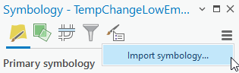

* 1. In the Apply Symbology From Layer window, select **TempChangeLowEmission** as the Input Layer, **TempChangeExtremeEmission** for the Symbology Layer, and click **Run**.

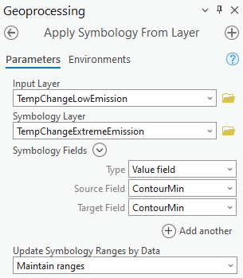

### **View basic metadata in the Catalog pane pop-up**

* 1. Open the Catalog pane by going to **View**>**Catalog Pane**.
  2. In the Catalog pane, right-click on **Folders** and select **Add Folder Connection** to make a connection to the **Folder** (not individual files) where you stored your data (i.e. the Climate folder) for this exercise.
  3. **Expand** the Folders icon in the Catalog Pane to see your new folder connection. Find the **TempChangeExtremeEmission** and **TempChangeLowEmission** layers within the folder, and **hover** your mouse pointer over each of them. You should see a pop-up with basic information for each layer.

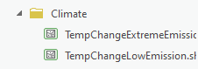

Q1. What is the File Type (i.e. Type) for the TempChangeExtremeEmission layer?

Q2. What is the File Type (i.e. Type) for the TempChangeLowEmission layer?

### **View and edit metadata from the Contents pane**

* 1. Go back to the Contents pane (not the Catalog pane), right-click the **TempChangeLowEmission** layer, and select **Properties**.
  2. Click **Metadata** found on the left side of the Layer Properties window.

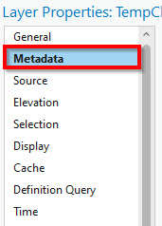

* 1. Within the Metadata section, on the right side of the window, select **Layer has its own metadata.**

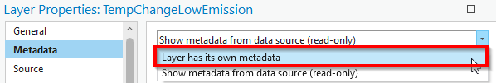

* 1. **Fill out** the Metadata section by copying and pasting from the contents below. (Source: <https://www.arcgis.com/home/item.html?id=b92294d54afc48499e1a8db479023e72>)
     1. Title

**Feature layer showing projected temperature and precipitation anomaly for RCP 2.6 from 2040 to 2059 using a CMIP5 multimodel ensemble of ten climate models.**

* + 1. Tags

[**climate**](https://www.arcgis.com/home/search.html?t=content&q=tags:%22climate%22)**,**[**climate change**](https://www.arcgis.com/home/search.html?t=content&q=tags:%22climate%20change%22)**,**[**temperature**](https://www.arcgis.com/home/search.html?t=content&q=tags:%22temperature%22)**,**[**Precipitation**](https://www.arcgis.com/home/search.html?t=content&q=tags:%22Precipitation%22)**,**[**IPCC**](https://www.arcgis.com/home/search.html?t=content&q=tags:%22IPCC%22)**,**[**model**](https://www.arcgis.com/home/search.html?t=content&q=tags:%22model%22)**,**[**RCP**](https://www.arcgis.com/home/search.html?t=content&q=tags:%22RCP%22)**,**[**CMIP**](https://www.arcgis.com/home/search.html?t=content&q=tags:%22CMIP%22)

* + 1. Summary

**RCPs (Representative Concentration Pathways) represent the ratio of energy absorbed by the Earth's atmosphere to the energy reflected back into space in watts per square meter. Climate scientists call this radiative forcing. As levels of greenhouse gasses increase or decrease in the atmosphere, radiative forcing values will correspondingly increase or decrease. As radiative forcing values increase, the atmosphere becomes warmer because more energy (heat) is retained in the atmosphere.**

**In 2014, the IPCC (Intergovernmental Panel on Climate Change) adopted four standard RCPs: 2.6, 4.5, 6.0, and 8.5 W/m2. These scenarios give us a range from the best case (2.6) to the worst (8.5) for greenhouse gasses being emitted into the atmosphere by human and natural sources.**

**RCP 2.6 is a "peak and decline" scenario where radiative forcing levels not only peak prior to, but decline to 2.6 W/m2 by 2100 (Van Vuuren, D.P., et al., 2011). Scenario 2.6 is no longer considered a realistic possibility.**

**Global climate projections are produced by general circulation models (GCMs). This particular layer was derived from the mean results of 10 of the best GCMs, called a multi-model ensemble (MME). Esri partnered with the**[**Research Applications Laboratory**](https://ral.ucar.edu/)**(RAL) from the National Center for Atmospheric Research (NCAR) to select the model members.**

* + 1. Description

**This layer was generated from data associated with the Learn ArcGIS Lesson “**[**Explore Future Climate Projections**](https://learn.arcgis.com/en/projects/explore-future-climate-projections/)**.”**

**A projected climate anomaly is the difference between the current climate, or “baseline” conditions, and a future climate scenario, or “projection”. This layer contains contoured features representing annual precipitation (mm) and temperature (°C) anomalies. These are computed for 2040 to 2059 using a scenario called "RCP 2.6". In this case, the baseline conditions are from 1986 to 2005.**

* + 1. Credits

**NCAR, Esri**

* + 1. Use Limitations

**This work is licensed under the Esri Master License Agreement.**

* 1. Click **Generate Thumbnail**
  2. Click **OK**
  3. To confirm that the information we entered for the layer is saved, right-click on the **TempChangeLowEmission** layer’s name in the Contents pane, and select **View Metadata**. You should be able to see the information that we entered in the previous section. *\*\*Tip: Do not worry if your thumbnail is different\*\**

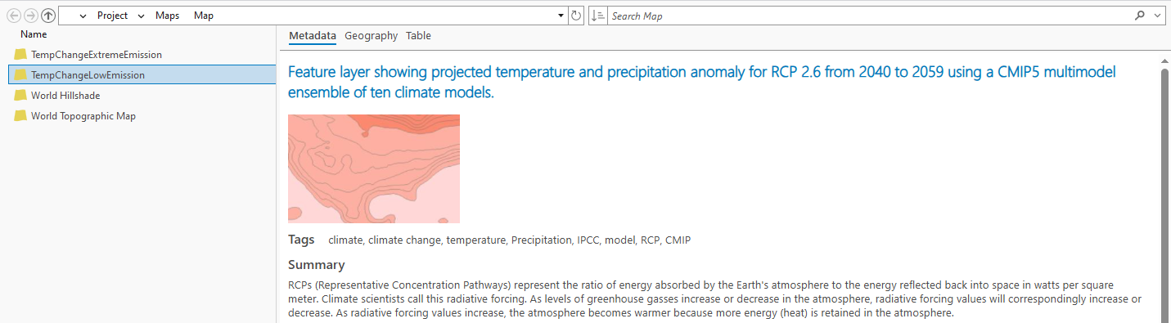

### **View and edit metadata from the Catalog pane**

* 1. We can also view and edit metadata from the Catalog pane. Open the Catalog pane if needed by going to **View**>**Catalog pane**.
  2. Navigate to the **TemperatureChangeExtremeEmission** layer within the Catalog pane. It should be under the Folders icon.
  3. Right-click on the **TemperatureChangeExtremeEmission** layer’s name in the Catalog pane and select **Edit Metadata**.
  4. A new window showing the metadata form for the layer appears. Depending on the metadata style you have chosen (we will learn how to change between different metadata styles in the next section), it will have its own set of required and optional fields.

In your window, the **fields/boxes that are in red** are those that must be completed to comply with the metadata style that you are currently using in ArcGIS.

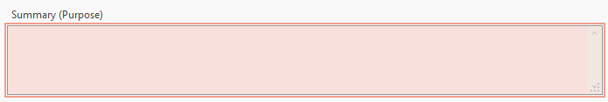

The **red exclamation signs** at the top of the window show the missing requirements for the specific metadata style. (If you are not seeing this, you may need to change your metadata styles back to the default option by going to Project>Options>Metadata>Item Description)

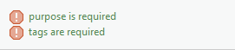

* 1. Given that the metadata form window is saying the only required sections with missing information are (1) purpose and (2) tags (assuming that you are currently using the default metadata style of Item Description), fill in **only the summary and tags** sections by copying and pasting from the appropriate sections below. (Source: <https://www.arcgis.com/home/item.html?id=8bdb6fbd60d346cfb272b6892ad45252>)
     1. Tags

[**climate**](https://www.arcgis.com/home/search.html?t=content&q=tags:%22climate%22)**,**[**climate change**](https://www.arcgis.com/home/search.html?t=content&q=tags:%22climate%20change%22)**,**[**Precipitation**](https://www.arcgis.com/home/search.html?t=content&q=tags:%22Precipitation%22)**,**[**Temperature**](https://www.arcgis.com/home/search.html?t=content&q=tags:%22Temperature%22)**,**[**CMIP**](https://www.arcgis.com/home/search.html?t=content&q=tags:%22CMIP%22)**,**[**RCP**](https://www.arcgis.com/home/search.html?t=content&q=tags:%22RCP%22)**,**[**model**](https://www.arcgis.com/home/search.html?t=content&q=tags:%22model%22)**,**[**IPCC**](https://www.arcgis.com/home/search.html?t=content&q=tags:%22IPCC%22)

* + 1. Summary (Purpose)

**RCPs (Representative Concentration Pathways) represent the ratio of energy absorbed by the Earth's atmosphere to the energy reflected back into space in watts per square meter. Climate scientists call this radiative forcing. As levels of greenhouse gasses increase or decrease in the atmosphere, radiative forcing values will correspondingly increase or decrease. As radiative forcing values increase, the atmosphere becomes warmer because more energy (heat) is retained in the atmosphere.**

**In 2014, the IPCC (Intergovernmental Panel on Climate Change) adopted four standard RCPs: 2.6, 4.5, 6.0, and 8.5 W/m2. These scenarios give us a range from the best case (2.6) to the worst (8.5) for greenhouse gasses being emitted into the atmosphere by human and natural sources.**

**RCP 8.5 is a scenario where radiative forcing levels are modeled with different assumptions than 2.6, 4.5, and 6.0. In 8.5 the assumptions are very high levels of radiative forcing due in part to high levels of population growth and continued lower incomes in developing countries will reach 8.50 W/m2 by 2100 (Van Vuuren, D.P., et al., 2011). At the time, RCP 8.5 was the most extreme model scenario, but it is now considered very likely.**

**Global climate projections are produced by general circulation models (GCMs). This particular layer was derived from the mean results of 10 of the best GCMs, called a multi-model ensemble (MME). Esri partnered with the**[**Research Applications Laboratory**](https://ral.ucar.edu/)**(RAL) from the National Center for Atmospheric Research (NCAR) to select the model members.**

* 1. Hit the **Save** icon  under the Metadata tab to save your changes. And save your project by going to **Project**>**Save Project**.
  2. **Close** the metadata form window.

### **Choose a different metadata stylesheet and verify metadata standard compliance**

* 1. To choose a different metadata stylesheet, click on **Project**>**Options**.
  2. Click **Metadata** on the left side of the Options window. On the right-hand side of the Metadata section window, you should now see a dropdown for different Metadata stylesheets. You can see that the metadata style we have been working with up to this point is the **Item Description** style, which is an Esri-specific metadata style.

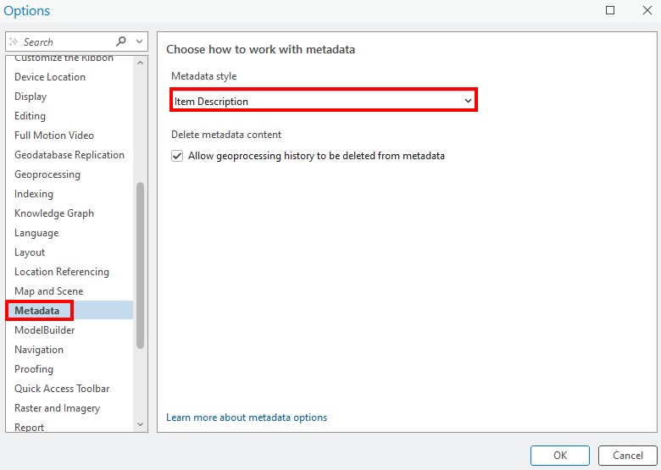

Using the dropdown, select the **FGDC CSDGM Metadata** stylesheet. Click **OK**.

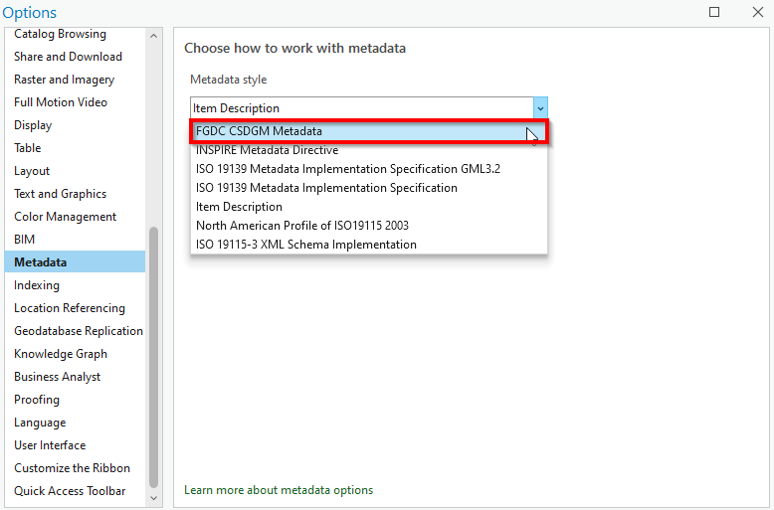

* 1. To verify that the information we entered in the previous section of this exercise is sufficient to comply with the FGDC CSDGM Metadata standard, navigate to the **TemperatureChangeExtremeEmission** layer within the **Catalog pane**.
  2. Right-click on the **TemperatureChangeExtremeEmission** layer’s name in the **Catalog pane** and select **Edit Metadata**.
  3. The metadata form window for the file appears. Switch to the Contents pane by going to **View**>**Contents**, and click on one of the many sections (e.g. Citation) of the FGDC CSDGM metadata standard that has a **red X mark**  in the **Contents pane** (not Catalog pane). Then, study the red exclamation sign at the top of the metadata form window to see what requirements we are missing for that section.
  4. Look at other sections of the FGDC CSDGM metadata standard in the **Contents pane.**

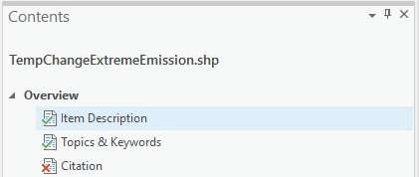

Q3. List the names of sections (e.g. Citation, …) in which we have missing requirements according to the FGDC CSDGM metadata standard.

**Close** the metadata form window.

* 1. **Modify and repeat** steps a to e from this section for the **TemperatureChangeExtremeEmission** layer, except select **North American Profile of ISO 19115 2003** for the metadata style in step b to see if our metadata is compliant with the ISO metadata standard.

Q4. Look at the various sections of the ISO metadata standard in the **Contents pane**, and list the names of the sections in which we have missing requirements.

**Close** the metadata form window.

### **Uploading data with metadata information to ArcGIS Online**

* 1. If necessary, navigate back to your map. Publish your map to ArcGIS Online by going to **Share**>**Web Map** 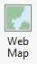. This will send all the layers that are currently in your map (whether they are on or off, excluding the basemaps) to ArcGIS Online at once. To send particular layers in your map to ArcGIS Online, pick the Web Layer option instead. For this step, we will be using the Web Map option.
  2. In the Share As a Web Map window, enter the following metadata information for the items we will be uploading to ArcGIS Online:
     1. Name: **IPCC Climate Change Map (and last 4 digits of your phone number)**
     2. Summary: **Visualization of different IPCC climate change scenarios**
     3. Tags: **Climate**
     4. Click **Analyze** to check for errors. You should see three errors .
        1. Double-click the **00230 error group**, right-click on each of the two individual **00230 errors,** and select **Update Map To Use Basemap’s Coordinate System**

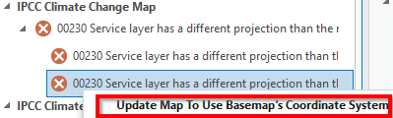

* + - 1. Right-click on the **00374 error** and select **Auto-Assign IDs Sequentially**.

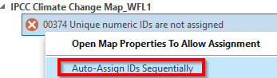

* + 1. Click **Analyze** again to check for errors. You should no longer see any errors or warnings. Click **Share**.
    2. Click the **Manage the web map** link at the bottom of the Share As a Web Map window to view your uploaded item in your default web browser. You should also see the simplified metadata information that we entered in the previous step (e.g. Name, Summary). You may need to sign into your ArcGIS Online account to view the item.

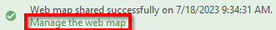

### **Performing raster analysis with ArcGIS Image for ArcGIS Online**

* 1. In the item’s overview page on ArcGIS Online in your web browser, select **Open in Map Viewer**.

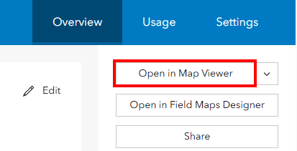

* 1. Within the new Map Viewer window, click the **Add** icon , and select **Browse layers**.
  2. Select **ArcGIS Online** in the dropdown list.

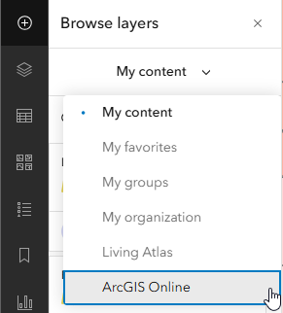

* 1. Search for the **MetadataClimateLab** layer by Wing Cheung, and click **Add**  to add it to the map.

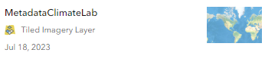

* 1. Within the new Map Viewer window, click the **Analysis** icon .

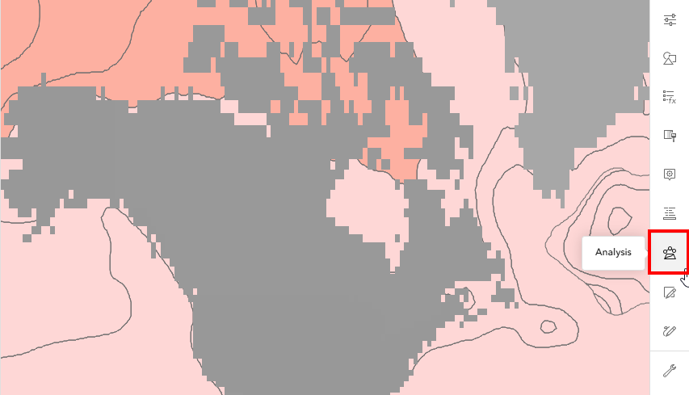

* 1. In the Analysis pane, click **Raster Functions**.

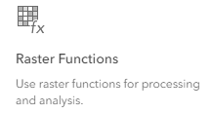

* 1. In the search bar, type in **Rasterize Features**. Click on the name of the tool. We will use this tool to convert our polygon layers into raster layers.
  2. Within the Rasterize Features window, enter the following:
     1. Raster: **MetadataClimateLab**
     2. Input Features: **TempChangeLowEmission**
     3. Field: **ContourMin**
     4. OutputName: **LowEmiss(last 4 digits of your phone number)**
     5. Click **Environment settings** to expand it. Under **Processing extent**, click the dropdown and select **Layer**. Click the **+ Layer** icon under processing extent and select **MetadataClimateLab**.

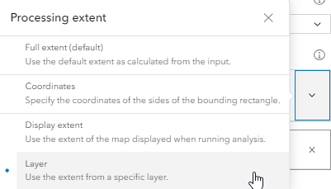 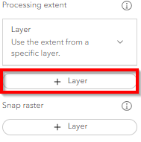

* + 1. Click **Estimate credits** to see how much credit this tool will consume (it should cost no more than 1 credit), then click **Run. (DO NOT run the tool and consult the instructor if the estimated number of credits needed is greater than 5.)**
  1. Repeat step h, except with the **TempChangeExtremeEmission** layer as the Input Features, and call the output **ExtEmiss(last 4 digits of your phone number).** Click **Run.**
  2. To calculate the average temperature change that will be experienced by each region under the low emission scenario, click **Analysis** in the map viewer and select the **raster functions** icon .
  3. In the search bar, type in **zonal statistics**. Click on the name of the tool.
  4. Within the Zonal Statistics window, enter the following:
     1. Zone Raster: **MetadataClimateLab**
     2. Zone Field: **Value**
     3. Value Raster: **LowEmiss(last 4 digits of your phone number)**
     4. Statistics Type: **Mean**
     5. Output name: **LowMean(last 4 digits of your phone number)**
     6. Click **Estimate credits** (it should cost no more than 1 credit). Click **Run.**
  5. To symbolize the newly created layer (i.e. **LowMean(last 4 digits of your phone number)**), click the **layers** icon  on the left side of the map viewer and ensure that the **correct layer is selected** (it may take a few minutes for the new layer to show up in the Layers pane). Then, click the **styles** icon on the right side of the map viewer, and select the **Classify** style to see which countries or regions will experience the greatest increase in average temperatures under the low emission scenario. Click **Done**.

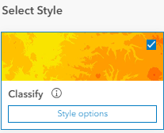

* 1. Repeat steps k and l with the **ExtEmiss(last 4 digits of your phone number)** layer as the Value Raster, and call the output **ExtMean(last 4 digits of your phone number)**
  2. Configure the new layer’s (i.e. **ExtMean(last 4 digits of your phone number)**)style as you did in step m.
  3. Click the **Save** icon  and select **Save** to save your map.
  4. Click the **Share map** icon  and select **Manage sharing**. Select **Organization** and hit **Save**.
  5. When prompted to Review sharing, click **Review sharing** and hit **Update sharing** to ensure that the layers in the map have the same sharing permission as the map itself.

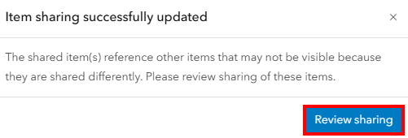 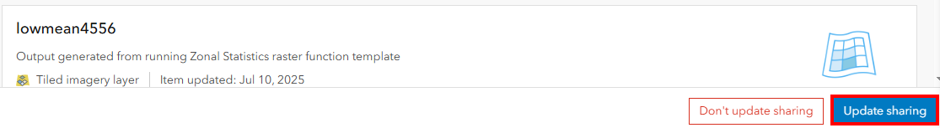

Q5. Click the **Share map** icon  and select **copy link to map**. Submit the link to your map.

Works Cited

Alexander, Lisa, et al. *Climate Change 2013: The Physical Science Basis. Contribution of Working Group I to the Fifth Assessment Report of the Intergovernmental Panel on Climate Change*. Cambridge University Press, 2013.

Furphy, David. “What on Earth Is an RCP?” *Medium*, Medium, 29 Sept. 2013, medium.com/@davidfurphy/what-on-earth-is-an-rcp-bbb206ddee26. Accessed 30 June 2019.

IPCC. “About the IPCC.” *IPCC Overview*, IPCC, 2019, www.ipcc.ch/about/.

‌

# Chapter 11: Plan your Mars landing

*In this exercise, you will:*

* *Reclassify raster layers*
* *Extract cells from a raster layer based on their attributes*
* *Perform basic terrain analysis (i.e. slope)*
* *Perform raster calculations*
* *Convert raster layers to the vector format*
* *Add and calculate new fields*
* *Perform zonal statistical analysis*

## **Introduction**

*Known as the Red Planet due to the oxidation of iron minerals (i.e. rust) in its soils, the diameter of the planet Mars (i.e. 6,790 kilometers) is only slightly more than half the size of the Earth’s diameter (i.e. 12,750 kilometers) (Kiefer et al., 1997; Erickson et al., 2019). The former Soviet Union and the United States have launched probes to Mars since 1960, and the first successful flyby of Mars was performed by the Mariner 4 mission in 1965 (Erickson et al., 2019). While the Soviet probes, Mars 2 and Mars 3, were the first to contact the Martian surface in 1971, these missions failed seconds after landing (Williams, 2019a; Williams, 2019b). NASA’s Viking 1 and Viking 2 missions provided us with the first color panoramic images of the planet. Both spacecraft landed on Mars’ surface in 1976 and remained operational for six and three years, respectively (NASA/JPL).*

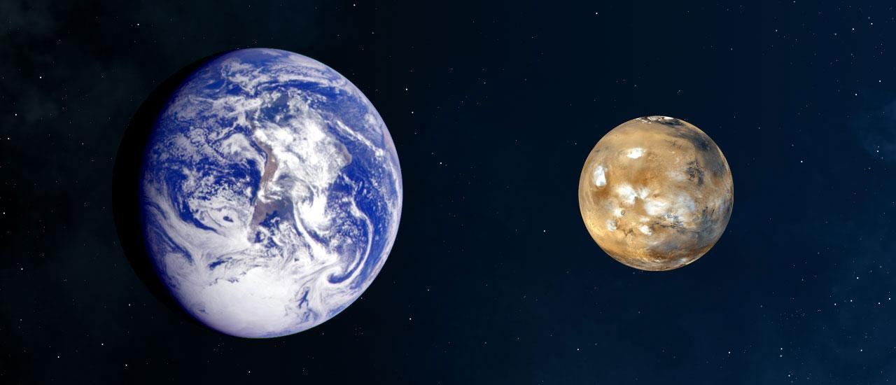

A comparison of the size of Earth with the size of Mars (Source: NASA)

*NASA’s Viking program was subsequently followed by other successful missions to Mars in the 1980s (e.g. Soviet’s Phobos 1, 2), 1990s (e.g. NASA’s Mars Global Surveyor, Mars Pathfinder & Sojourner), 2000s (e.g. NASA’s Phoenix, European Space Agency’s Mars Express), and up to the present day (e.g. NASA’s Curiosity, InSight) (The Planetary Society).*

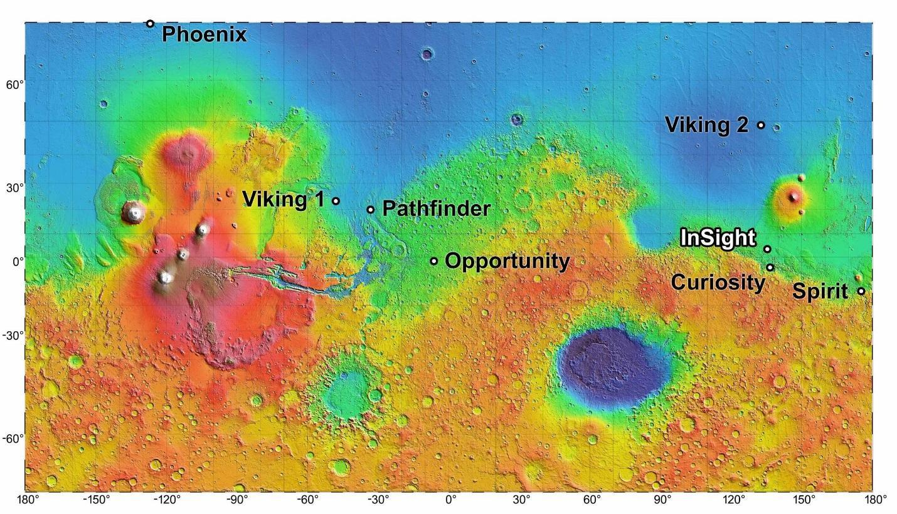

Selected Soviet and NASA landing sites on Mars (Source: NASA)

*As various countries and space agencies continue to be fascinated by the Red Planet, the research objective of Mars Exploration has also evolved from a “skin-deep” exploration that seeks to photograph and study the planet’s surface features, to one that will explore the planet’s geological processes and deep interior (Byrd, 2018). Ultimately, scientists hope to learn more about Mars’ history of life and habitability by understanding the forces that shaped the planet’s evolution over time (NASA, 2014).*

*A crucial obstacle for many expeditions is the ability to land rovers with scientific instruments on Mars. In this exercise, you will find a suitable landing site for future rovers based on elevation and terrain data, as well as dust level information that has been gathered in past missions. Specifically, in this simplified exercise to determine a suitable landing site, you will look for areas that fulfill the following criteria:*

* *Low dust level: Since dust storm is a common phenomenon on Mars, areas with relatively low dust levels are preferred, because high dust level may prevent rovers from accessing the sunlight needed to charge their solar panels (Witze, 2018).*
* *Low slope value: When looking at many of the past landing sites, smooth and flat surfaces were intentionally chosen, because rocky terrain may not only damage the spacecraft, but also cause it to tip over (Koren, 2017).*
* *Low elevation: Relative to Earth, Mars’s atmosphere is about 100 times thinner (Sharp, 2017). Consequently, landing spots at low elevations are preferred, because Mar’s atmosphere is thickest at these locations, and provides sufficient atmospheric friction for the spacecraft’s landing gear to slow its landing (JPL, 2018).*

### **Identify areas of low elevation**

* 1. Open **ArcGIS Pro**, and start a new **project** and a new **map**.
  2. Add in the **Elevation** layer. This will take several minutes to open, as it contains the elevation information for the entire planet of Mars. Explore the layer’s properties.

Q1. What is the Projected Coordinate System used by this layer? *\*\*Tip: Check the layer’s Properties, the Source section, and the Spatial Reference subsection\*\**

* 1. Go to **Analysis**>**Tools**. Look for **Reclassify (Spatial Analyst Tools)**. Enter the following:
     1. Input raster: **Elevation**
     2. Reclass field: **Value**
     3. (Click **Classify**), select **Equal Interval** for Method, enter **10** for the Number of classes, and click **OK**.

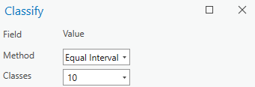

In the table below, fill out the Start and End values for each New class. **You will be submitting a copy or photo of this table for the assignment.**

| *Reclassification of the ELEVATION layer* | | |
| --- | --- | --- |
| Start | End | New |
| -8201 | -5256.8 | 1 |
|  |  | 2 |
|  |  | 3 |
|  |  | 4 |
|  |  | 5 |
|  |  | 6 |
|  |  | 7 |
|  |  | 8 |
|  |  | 9 |
| 18296.8 | 21241 | 10 |
| NODATA | NODATA | NODATA |

* + 1. Output raster: **ReclElev** *(**Tip: Replace the characters after the last backslash ( \ ) with ReclElev. Do not delete everything and just type in ReclElev**)*
    2. Click **Run** (This process will take several minutes)
  1. We want to land at relatively low elevations since Mars’ atmosphere is thickest at these locations, which enables the spacecraft to make a slow and stable descent. In this step, we will single out the low-elevation areas that we previously reclassified to the new class value of 1.

Go to **Analysis**>**Tools**. Look for **Extract by Attributes (Spatial Analyst Tools)**. Enter the following:

* + 1. Input raster: **ReclElev**
    2. Use the dropdown menus to enter **Value** for the first dropdown, **is equal to** for the second dropdown, and **1** for the third dropdown.

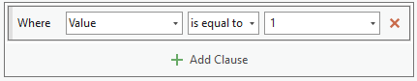

* + 1. Output raster: **ClipElev**
    2. Click **Run** (This process will take several minutes) 
  1. **Turn off** the ReclElev layer in the Contents pane, so you can see the ClipElev output clearly.

### **Identify relatively flat areas**

* 1. Go to **Analysis**>**Tools**. Look for **Slope (Spatial Analyst Tools)**. Enter the following:
     1. Input raster: **Elevation**
     2. Output raster: **MarsSlope**
     3. Click **Run** (This process will take several minutes)
  2. Go to **Analysis**>**Tools**. Look for **Reclassify (Spatial Analyst Tools)**. Enter the following:
     1. Input raster: **MarsSlope**
     2. Reclass field: **Value**
     3. (Click **Classify**), select **Equal Interval** for Method, enter **10** for the Number of classes, and click **OK**.

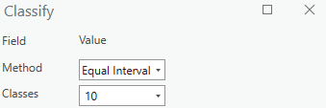

In the table below, fill out the Start and End values for each New class. **You will be submitting a copy or photo of this table for the assignment.**

| *Reclassification of the SLOPE layer* | | |
| --- | --- | --- |
| Start | End | New |
| 0 | 7.975194 | 1 |
|  |  | 2 |
|  |  | 3 |
|  |  | 4 |
|  |  | 5 |
|  |  | 6 |
|  |  | 7 |
|  |  | 8 |
|  |  | 9 |
| 71.776744 | 79.751938 | 10 |
| NODATA | NODATA | NODATA |

* + 1. Output raster: **ReclSlope**
    2. Click **Run** (This process will take several minutes)
  1. We want to land on relatively flat areas, much like previous landings, especially taking care to avoid overly steep areas (i.e. areas with high slope values), in order to avoid tipping over or damaging the spacecraft.

Go to **Analysis**>**Tools**. Look for **Extract by Attributes (Spatial Analyst Tools)**. Enter the following:

* + 1. Input raster: **ReclSlope**
    2. Use the dropdown menus to enter **Value** for the first dropdown, **is equal to** for the second dropdown, and **1** for the third dropdown.
    3. Output raster: **ClipSlope**
    4. Click **Run** (This process will take several minutes)

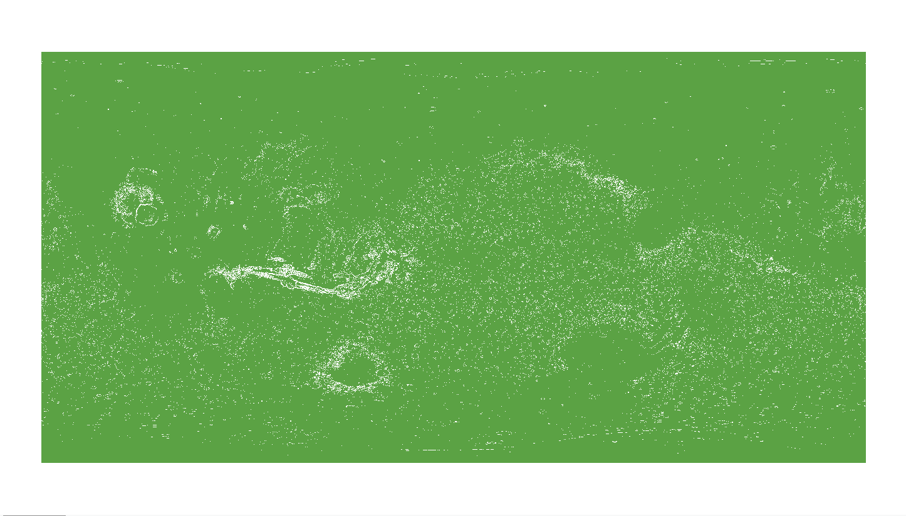

### **Find areas at low elevations that are also flat**

* 1. **Turn off** all layers in the Contents pane except **ClipElev** and **ClipSlope**. All the cells that are in the ClipElev layer have a class value of 1 (i.e. low elevation), and all other areas have a value of no data (hidden). Similarly, all the cells that are in the ClipSlope layer have a class value of 1 (i.e. relatively flat), and all other areas have no data values (hidden).
  2. Go to **Analysis**>**Tools**. Look for **Raster Calculator (Spatial Analyst Tools)**. Enter the following equation by double-clicking the appropriate items from the **Rasters** and **Tools** sections:

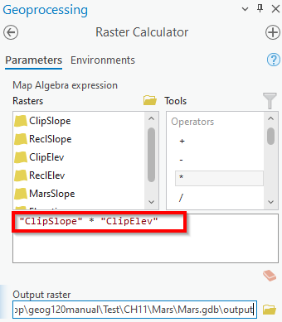

* + 1. Output raster: **Output**
    2. Click **Run** (This process will take several minutes)

### **Convert raster output into vector features**

* 1. **Turn off** all layers in the Contents pane except Output. Only those cells that have a value of 1 in the ClipSlope layer (relatively flat) AND a value of 1 in the ClipElev layer (low elevation) should be found in the Output layer, because:
     + *1 in ClipSlope (flat) * 1 in ClipElev (low elevation) = 1 in output*
     + *nodata in ClipSlope (not flat) * 1 in ClipElev (low elevation) = nodata in output*
     + *1 in ClipSlope (flat) * nodata in ClipElev (not low elevation) = nodata in output*
  2. We will need to convert the raster output into a polygon layer in order to calculate the area of suitable (low elevation, flat) landing sites. To do this, go to **Analysis**>**Tools**. Look for **Raster to Polygon (Conversion Tools)**, and enter the following:
     1. Input raster: **Output**
     2. Field: **Value**
     3. Output polygon features: **OutputPoly**
     4. **(Keep Simplify polygons checked)**
     5. Click **Run**

### **Add field and calculate area**

* 1. To calculate the area of the suitable sites in our OutputPoly layer, we will first need to add a new field in the layer’s attribute table. Go to **Analysis**>**Tools**, and look for **Add Field (Data Management Tools)**. Enter the following:
     1. Input Table: **OutputPoly**
     2. Field Name: **NewArea**
     3. Field Type: **Double (64-bit floating point)**
     4. Click **Run**
  2. To perform our area calculation and store the result in the NewArea field, go to **Analysis**>**Tools**, and look for **Calculate Geometry Attributes (Data Management Tools)**. Enter the following:
     1. Input Features: **OutputPoly**
     2. Geometry Attributes: Field (Existing or New)-**NewArea,** Property-**Area**
     3. Area Unit: **Square US Survey Miles**
     4. Coordinate System: **Current Map [Map]**
     5. Click **Run**
  3. Open the attribute table of the **OutputPoly** layer, and **sort** the NewArea field in a Descending order.

Q2. What is the size of the largest site which is relatively flat and at a low elevation (i.e. largest value in the NewArea column)?

Submit a screenshot of your map with the largest site selected.

* 1. **Clear** any selected feature(s) before moving on to the next step.

### **Compare the dust level at our potential landing sites**

* 1. Add in **MarsDust** layer.
  2. Go to **Analysis**>**Tools**. Look for **Zonal Statistics (Spatial Analyst Tools)**. Enter the following parameters to calculate the average dust level at each of the zone/site polygons that are in the OutputPoly layer:
     1. Input raster or feature zone data: **OutputPoly**
     2. Zone field: **Id**
     3. Input value raster: **MarsDust**
     4. Output raster: **DustStat**
     5. Statistics type: **Mean**
     6. Click **Run**
  3. **Turn off** all layers in the Contents pane except DustStat.
  4. We want to avoid areas with high levels of dust, as Martian dust storms can prevent the sun’s radiation from reaching our spacecraft’s solar panels and recharging its battery. **Symbolize** the new DustStat layer (under the **Raster Layer** tab) to increase the contrast between the levels of dust at various landing sites/zones if necessary.
  5. Using the **Explore** tool under the **Map** tab, click on the approximate location of the polygon that was in your screenshot for your answer to Question 2.

Q3. What is the average/mean level of dust [i.e. Stretch.Pixel Value] at that site?

* 1. Refer to the **DustStat** (not MarsDust) layer’s legend in the Contents pane.

Q4. Of the average dust levels among our suitable sites, what is the minimum dust level value?

Q5. What is the maximum dust level value?

Q6. Is the value that you reported for Question 3 closer to the minimum or maximum dust level value?

*Be sure to submit all the tables for this lab exercise with your answers.*

Works Cited

“About the Mission.” *Mission to Mars: Viking 1*, NASA/JPL, www.jpl.nasa.gov/missions/viking-1/.

“About the Mission.” *Mission to Mars: Viking 2*, NASA/JPL, www.jpl.nasa.gov/missions/viking-2/.

Byrd, Deborah. “Landing on Mars Is Still Hard.” *EarthSky*, EarthSky Communications, 25 Nov. 2018, earthsky.org/space/landing-on-mars-is-still-hard.

Erickson, Kristen, et al. “Mars: The Red Planet.” *NASA Science: Solar System Exploration*, NASA, 13 Feb. 2019, solarsystem.nasa.gov/planets/mars/overview/.

Kiefer, Walter, et al. “Earth-Mars Comparison.” *The Red Planet: A Survey of Mars*, Lunar and Planetary Institute, 1997, www.lpi.usra.edu/publications/slidesets/redplanet2/slide_1.html.

Koren, Marina. “What Makes a Good Landing Site on Mars?” *The Atlantic*, Atlantic Media Company, 3 Apr. 2017, www.theatlantic.com/science/archive/2017/04/mars-landing-site/521715/.

“Missions to Mars.” *Space Missions*, The Planetary Society, www.planetary.org/explore/space-topics/space-missions/missions-to-mars.html#insight.

Sharp, Tim. “Mars' Atmosphere: Composition, Climate & Weather.” *Space.com*, Space.com, 12 Sept. 2017, www.space.com/16903-mars-atmosphere-climate-weather.html.

“The Mars InSight Landing Site Is Just Plain Perfect.” *JPL News*, JPL, 5 Nov. 2018, www.jpl.nasa.gov/news/news.php?feature=7273.

“The Red Planet: Science Goals.” *NASA Science: Mars Exploration Program*, NASA, 3 June 2014, mars.nasa.gov/#red_planet/1.

Williams, David. “Mars 2 Lander.” *NASA Space Science Data Coordinated Archive*, NASA, 1 Feb. 2019, nssdc.gsfc.nasa.gov/nmc/spacecraft/display.action?id=1971-045D.

Williams, David. “Mars 3 Lander.” *NASA Space Science Data Coordinated Archive*, NASA, 1 Feb. 2019, nssdc.gsfc.nasa.gov/nmc/spacecraft/display.action?id=1971-049F.

Witze, Alexandra. “Massive Martian Dust Storm Endangers NASA Rover.” *Nature News*, Nature Publishing Group, 13 June 2018, www.nature.com/articles/d41586-018-05425-1.